V3UDJ0M/N9M0D0X1

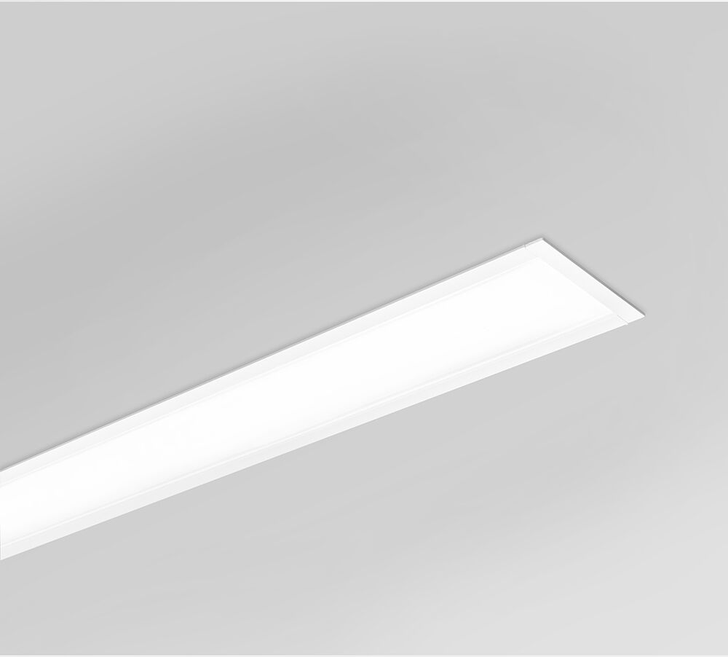
- Architectural light line luminaire.
- Diffuser optics, opal acrylic (PMMA), wide-angle light distribution.
- Dimensions: 2537 mm x 76 mm x 72 mm.
- Individual linear
- Flat panel diffuser for bright and uniform illumination.
- Luminous flux: 6900 lm, Luminous efficacy: 122 lm/W.
- Power: 56.7 W, DALI dimmable.
- Frequency: 50-60Hz AC.
- Voltage: 220-240V.
- Electrical isolation class: class I.
- LED with very good light maintenance; at 50000 hrs the luminaire retains 97% of it's initial flux (Tq=25°C).
- Correlated colour temperature: 4000 K, Colour rendering ra: 80.
- Colour consistency (McAdam ellipse): ≤ SDCM.
- Photobiological safety IEC/TR 62778: RG1.
- Lacquered aluminium housing, RAL9003 - white.
- IP protection level: IP20.
- IK protection level: IK07.
- Replaceable (LED only) light source by a professional. Replaceable control gear by a professional.
- Energy efficiency class of the light source according to EU regulation 2019/2015: C.
- Glowwire: 850°C.
- 5 years warranty on luminaire and driver.
- Certifications: CE, ENEC.
- Luminaire with halogen free leads.
- The luminaire has been developed and produced according to standard EN60598-1 in a company that is ISO9001 and ISO14001 certified.

