D11R1/LEDN20DX1

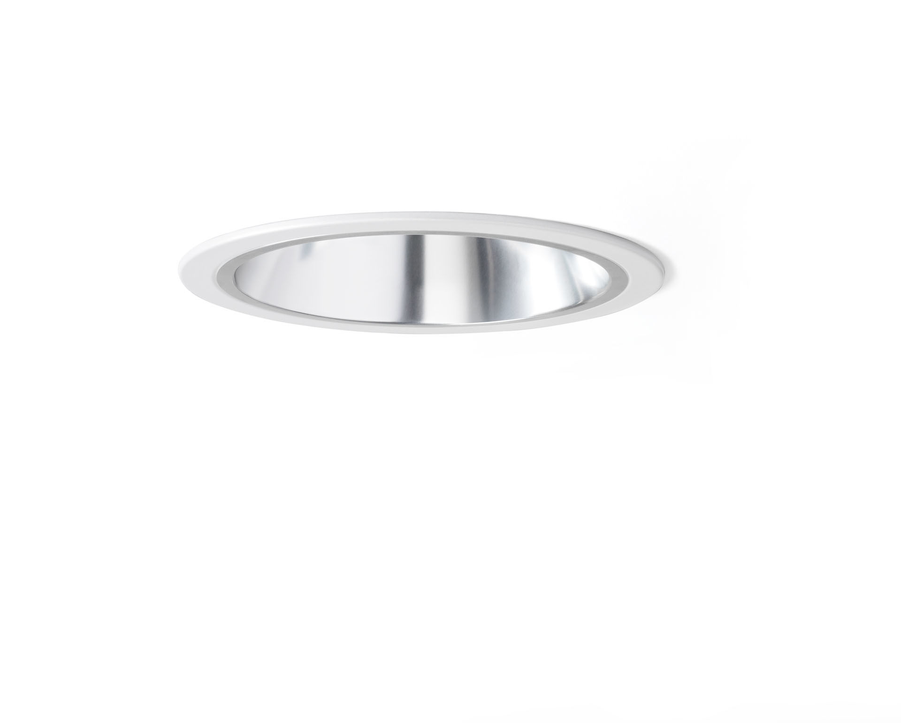
Recessed downlight with aluminium reflector. Reflector optics, aluminium, satin anodised, wide-angle light distribution. Metal trim 1 mm thickness, other RAL colours possible on demand. Dimensions: Ø 220 mm x 120 mm. Ceiling cut-out: Ø 205 mm. Reflector shields the light source thus preventing glare from the LED source. Wide-angle light distribution. Luminous flux: 2350 lm, Luminous efficacy: 118 lm/W. Power: 20.0 W, DALI dimmable. Frequency: 50Hz AC. Voltage: 230-240V. Electrical isolation class: class II. LED with very good light maintenance; at 50000 hrs the luminaire retains 98% of it's initial flux (Tq=25°C). Correlated colour temperature: 4000 K, Colour rendering ra: 80. Standard deviation colour matching satisfy 3 SDCM. Photobiological safety IEC/TR 62778: RG1. Injection-moulded aluminium housing, RAL9003 - signal white. 5 years warranty on luminaire and driver. Certifications: CE, ENEC. Luminaire with halogen free leads. The luminaire has been developed and produced according to standard EN60598-1 in a company that is ISO9001 and ISO14001 certified.

