D7R3RBW/N3CHD

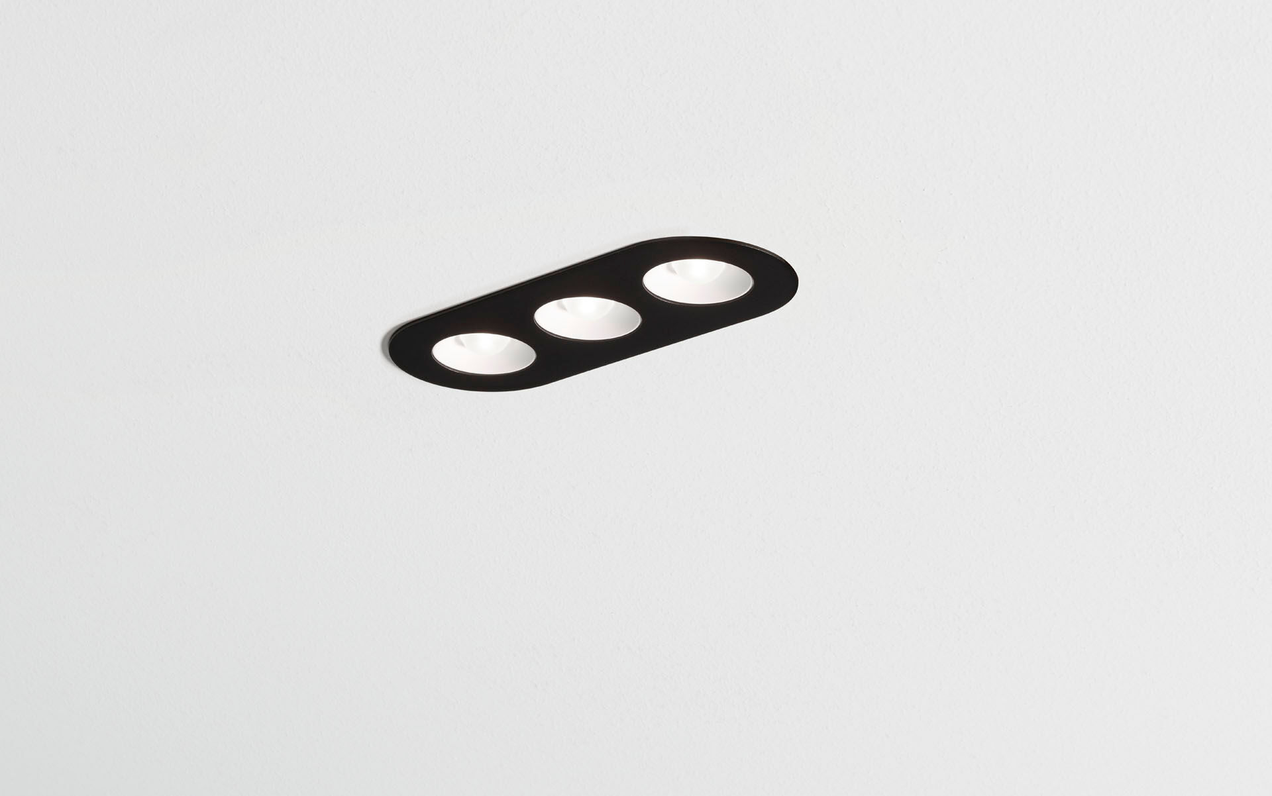
Linear downlight with round edges, black housing. Led+lens™ optics, white cups, polycarbonate, very wide-angle light distribution. 3 lenses recessed in circular lens cups. Dimensions: 235 mm x 95 mm x 40 mm. LED+LENS™, a combination of high performance LEDs and individual lenses with a patented surface structure. The lenses are recessed in small cups for a comfortable light experience. Luminous flux: 1100 lm, Luminous efficacy: 92 lm/W. Power: 12.0 W, DALI dimmable. Frequency: 50-60Hz AC. Voltage: 220-240V. Electrical isolation class: class II. LED with very good light maintenance; at 50000 hrs the luminaire retains 94% of it's initial flux (Tq=25°C). Correlated colour temperature: 4000 K, Colour rendering ra: 80. Standard deviation colour matching satisfy 3 SDCM. LED+LENS™ with UGR <= 22 conform norm EN 12464-1 for moderate visual and concentration demands. Photobiological safety IEC/TR 62778: RG1. RAL9005 - jetblack (textured). IP protection level: IP20. Glowwire: 850°C. 5 years warranty on luminaire and driver. Certifications: CE, ENEC. Luminaire with halogen free leads. The luminaire has been developed and produced according to standard EN60598-1 in a company that is ISO9001 and ISO14001 certified.

