D7R6RWW/N2CHS

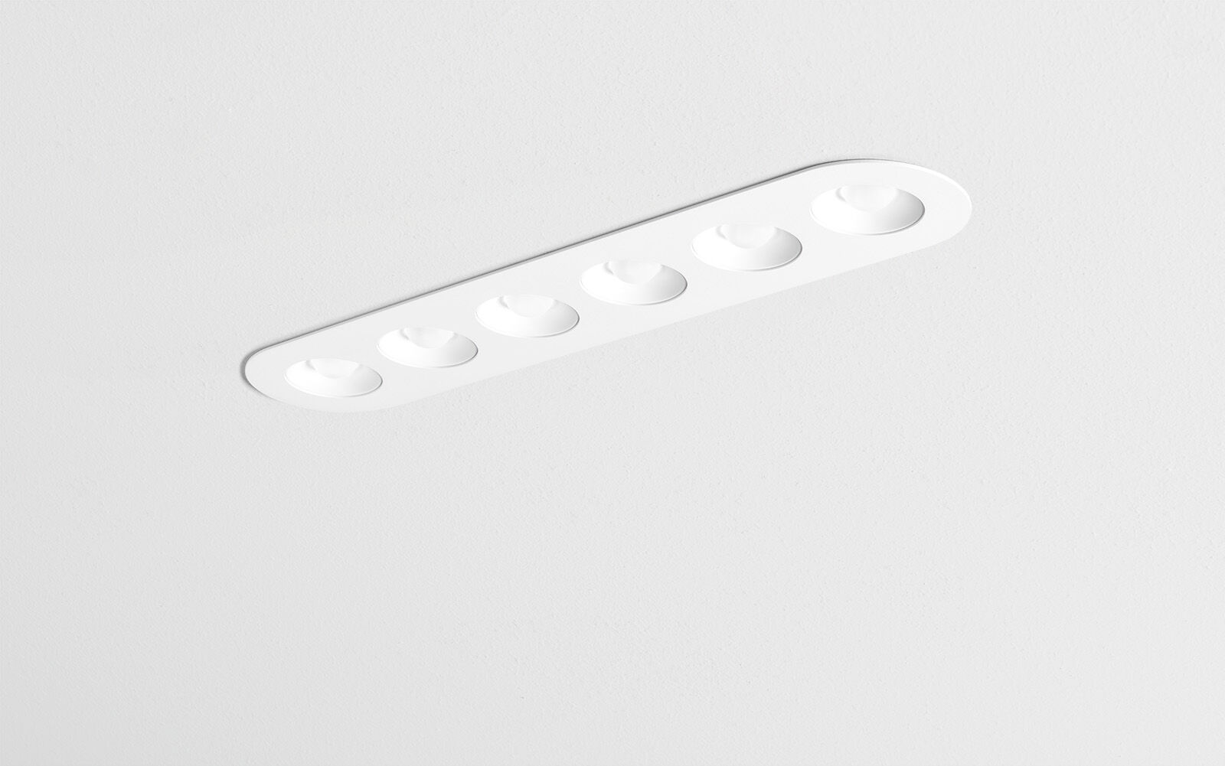
Linear downlight with round edges, white housing. Led+lens™ optics, white cups, polycarbonate, wide-angle light distribution. 6 lenses recessed in circular lens cups. Dimensions: 445 mm x 95 mm x 40 mm. LED+LENS™, a combination of high performance LEDs and individual lenses with a patented surface structure. The lenses are recessed in small cups for a comfortable light experience. Luminous flux: 2200 lm, Luminous efficacy: 100 lm/W. Power: 22.0 W, not dimmable. Frequency: 50-60Hz AC/DC. Voltage: 220-240V. Electrical isolation class: class II. LED with very good light maintenance; at 50000 hrs the luminaire retains 93% of it's initial flux (Tq=25°C). Correlated colour temperature: 4000 K, Colour rendering ra: 80. Standard deviation colour matching satisfy 3 SDCM. LED+LENS™ with UGR <= 22 conform norm EN 12464-1 for moderate visual and concentration demands. Photobiological safety IEC/TR 62778: RG1. RAL9003 - white (textured). IP protection level: IP20. Glowwire: 850°C. 5 years warranty on luminaire and driver. Certifications: CE. Luminaire with halogen free leads. The luminaire has been developed and produced according to standard EN60598-1 in a company that is ISO9001 and ISO14001 certified.

