D90/LEDN20DEX1

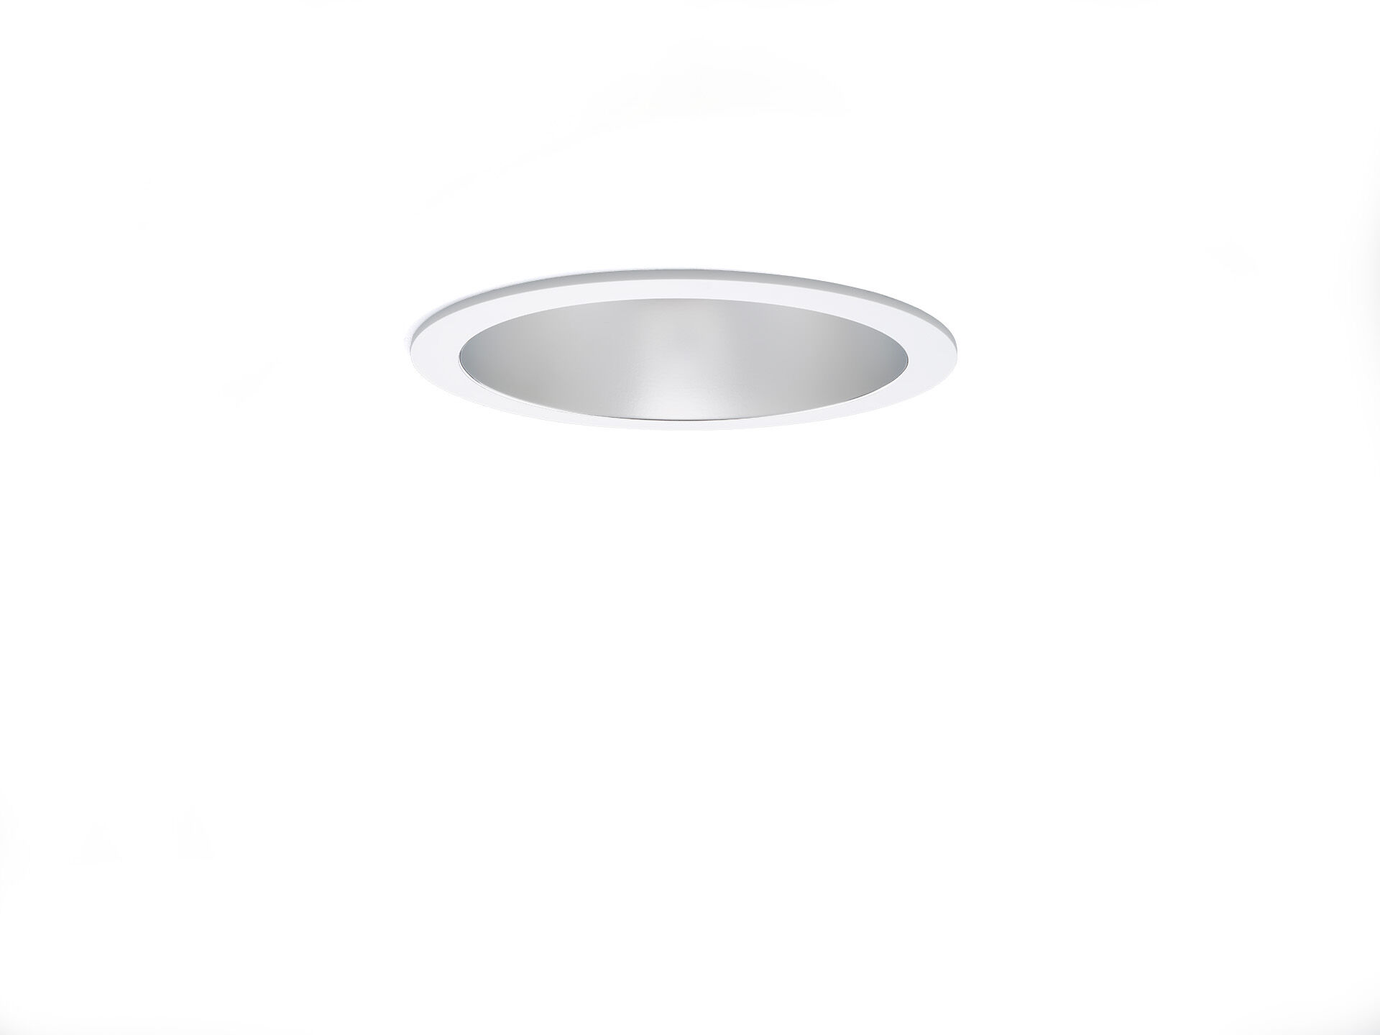
Seamless polycarbonate downlight. Reflector and lens optics, polycarbonate (PC) with aluminium thin film, satin look, wide-angle light distribution. White polycarbonate trim and reflector form one unit, without visible seams. Dimensions: Ø 190 mm x 100 mm. Ceiling cut-out: Ø 175 mm. Reflector shields the light source and a lens prevents glare. Luminous flux: 2150 lm, Luminous efficacy: 119 lm/W. Power: 18.1 W, DALI driver controlled by integrated sensor. Frequency: 50-60Hz AC/DC. Voltage: 220-240V. Electrical isolation class: class II. LED with very good light maintenance; at 50000 hrs the luminaire retains 98% of it's initial flux (Tq=25°C). Correlated colour temperature: 4000 K, Colour rendering ra: 80. Standard deviation colour matching satisfy 3 SDCM. Photobiological safety IEC/TR 62778: RG1. Polycarbonate housing, RAL9003 - signal white. IP protection level: IP20. Glowwire: 850°C. 5 years warranty on luminaire and driver. Certifications: CE, ENEC. Luminaire with halogen free leads. The luminaire has been developed and produced according to standard EN60598-1 in a company that is ISO9001 and ISO14001 certified.

