E22/LED4N060S3-ATEX1

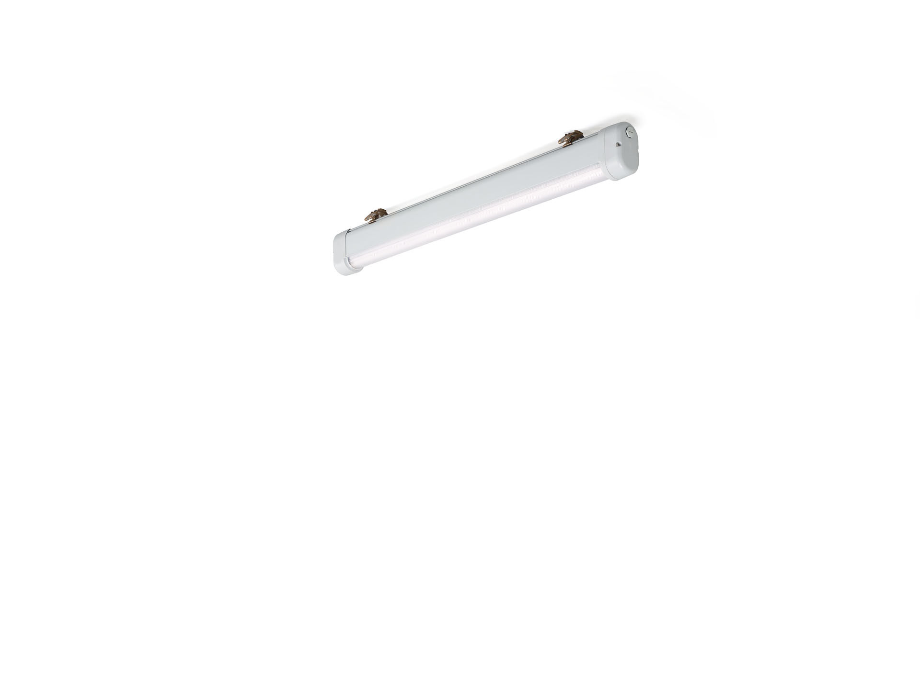
Industrial dust- and waterproof ATEX luminaire. Linear lens optics, polycarbonate (PC), wide-angle light distribution. Suitable for ATEX zone 2, zone 21, zone 22 (2014/34/EU). Dimensions: 1120 mm x 80 mm x 135 mm. Luminous flux: 6650 lm, Luminous efficacy: 130 lm/W. Power: 51.0 W, not dimmable. Frequency: 50-60Hz AC. Voltage: 220-240V. Electrical isolation class: class I. LED with very good light maintenance; at 50000 hrs the luminaire retains 96% of it's initial flux (Tq=25°C). Correlated colour temperature: 4000 K, Colour rendering ra: 80. Standard deviation colour matching satisfy 3 SDCM. Photobiological safety IEC/TR 62778: RG1. Lacquered aluminium housing, RAL7035 - light grey. IP protection level: IP66. IP from below: IP69K. Non-replaceable light source. Replaceable control gear by a professional. Ambient temperature: -20°C - 40°C. ATEX classification: II 2D Ex tb IIIC T80°C Db, II 3G Ex ec IIC T4 Gc. Glowwire: 850°C. 5 years warranty on luminaire and driver. Certifications: CE, ATEX, ENEC. Luminaire with halogen free leads. The luminaire has been developed and produced according to standard EN60598-1 in a company that is ISO9001 and ISO14001 certified.

