E4001/LED2W040S

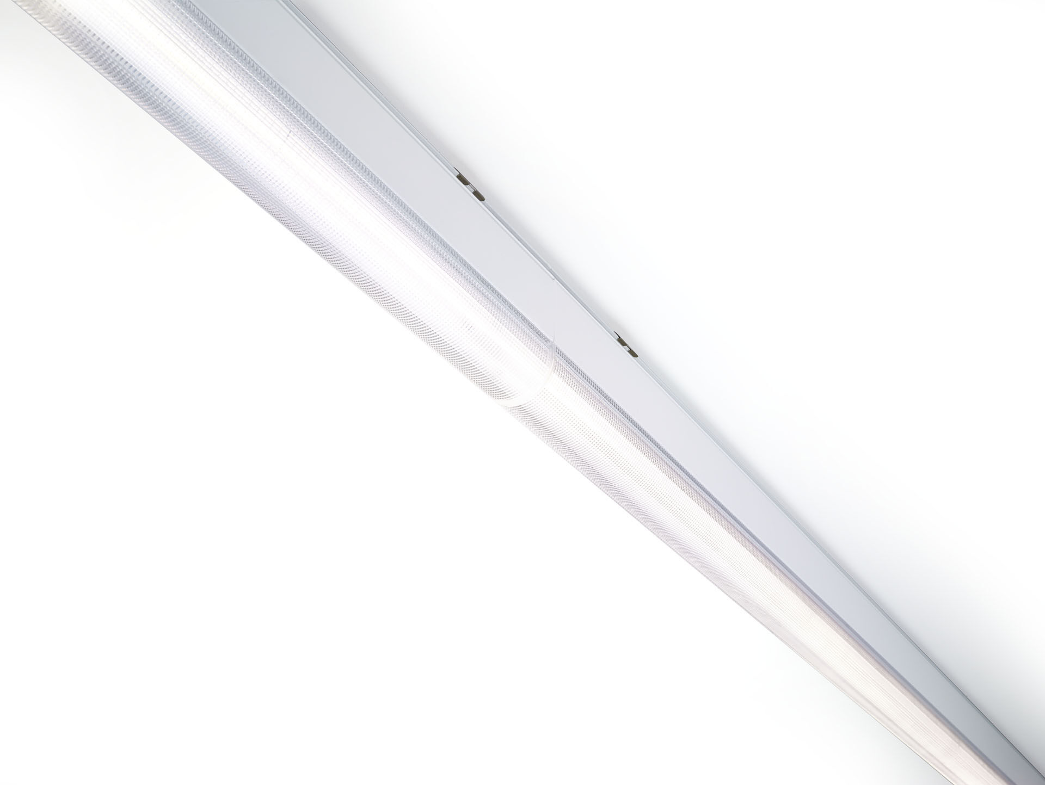
Industrial line luminaire with sleek design. Dual●lens optics, polycarbonate (PC), narrow-angle light distribution. Dimensions: 2000 mm x 60 mm x 135 mm. Luminous flux: 4800 lm, Luminous efficacy: 126 lm/W. Power: 38.0 W, not dimmable. Frequency: 50-60Hz AC. Voltage: 220-240V. Electrical isolation class: class I. LED with very good light maintenance; at 50000 hrs the luminaire retains 97% of it's initial flux (Tq=25°C). Correlated colour temperature: 3000 K, Colour rendering ra: 80. Standard deviation colour matching satisfy 3 SDCM. DUAL●LENS™ with UGR <= 22 conform norm EN 12464-1 for moderate visual and concentration demands. Lacquered aluminium housing, RAL9016 - traffic white (textured). IP protection level: IP40. IK protection level: IK06. Glowwire: 850°C. 5 years warranty on luminaire and driver. Certifications: CE, ENEC. Luminaire with halogen free leads. The luminaire has been developed and produced according to standard EN60598-1 in a company that is ISO9001 and ISO14001 certified. Mandatory accessoires for mounting the luminaire: E7H301, E4H1000, E4H111, E4H112, E4H121, E4H122, E4H131, E4H141, E4H142, .

