E4215/LED4W080S

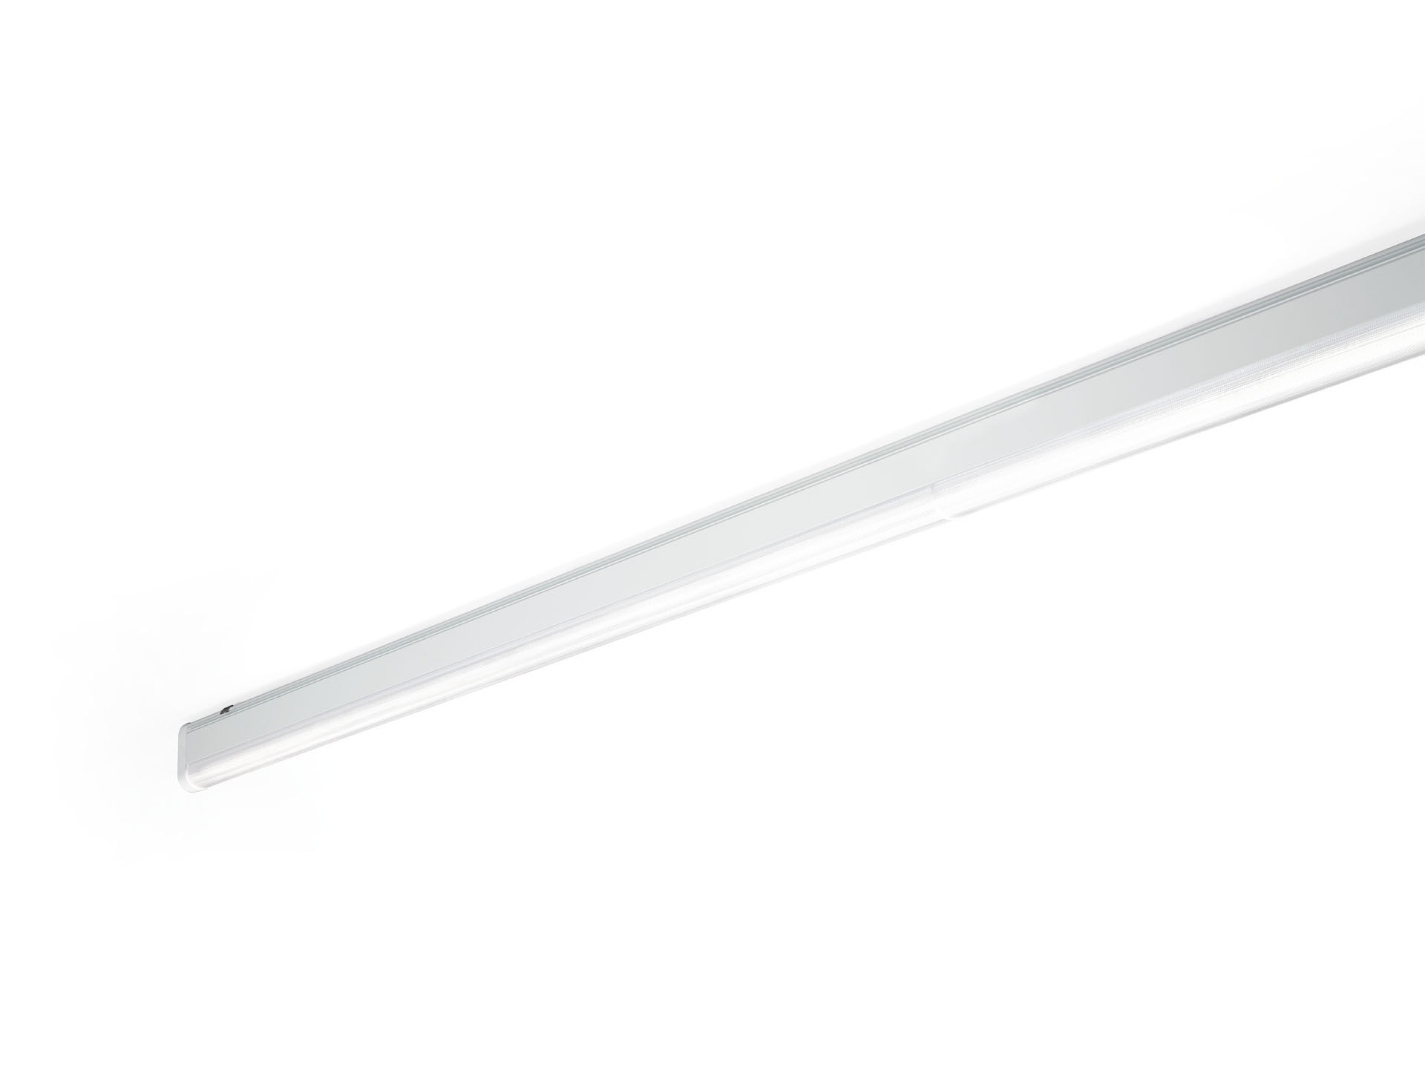
Industrial line luminaire with sleek design. Surge protection (LN/PE): 1kV/2kV (for light industrial environments). Dual●lens optics, polycarbonate (PC), wide-angle light distribution. Dimensions: 4000 mm x 60 mm x 135 mm. Luminous flux: 10350 lm, Luminous efficacy: 134 lm/W. Power: 77.0 W, not dimmable. Frequency: 50-60Hz AC. Voltage: 220-240V. Electrical isolation class: class I. LED with very good light maintenance; at 50000 hrs the luminaire retains 99% of it's initial flux (Tq=25°C). Correlated colour temperature: 3000 K, Colour rendering ra: 80. Colour consistency (McAdam ellipse): ≤ SDCM. DUAL●LENS™ with UGR <= 25 conform norm EN 12464-1 for low visual and concentration demands, frequent mobility. Lacquered aluminium housing, RAL9016 - traffic white. IP protection level: IP40. IK protection level: IK06. Replaceable (LED only) light source by a professional. Replaceable control gear by a professional. Glowwire: 850°C. 5 years warranty on luminaire and driver. Certifications: CE, ENEC. Luminaire with halogen free leads. The luminaire has been developed and produced according to standard EN60598-1 in a company that is ISO9001 and ISO14001 certified. Mandatory accessoires for mounting the luminaire: E7H301, E4H1000, E4H111, E4H112, E4H121, E4H122, E4H131, E4H141, E4H142, .

