E5B-S714-2A-840-090S

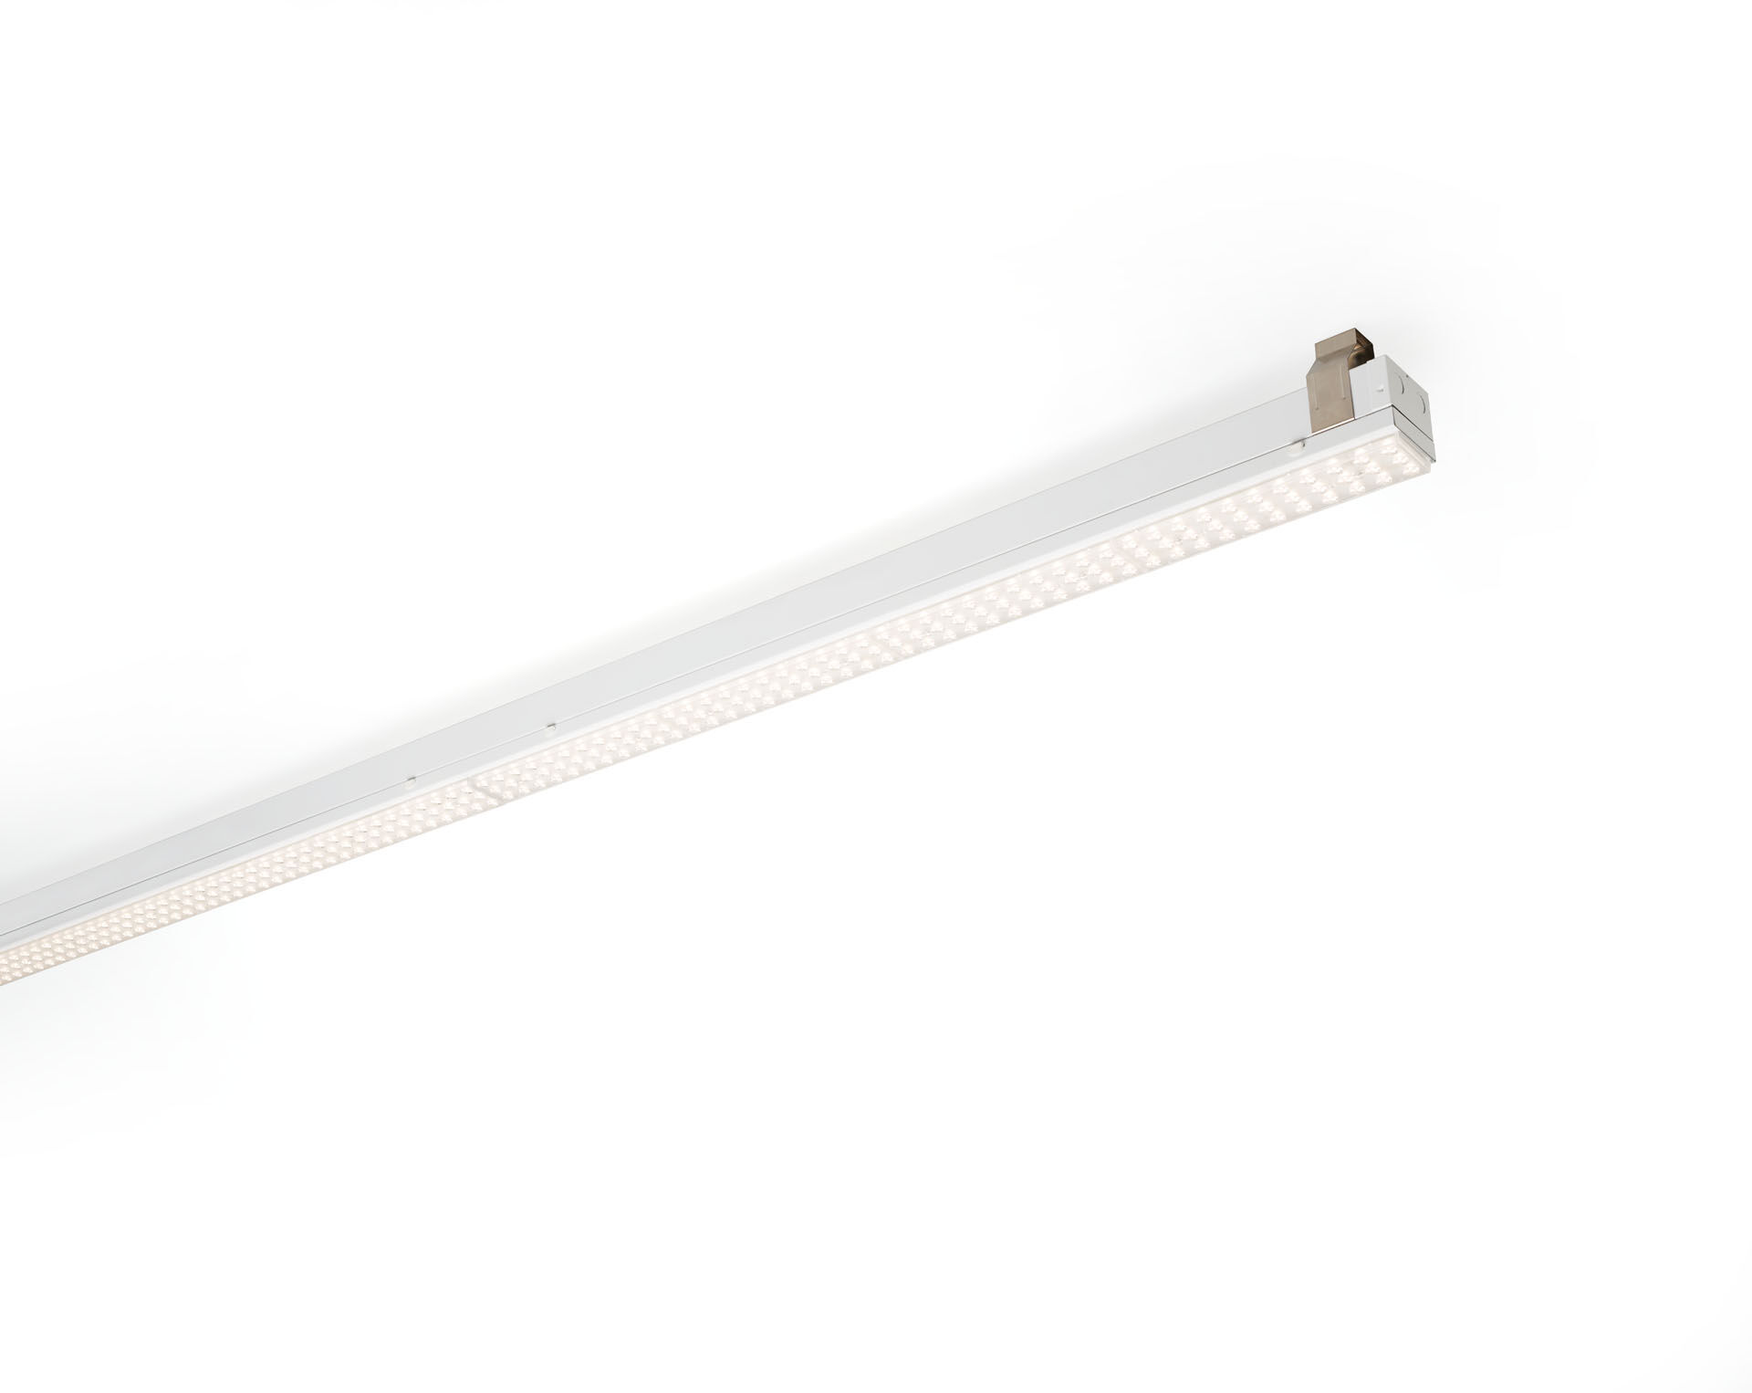
Industrial line luminaire. Surge protection (LN/PE): 1kV/2kV (for light industrial environments). Multilens optics, acrylic (PMMA), wide-angle light distribution. Module for mounting on base profile. Base profile in strong and rigid 0,8 mm steel. Module in coated sheet steel. Tool-free mounting of module on base. Suitable for retrofit on ETAP E3/E5 fluo systems. Electrical connection in base with phase selector plug. Dimensions: 1152 mm x 78 mm x 31 mm. Luminous flux: 9000 lm, Luminous efficacy: 143 lm/W. Power: 63.0 W, not dimmable. Frequency: 50-60Hz AC. Voltage: 220-240V. Electrical isolation class: class I. LED with very good light maintenance; at 50000 hrs the luminaire retains 93% of it's initial flux (Tq=25°C). Correlated colour temperature: 4000 K, Colour rendering ra: 80. Standard deviation colour matching satisfy 3 SDCM. Photobiological safety IEC/TR 62778: RG1. Lacquered sheet steel housing, RAL9003 - signal white. IP protection level: IP20. IK protection level: IK03. Replaceable (LED only) light source by a professional. Replaceable control gear by a professional. Glowwire: 650°C. 5 years warranty on luminaire and driver. Certifications: CE, ENEC. Luminaire with halogen free leads. The luminaire has been developed and produced according to standard EN60598-1 in a company that is ISO9001 and ISO14001 certified. Mandatory accessoires for mounting the luminaire: E5C11/0100, E5C11/0200, E5C11/0300, E5C11/0400, E5C11/0500, E5C11/1000, E5C11/1500, E5C11/2000, E5C11/2500, E3H115, E3H116, E3H117, E3H118, E3H119, E3H128, E3H129, E3H120, E3H121, E3H122, E3H123, E3H124, E3H125.

