E5B-S714-4A-840-050S

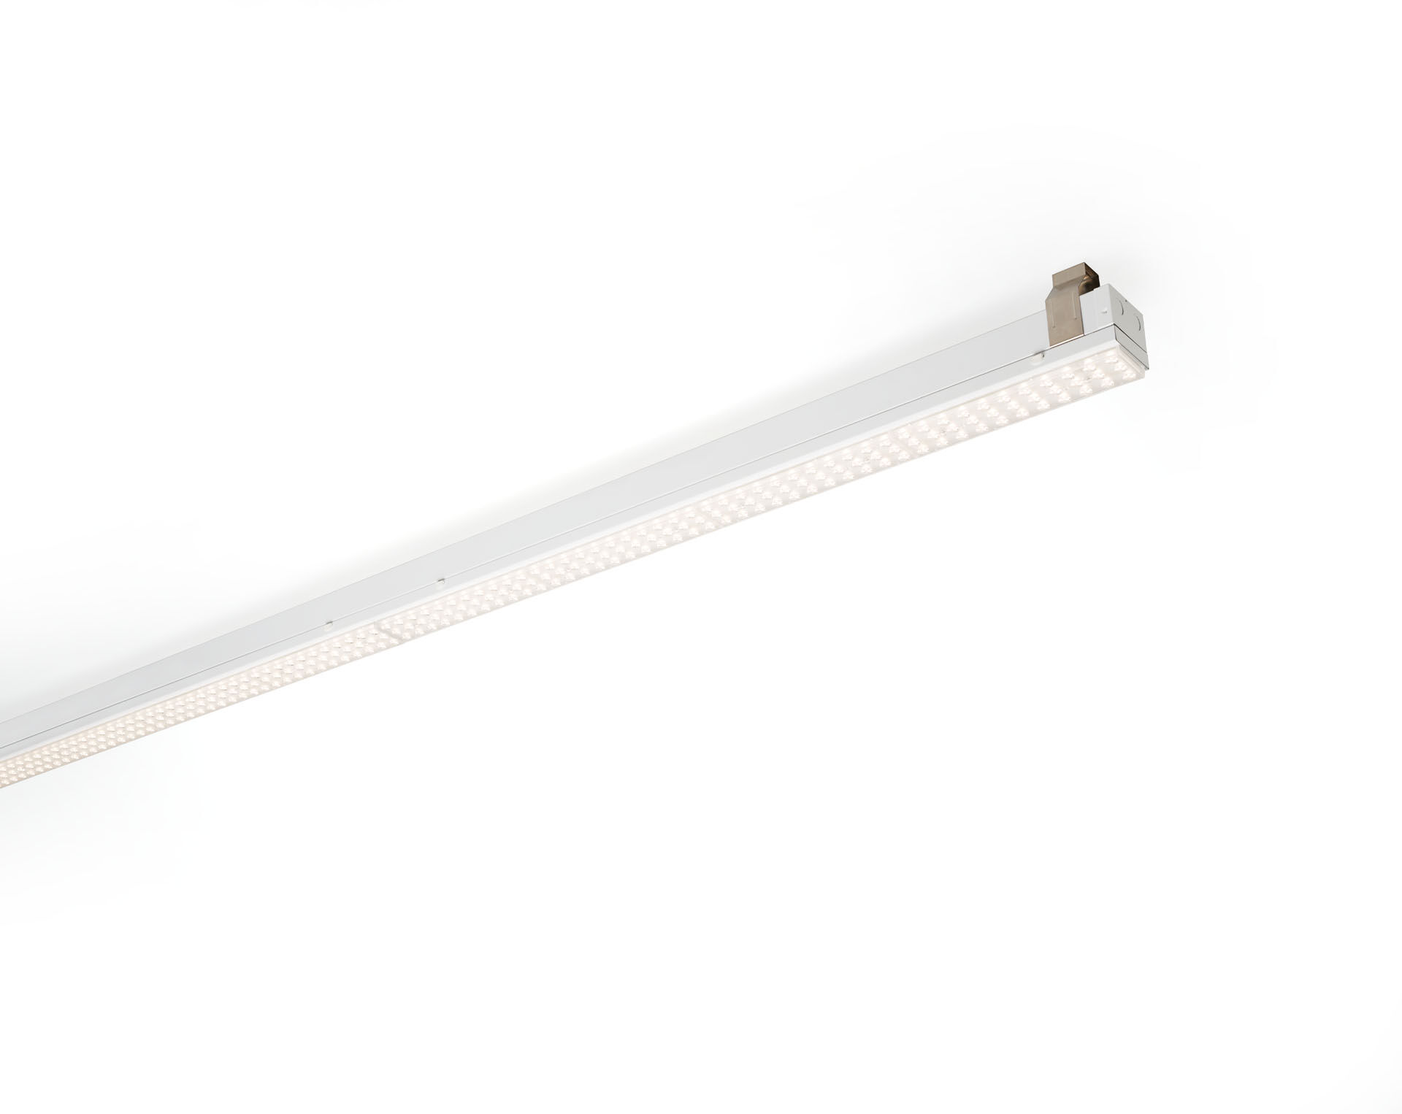
Industrial line luminaire. Surge protection (LN/PE): 1kV/2kV (for light industrial environments). Multilens optics, acrylic (PMMA), asymmetric light distribution. Module for mounting on base profile. Base profile in strong and rigid 0,8 mm steel. Module in coated sheet steel. Tool-free mounting of module on base. Suitable for retrofit on ETAP E3/E5 fluo systems. Electrical connection in base with phase selector plug. Dimensions: 1152 mm x 78 mm x 31 mm. Luminous flux: 5000 lm, Luminous efficacy: 161 lm/W. Power: 31.0 W, not dimmable. Frequency: 50-60Hz AC. Voltage: 220-240V. Electrical isolation class: class I. LED with very good light maintenance; at 50000 hrs the luminaire retains 95% of it's initial flux (Tq=25°C). Correlated colour temperature: 4000 K, Colour rendering ra: 80. Standard deviation colour matching satisfy 3 SDCM. Photobiological safety IEC/TR 62778: RG1. Lacquered sheet steel housing, RAL9003 - signal white. IP protection level: IP20. IK protection level: IK03. Replaceable (LED only) light source by a professional. Replaceable control gear by a professional. Glowwire: 650°C. 5 years warranty on luminaire and driver. Certifications: CE, ENEC. Luminaire with halogen free leads. The luminaire has been developed and produced according to standard EN60598-1 in a company that is ISO9001 and ISO14001 certified. Mandatory accessoires for mounting the luminaire: E5C11/0100, E5C11/0200, E5C11/0300, E5C11/0400, E5C11/0500, E5C11/1000, E5C11/1500, E5C11/2000, E5C11/2500, E3H115, E3H116, E3H117, E3H118, E3H119, E3H128, E3H129, E3H120, E3H121, E3H122, E3H123, E3H124, E3H125.

