E62/LED3N40S3

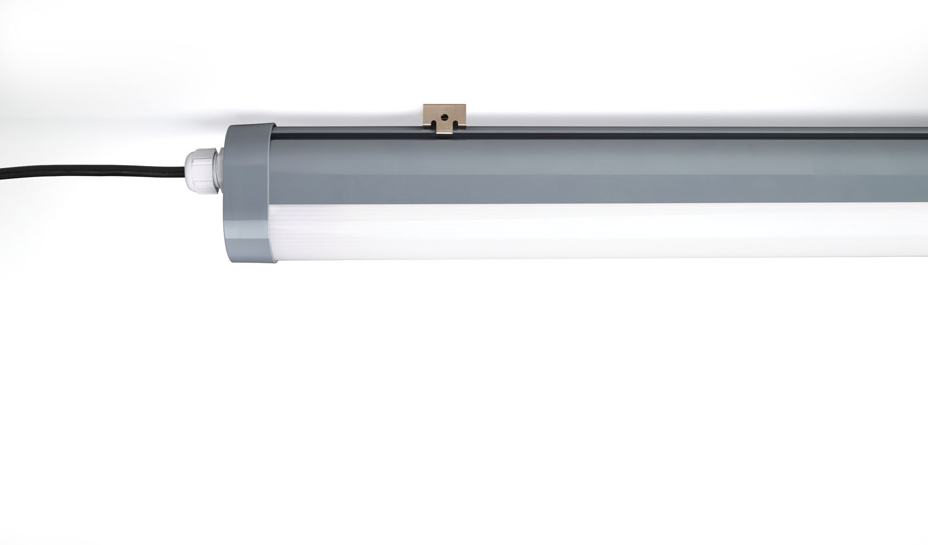
Industrial dust- and waterproof luminaire. Surge protection 1kV/2kV (for light industrial environments). Linear lens optics, polycarbonate (PC), wide-angle light distribution. Coextrusion housing. For use in technical spaces and parking lots. Dimensions: 1260 mm x 56 mm x 80 mm. Luminous flux: 4000 lm, Luminous efficacy: 129 lm/W. Power: 31.0 W, not dimmable. Frequency: 50-60Hz AC. Voltage: 220-240V. Electrical isolation class: class I. LED with very good light maintenance; at 50000 hrs the luminaire retains 99% of it's initial flux (Tq=25°C). Correlated colour temperature: 4000 K, Colour rendering ra: 80. Standard deviation colour matching satisfy 3 SDCM. Photobiological safety IEC/TR 62778: RG1. Polycarbonate housing, RAL7037 - dusty grey. IP protection level: IP66. IK protection level: IK07. Replaceable (LED only) light source by a professional. Replaceable control gear by a professional. Ambient temperature: -20°C - 35°C. Glowwire: 850°C. 5 years warranty on luminaire and driver. Certifications: CE, ENEC. Luminaire with halogen free leads. The luminaire has been developed and produced according to standard EN60598-1 in a company that is ISO9001 and ISO14001 certified.

