E7120/LED1N064100ST8

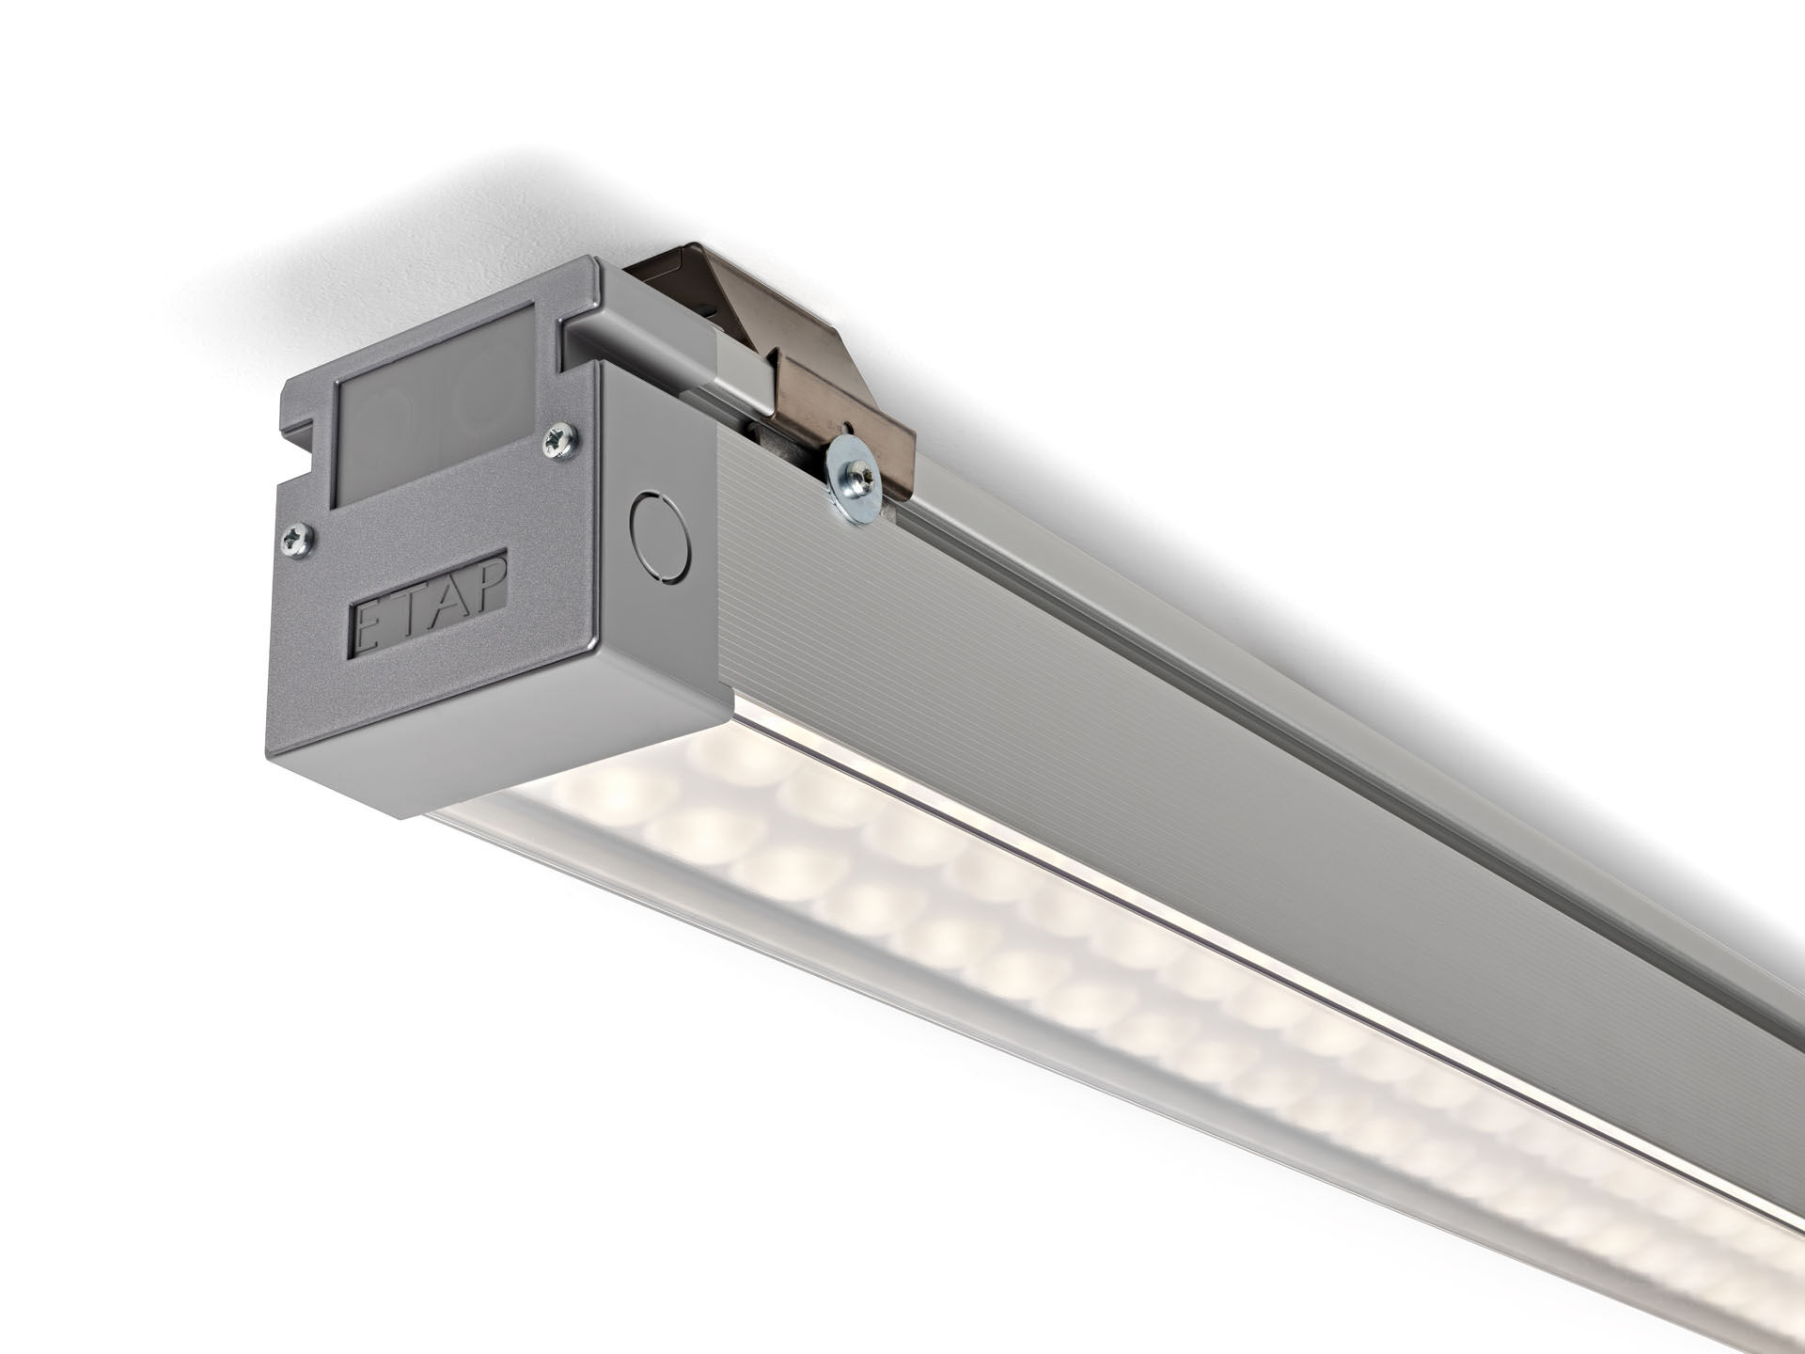
Ball-proof luminaire with a slender design. Led+lens™ optics, polycarbonate (PC) lens and cup, medium wide-angle light distribution. For sports halls (conforms DIN 18032-3 / DIN 57710-13). Dimensions: 1070 mm x 90 mm x 88 mm. LED+LENS™, a combination of high performance LEDs and individual lenses with a patented surface structure. The lenses are recessed in small cups for a comfortable light experience. Luminous flux: 9400 lm, Luminous efficacy: 147 lm/W. Power: 64.0 W, not dimmable. Frequency: 50-60Hz AC. Voltage: 220-240V. Electrical isolation class: class I. LED with very good light maintenance; at 50000 hrs the luminaire retains 99% of it's initial flux (Tq=25°C). Correlated colour temperature: 4000 K, Colour rendering ra: 80. Standard deviation colour matching satisfy 3 SDCM. LED+LENS™ with UGR <= 22 conform norm EN 12464-1 for moderate visual and concentration demands. Photobiological safety IEC/TR 62778: RG1. Satin-anodised aluminium housing, anodised aluminium. IP protection level: IP40. IK protection level: IK08. Ambient temperature: from 5°C to 35°C. Glowwire: 850°C. 5 years warranty on luminaire and driver. Certifications: CE, ENEC. Luminaire with halogen free leads. The luminaire has been developed and produced according to standard EN60598-1 in a company that is ISO9001 and ISO14001 certified. Mandatory accessoires for mounting the luminaire: E7H151, E7H152, E7H171, E7H172.

