E7B-S104-1C-840-100D

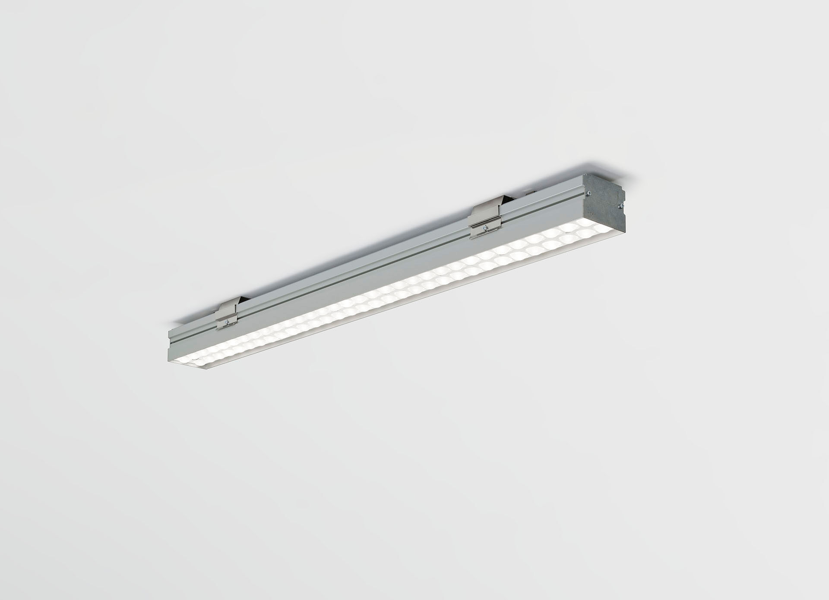
Industrial luminaire with LED+LENS: optimal visual comfort for high ceilings, with surge protection (LN/PE) 2kV/4kV. Led+lens™ optics, polycarbonate (PC) lens and cup, medium wide-angle light distribution. Suitable for use in sports halls (ball-proof conform DIN 18032-3 / DIN 57710-13). Dimensions: 1005 mm x 90 mm x 65 mm. Individual linear LED+LENS™, a combination of high performance LEDs and individual lenses with a patented surface structure. The lenses are recessed in small cups for a comfortable light experience. Luminous flux: 10000 lm, Luminous efficacy: 156 lm/W. Power: 64.0 W, DALI dimmable. Frequency: 50/60Hz AC. Voltage: 220-240V. Electrical isolation class: class I. LED with very good light maintenance; at 50000 hrs the luminaire retains 99% of it's initial flux (Tq=25°C). Correlated colour temperature: 4000 K, Colour rendering ra: 80. Colour consistency (McAdam ellipse): ≤ 3 SDCM. LED+LENS™ with UGR <= 22 conform norm EN 12464-1 for moderate visual and concentration demands. Photobiological safety IEC/TR 62778: RG1. Profile in extruded aluminium housing, anodised. IP protection level: IP20. IK protection level: IK08. Replaceable (LED only) light source by a professional. Replaceable control gear by a professional. Energy efficiency class of the light source according to EU regulation 2019/2015: C. Ambient temperature: 5°C - 35°C. Glowwire: 850°C. 5 years warranty on luminaire and driver. Certifications: CE, ENEC. Luminaire with halogen free leads. The luminaire has been developed and produced according to standard EN60598-1 in a company that is ISO9001 and ISO14001 certified.

