E7B-S706-2C-840-150D

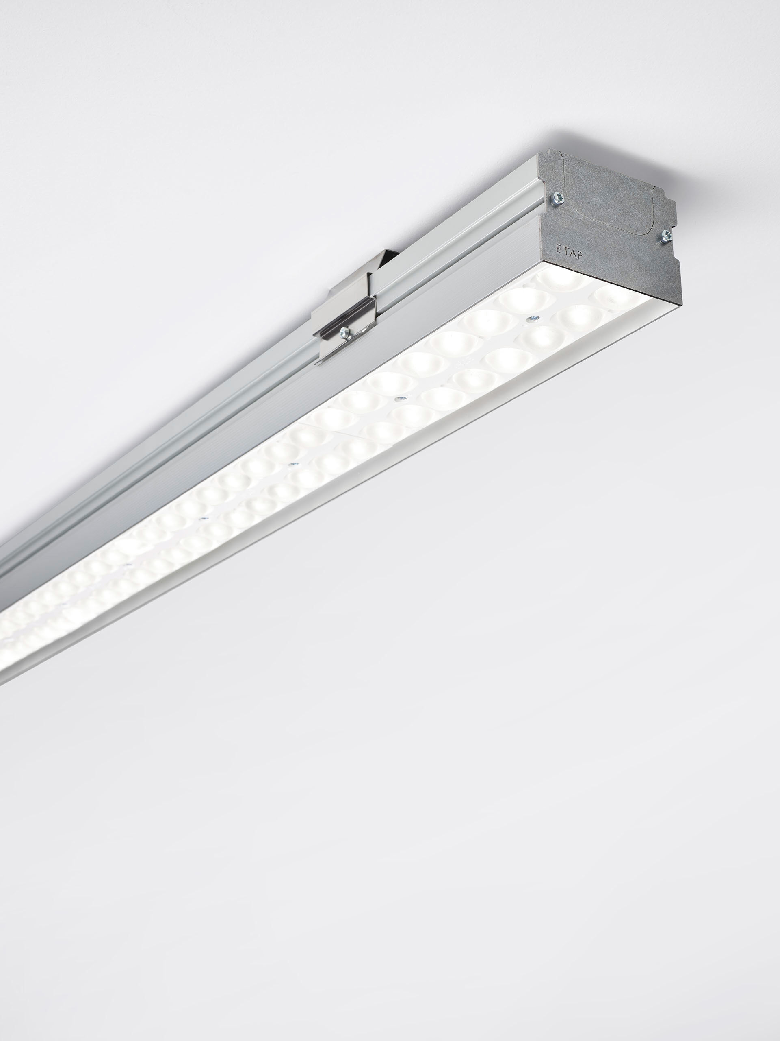
Industrial luminaire with LED+LENS: optimal visual comfort for high ceilings Led+lens™ optics, polycarbonate (PC) lens and cup, wide-angle light distribution. Suitable for use in sports halls (ball-proof conform DIN 18032-3 / DIN 57710-13). Dimensions: 1500 mm x 90 mm x 65 mm. LED+LENS™, a combination of high performance LEDs and individual lenses with a patented surface structure. The lenses are recessed in small cups for a comfortable light experience. Luminous flux: 14000 lm, Luminous efficacy: 157 lm/W. Power: 89.0 W, DALI dimmable. Frequency: 50-60Hz AC/DC. Voltage: 220-240V. Electrical isolation class: class I. LED with very good light maintenance; at 50000 hrs the luminaire retains 99% of it's initial flux (Tq=25°C). Correlated colour temperature: 4000 K, Colour rendering ra: 80. Standard deviation colour matching satisfy 3 SDCM. LED+LENS™ with UGR <= 22 conform norm EN 12464-1 for moderate visual and concentration demands. Photobiological safety IEC/TR 62778: RG1. Profile in extruded aluminium housing, anodised aluminium. IP protection level: IP20. IK protection level: IK08. Ambient temperature: 5°C - 35°C. Glowwire: 850°C. 5 years warranty on luminaire and driver. Certifications: CE, ENEC. Luminaire with halogen free leads. The luminaire has been developed and produced according to standard EN60598-1 in a company that is ISO9001 and ISO14001 certified.

