E826/2NMDE

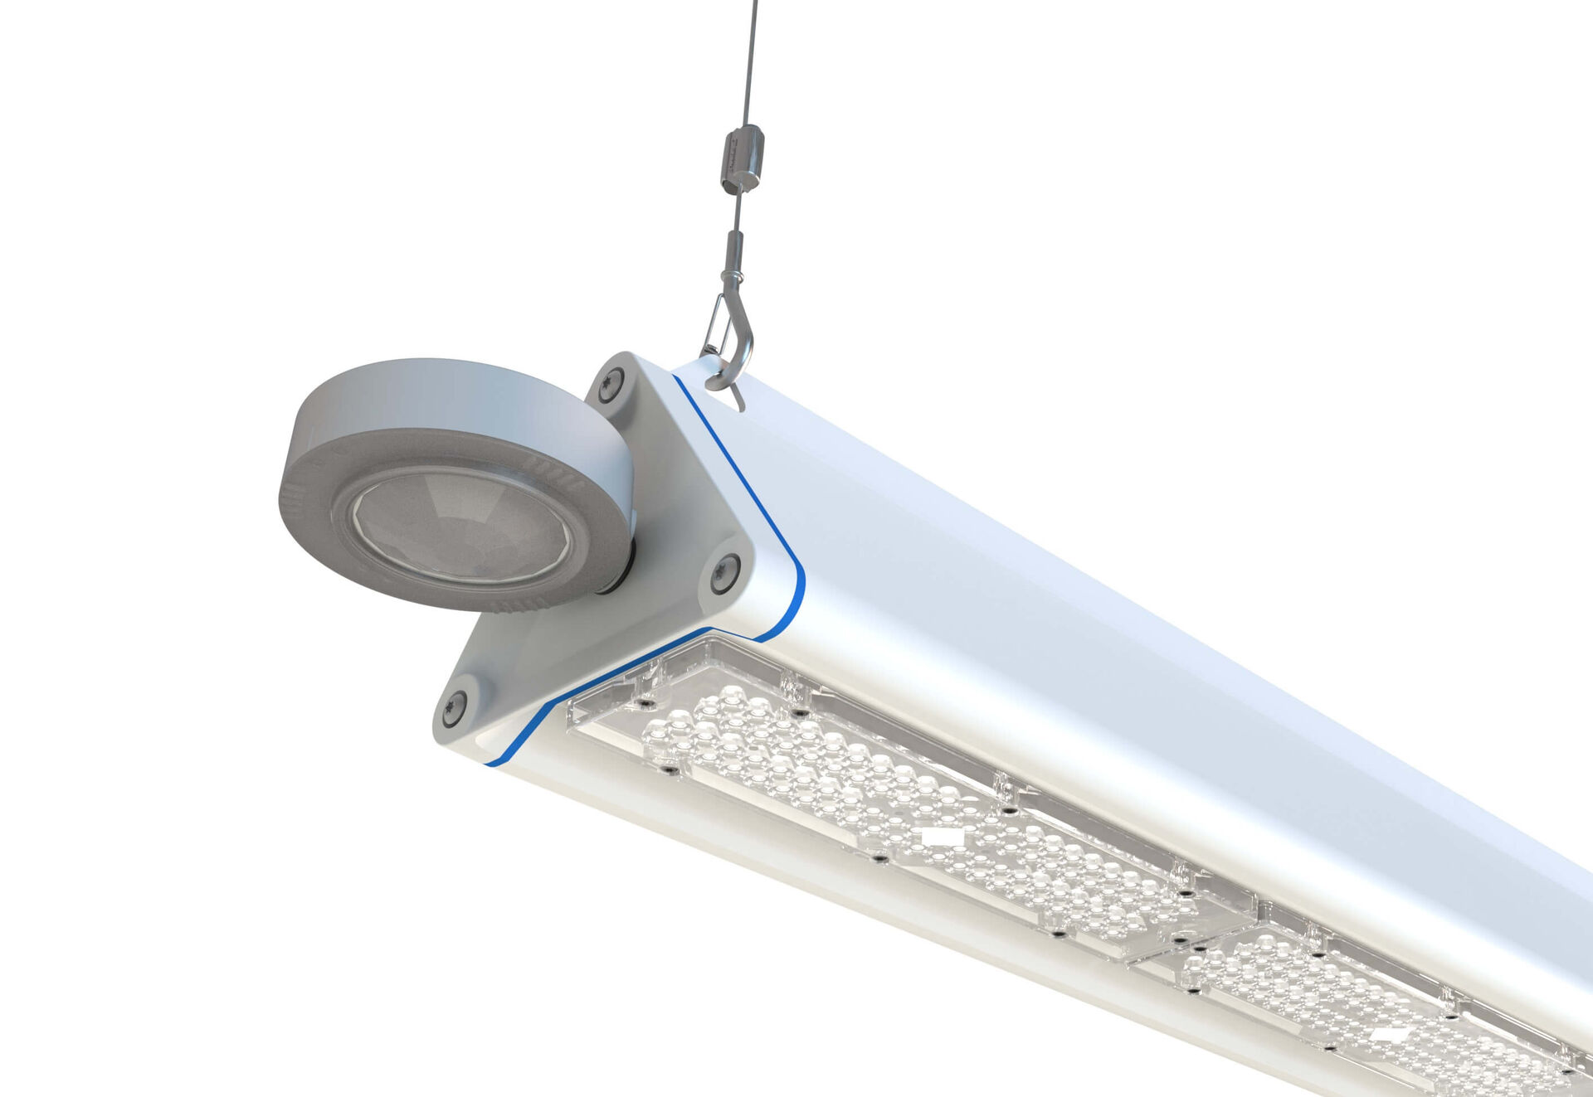
Highbay with triangular design, and occupancy and daylight sensor. Surge protection (LN/PE) 2kV/4kV. Multilens optics, polycarbonate (PC), wide-angle light distribution. With reinforced EasyAir occupancy and daylight sensor. Master luminaire for master/slave combination for up to 20 DALI drivers. Optionally available with IP65 RST20i Wieland connector or with two M20 cable glands at the same end for looping-in., Smooth triangular shape without obstrusions or cooling fins, minimizes dust accumulation and allows for easy cleaning. Suitable for use in food-processing companies, with HACCP declaration of conformity. Dimensions: 805 mm x 180 mm x 165 mm. Luminous flux: 12000 lm, Luminous efficacy: 162 lm/W. Power: 74.0 W Frequency: 50-60Hz AC/DC. Voltage: 220-240V. Electrical isolation class: class I. LED with very good light maintenance; at 50000 hrs the luminaire retains 91% of it's initial flux (Tq=25°C). Correlated colour temperature: 4000 K, Colour rendering ra: 80. Standard deviation colour matching satisfy 3 SDCM. Photobiological safety IEC/TR 62778: RG1. Lacquered aluminium housing, RAL9003 - signal white. IP protection level: IP65. Replaceable (LED only) light source by a professional. Replaceable control gear by a professional. Ambient temperature: -30°C - 50°C. Glowwire: 650°C. 5 years warranty on luminaire and driver. Certifications: CE, ENEC. Luminaire with halogen free leads. The luminaire has been developed and produced according to standard EN60598-1 in a company that is ISO9001 and ISO14001 certified.

