E826/4NMD

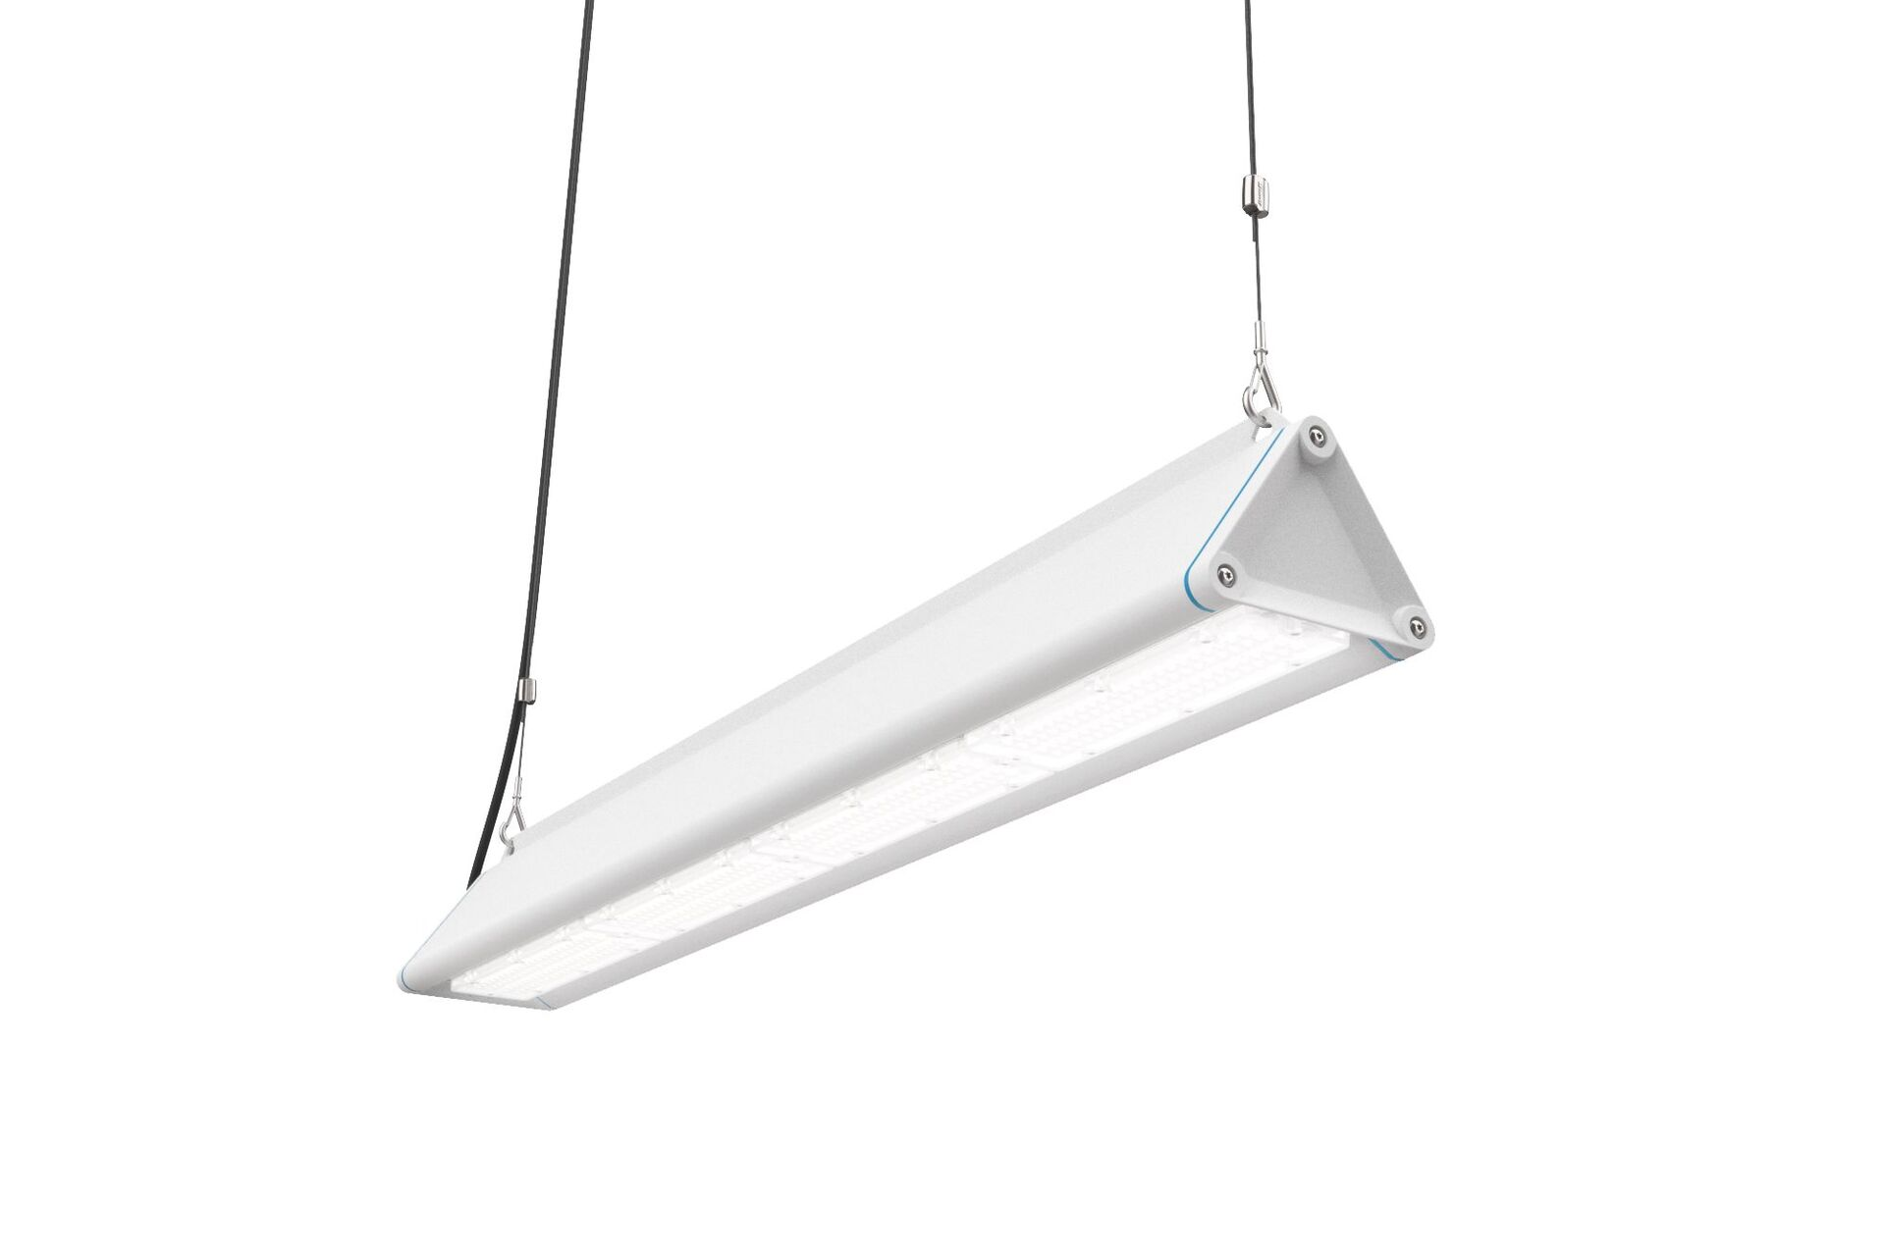
Highbay with triangular design, with surge protection (LN/PE) 2kV/4kV. Multilens optics, polycarbonate (PC), wide-angle light distribution. Smooth triangular shape without obstrusions or cooling fins, minimizes dust accumulation and allows for easy cleaning. Suitable for use in food-processing companies, with HACCP declaration of conformity. Optionally available with throughwiring 5 x 2.5 mm2, with IP65 wieland connectors or with two cable glands at the same end for looping-in. Dimensions: 1325 mm x 180 mm x 165 mm. Individual linear Luminous flux: 24000 lm, Luminous efficacy: 178 lm/W. Power: 135.0 W, DALI dimmable. Frequency: 50/60Hz AC. Voltage: 220-240V. Electrical isolation class: class I. LED with very good light maintenance; at 50000 hrs the luminaire retains 91% of it's initial flux (Tq=25°C). Correlated colour temperature: 4000 K, Colour rendering ra: 80. Colour consistency (McAdam ellipse): ≤ 3 SDCM. Photobiological safety IEC/TR 62778: RG1. Lacquered aluminium housing, RAL9003 - white. IP protection level: IP65. IK protection level: IK08. Replaceable (LED only) light source by a professional. Replaceable control gear by a professional. Energy efficiency class of the light source according to EU regulation 2019/2015: C. Ambient temperature: -40°C - 55°C. Glowwire: 650°C. 5 years warranty on luminaire and driver. Certifications: CE, ENEC. Luminaire with halogen free leads. The luminaire has been developed and produced according to standard EN60598-1 in a company that is ISO9001 and ISO14001 certified.

