E826/6NHDE

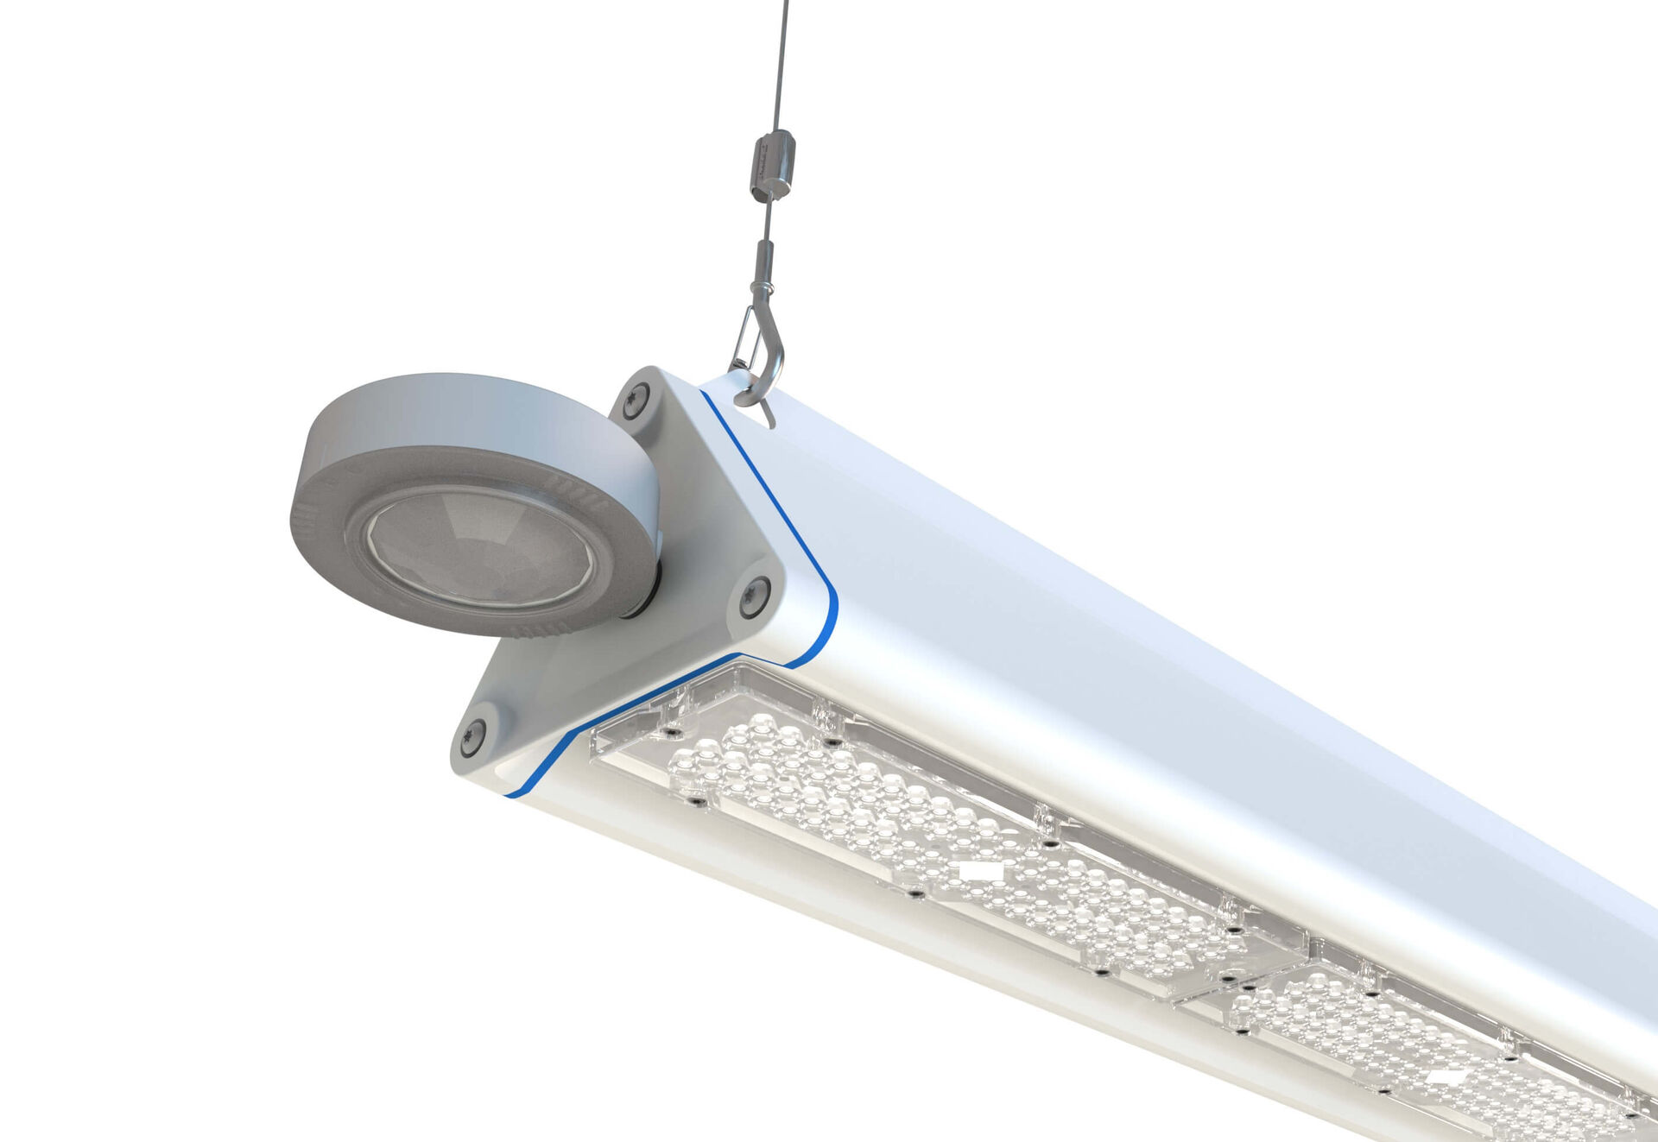
Highbay with triangular design, and occupancy and daylight sensor. Surge protection (LN/PE) 2kV/4kV. Multilens optics, polycarbonate (PC), wide-angle light distribution. With reinforced EasyAir occupancy and daylight sensor. Master luminaire for master/slave combination for up to 20 DALI drivers. Optionally available with IP65 RST20i Wieland connector or with two M20 cable glands at the same end for looping-in. Smooth triangular shape without obstrusions or cooling fins, minimizes dust accumulation and allows for easy cleaning. Suitable for use in food-processing companies, with HACCP declaration of conformity. Dimensions: 2085 mm x 180 mm x 165 mm. Individual linear Luminous flux: 42000 lm, Luminous efficacy: 175 lm/W. Power: 240.0 W, DALI dimmable. Frequency: 50/60Hz AC. Voltage: 220-240V. Electrical isolation class: class I. LED with very good light maintenance; at 50000 hrs the luminaire retains 90% of it's initial flux (Tq=25°C). Correlated colour temperature: 4000 K, Colour rendering ra: 80. Colour consistency (McAdam ellipse): ≤ 3 SDCM. Photobiological safety IEC/TR 62778: RG1. Lacquered aluminium housing, RAL9003 - white. IP protection level: IP65. Replaceable (LED only) light source by a professional. Replaceable control gear by a professional. Energy efficiency class of the light source according to EU regulation 2019/2015: C. Ambient temperature: -30°C - 40°C. Glowwire: 650°C. 5 years warranty on luminaire and driver. Certifications: CE, ENEC. Luminaire with halogen free leads. The luminaire has been developed and produced according to standard EN60598-1 in a company that is ISO9001 and ISO14001 certified.

