E8M1/LEDC128345ST1

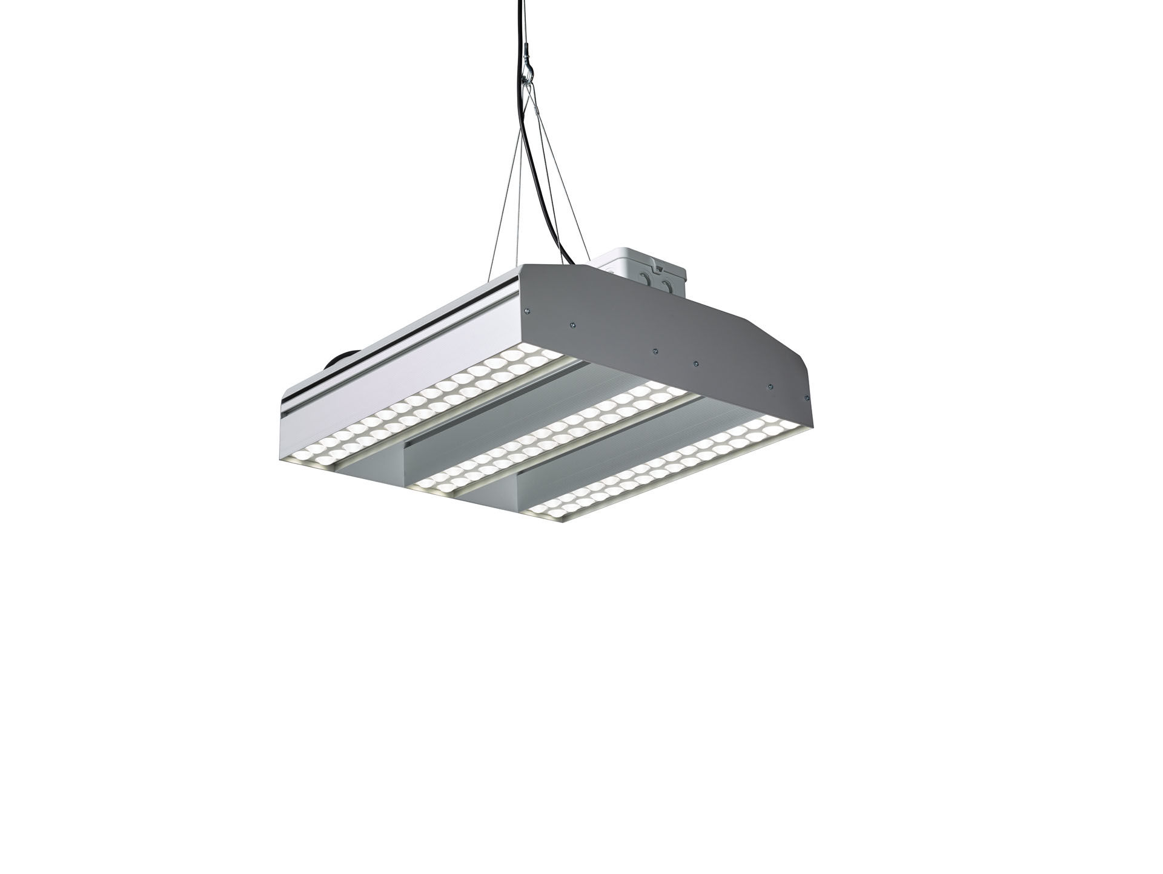
Square industrial luminaire, LED+LENS™ optics, polycarbonate (PC)
lens and cup, medium wide-angle light distribution. Dimensions: 510 mm x 510 mm x 160 mm. LED+LENS™, a combination of high-power LEDs and individual lenses
with a patented surface structure. The lenses are recessed in small
cups for a comfortable light experience. Luminous flux: 29800 lm, Luminous efficacy: 108 lm/W. Power: 276.0 W, not dimmable. Frequency: 50-60Hz AC. Voltage: 110-240V. Electrical isolation class: class I. LED with very good light maintenance; at 50000 hrs the luminaire
retains 91% of its initial flux (Tq=25°C). Correlated colour temperature: 5000 K, Colour rendering ra: 80. Standard deviation colour matching satisfy 3 SDCM. Photobiological safety EN 62471: RISK GROUP 1 UNLIMITED. Lacquered aluminium housing, . IP protection level: IP41. IK protection level: IK08. Glowwire: 850°C. 5 years warranty on luminaire and driver. Certifications: CE, ENEC. Luminaire with halogen free leads. The luminaire has been developed and produced according to standard
EN60598-1 in a company that is ISO9001 and ISO14001 certified.

