FLARE-11/LEDW6S

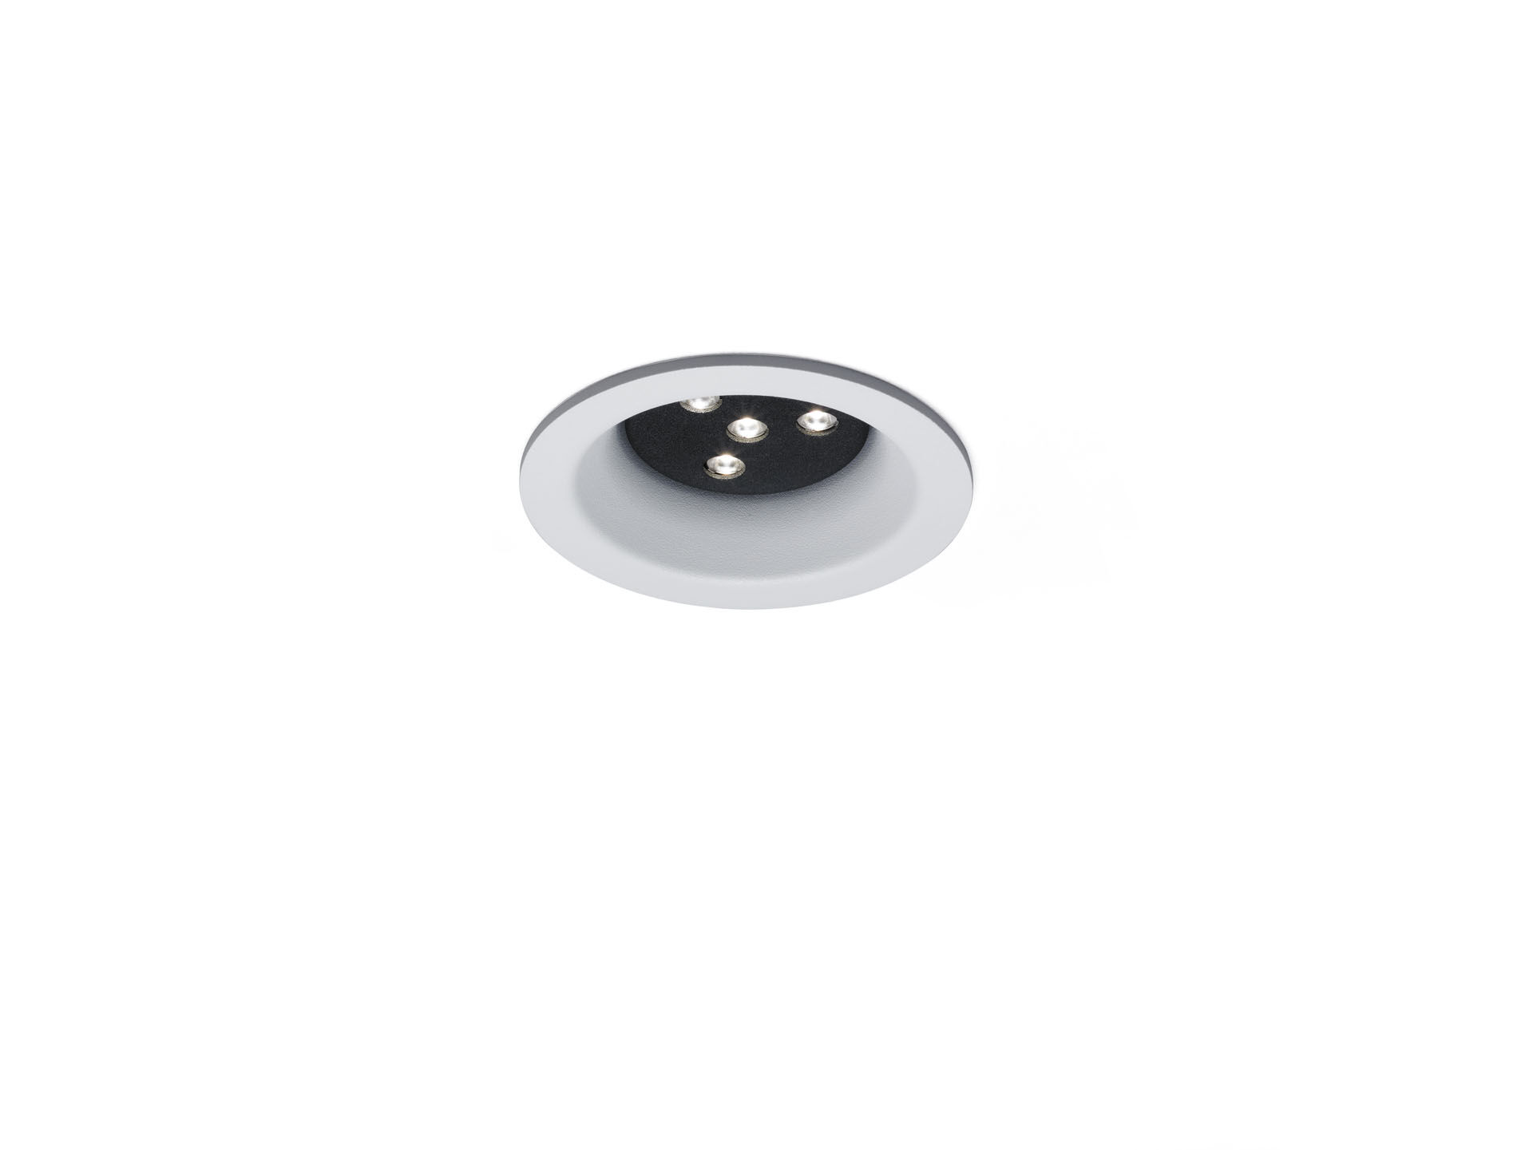
Architectural spot light. Led+lens™ flare optics, polycarbonate (PC) lens, fixed medium wide-angle light distribution. White trim (RAL9003) and black (RAL9005) inner part; other colour combinations possible on demand. Dimensions: Ø 98 mm x 63 mm. Ceiling cut-out: Ø 81 mm. Luminous flux: 740 lm, Luminous efficacy: 99 lm/W. Power: 7.5 W, not dimmable. Frequency: 50-60Hz AC. Voltage: 110-240V. Electrical isolation class: class I. LED with very good light maintenance; at 50000 hrs the luminaire retains 98% of it's initial flux (Tq=25°C). Correlated colour temperature: 3000 K, Colour rendering ra: 80. Standard deviation colour matching satisfy 3 SDCM. Injection-moulded aluminium housing, . IP protection level: IP20. 5 years warranty on luminaire and driver. Certifications: CE. Luminaire with halogen free leads. The luminaire has been developed and produced according to standard EN60598-1 in a company that is ISO9001 and ISO14001 certified.

