FLARE-21/LEDN10S

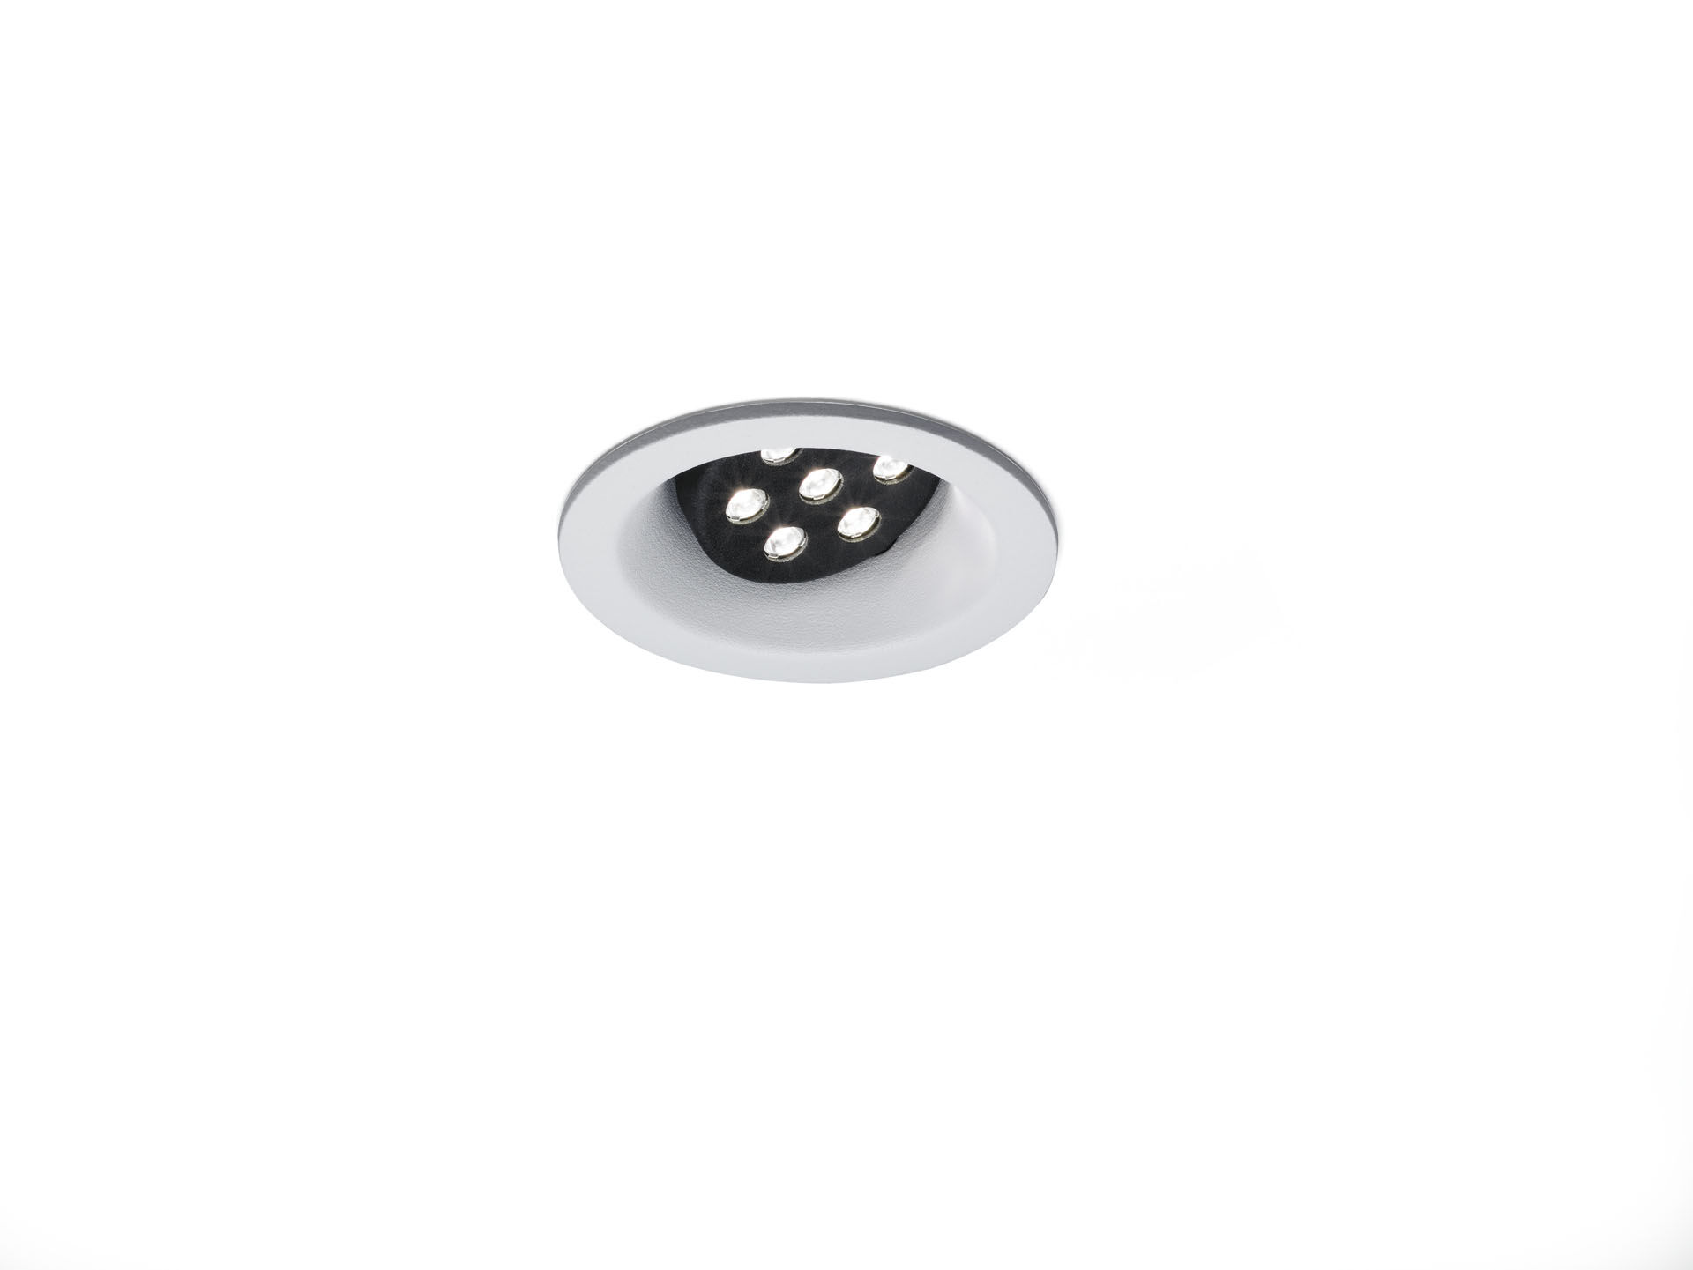
Architectural spot light. Led+lens™ flare optics, polycarbonate (PC) lens, directional medium wide-angle light distribution. White trim (RAL9003) and black (RAL9005) inner part; other colour combinations possible on demand. Dimensions: Ø 98 mm x 93 mm. Individual round, Ceiling cut-out: Ø 86 mm. Luminous flux: 975 lm, Luminous efficacy: 115 lm/W. Power: 8.4 W, not dimmable. Frequency: 50/60Hz AC. Voltage: 220-240V. Electrical isolation class: class I. LED with very good light maintenance; at 50000 hrs the luminaire retains 97% of it's initial flux (Tq=25°C). Correlated colour temperature: 4000 K, Colour rendering ra: 80. Colour consistency (McAdam ellipse): ≤ 3 SDCM. Photobiological safety IEC/TR 62778: RG1. Injection-moulded aluminium housing, RAL9003 - white. IP protection level: IP20. Replaceable (LED only) light source by a professional. Replaceable control gear by a professional. 5 years warranty on luminaire and driver. Certifications: CE. Luminaire with halogen free leads. The luminaire has been developed and produced according to standard EN60598-1 in a company that is ISO9001 and ISO14001 certified.

