K11/3N-230C3

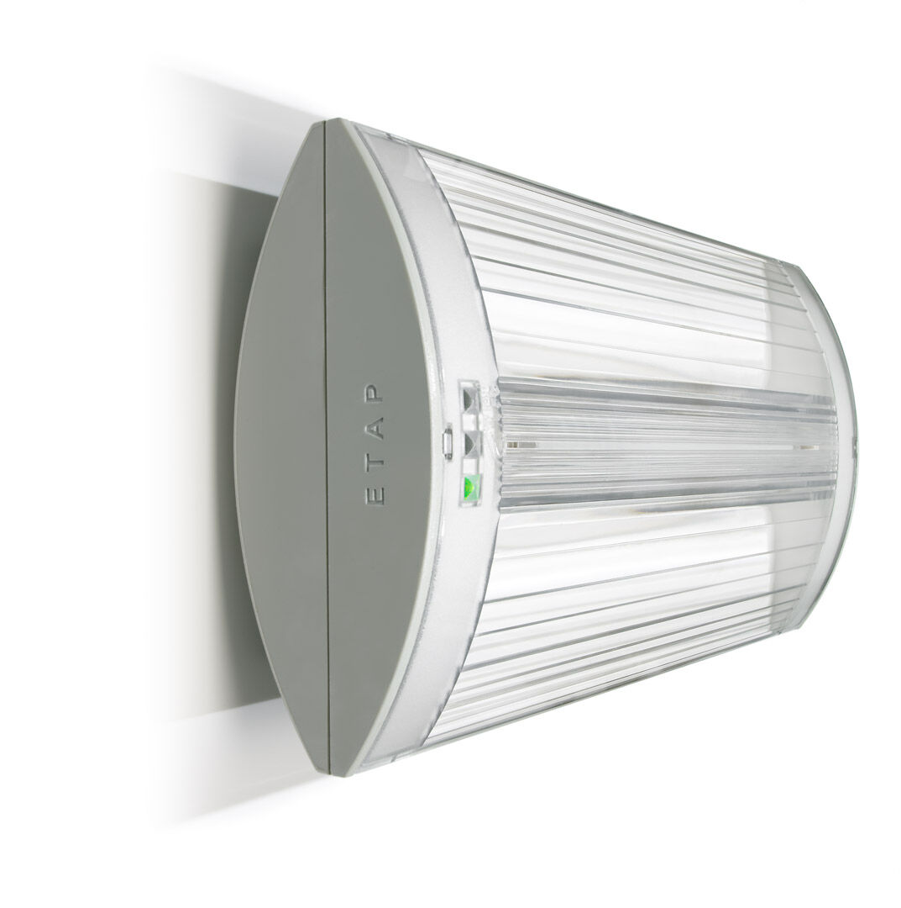
Emergency luminaire for escape route lighting. Surface mounted. For central supply. Dimensions: 304 mm x 155 mm x 73 mm. Screwless opening, automatic electrical connection (up to 2.5 mm²), optional accessories for recessed mounting. Line-shaped light distribution, optimized for 1 lux along the escape route axis. Lumen output in emergency mode: 320 lm. Power consumption in standby: 5.1 W. Interdistance anti-panic: at a mounting height of 2.8 m, the illumination on the floor is 0.5 lux with an interdistance ("b") of 20.9 m. At a mounting height of 2.8 m, the illumination on the floor is 1 lux with an interdistance ("b") of 14.6 m. Voltage: 220-230V. Contains addressable MSÜ3 communication module, for use with a central battery system. Electrical insulation class: class II. Photobiological safety IEC/TR 62778: RG0. Impact-resistant polycarbonate housing, RAL9018 - papyrus white. IP protection level: IP42. IK protection level: IK04. Ambient temperature: -10°C - 35°C. Glowwire: 850°C. 5 years warranty on luminaire, light source, driver and battery (for autonomous luminaires). Certifications: CE, ENEC. The luminaire has been developed and produced according to standard EN60598-1 in a company that is ISO9001 and ISO14001 certified.

