K112/6

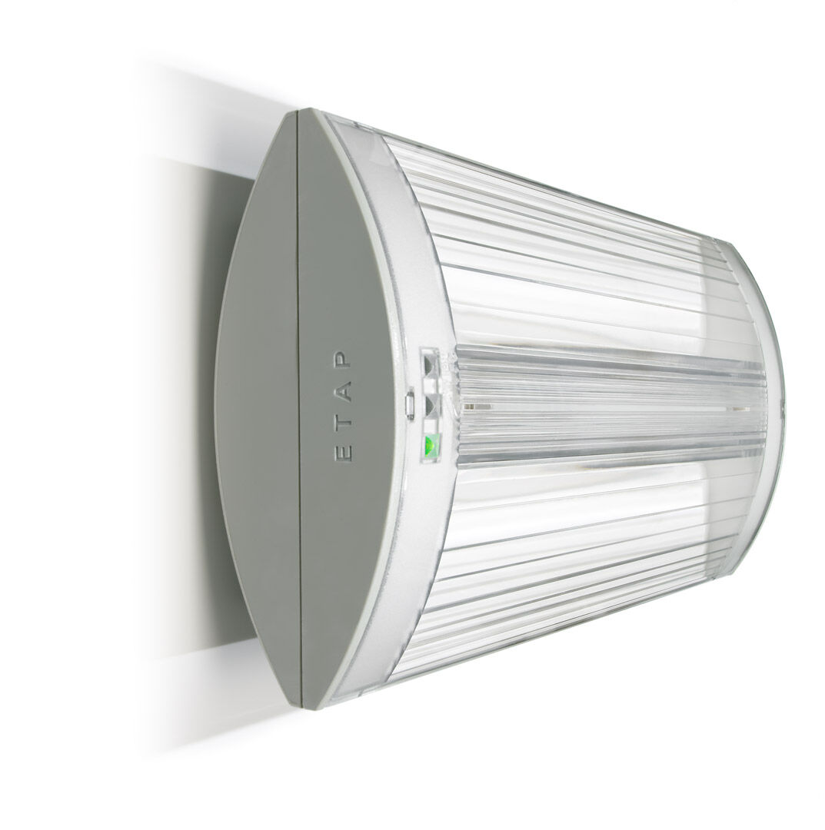
Emergency luminaire for escape route lighting. Surface mounted. Autonomous luminaire (contains battery). Dimensions: 304 mm x 155 mm x 73 mm. Screwless opening, automatic electrical connection (up to 2.5 mm²), optional accessories for recessed mounting. Concentrated light distribution, optimized for high mounting or staircase illumination. Lumen output in emergency mode: 575 lm. Power consumption in standby: 2.3 W. Inderdistance escape route: at a mounting height of 2.8 m, the illumination on the floor is 1 lux with an interdistance ("b") of 17.1 m. Interdistance anti-panic: at a mounting height of 2.8 m, the illumination on the floor is 0.5 lux with an interdistance ("b") of 20.9 m. At a mounting height of 2.8 m, the illumination on the floor is 1 lux with an interdistance ("b") of 14.6 m. Voltage: 220-230V. Battery: 4 x NiMh 1,2V 2,2Ah. Automatic functional test every week, duration test every 13 weeks, in accordance to EN 50172 and EN 62034. Maintained/non maintained mode selectable, preset for most common application. Electrical insulation class: class II. Photobiological safety IEC/TR 62778: RG0. Impact-resistant polycarbonate housing, RAL9018 - papyrus white. IP protection level: IP42. IK protection level: IK04. Ambient temperature: 5°C - 35°C. Glowwire: 850°C. 5 years warranty on luminaire, light source, driver and battery (for autonomous luminaires). Certifications: CE, ENEC. The luminaire has been developed and produced according to standard EN60598-1 in a company that is ISO9001 and ISO14001 certified.

