K14/3-230

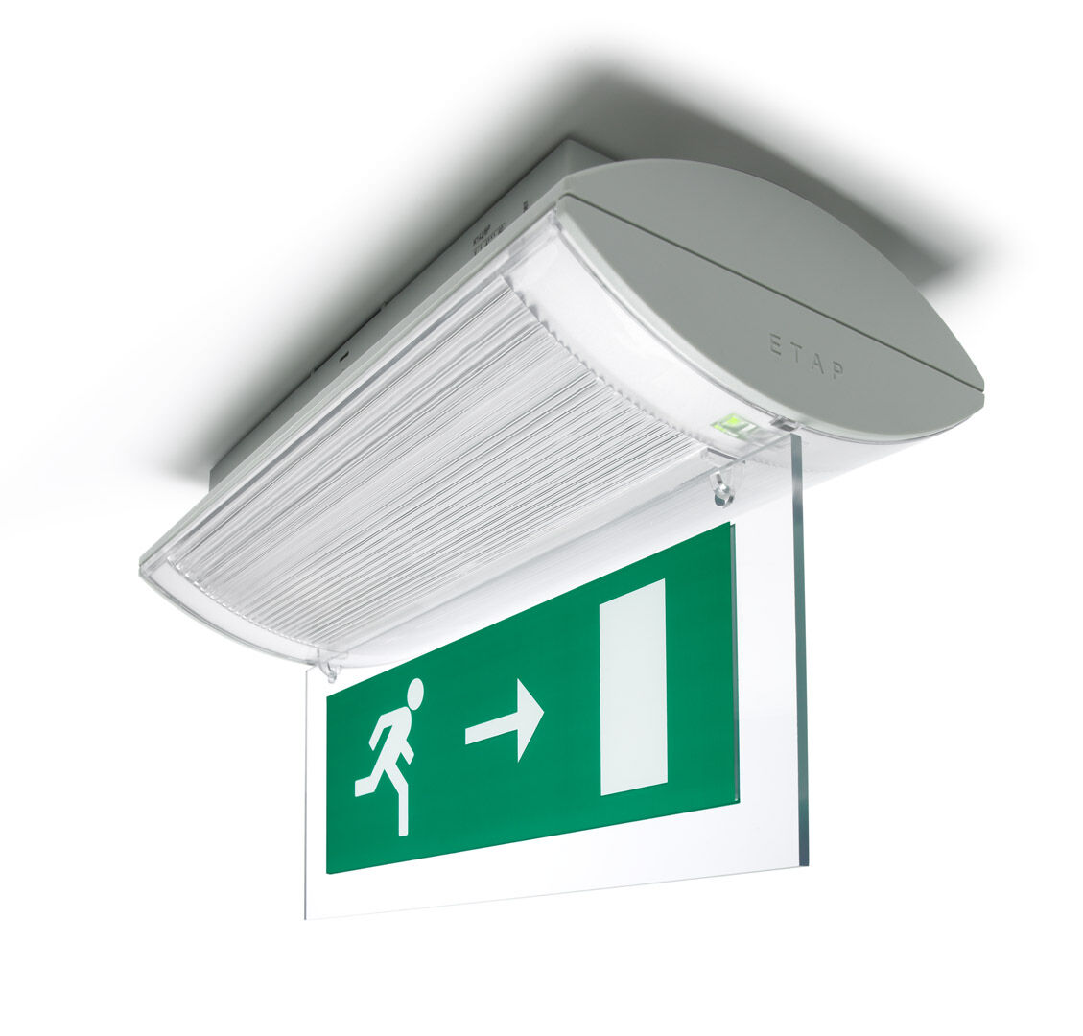
Emergency luminaire for single or double sided signage. Surface mounted. For central supply. Dimensions: 304 mm x 155 mm x 73 mm. Screwless opening, automatic electrical connection (up to 2.5 mm²) to terminal block, optional accessories for recessed mounting Lumen output in emergency mode: 240 lm. Power consumption in standby: 4.2 W. Voltage: 220-230V. The perception distance of the pictogram is 26 m. For use with central battery system on 230 V AC/DC. Maintained mode of operation. Electrical insulation class: class II. Photobiological safety IEC/TR 62778: RG0. Impact-resistant polycarbonate housing, RAL9018 - papyrus white. IP protection level: IP42. IK protection level: IK04. Ambient temperature: -20°C - 35°C. Glowwire: 850°C. 5 years warranty on luminaire, light source, driver and battery (for autonomous luminaires). Certifications: CE, ENEC. The luminaire has been developed and produced according to standard EN60598-1 in a company that is ISO9001 and ISO14001 certified.

