K143/3

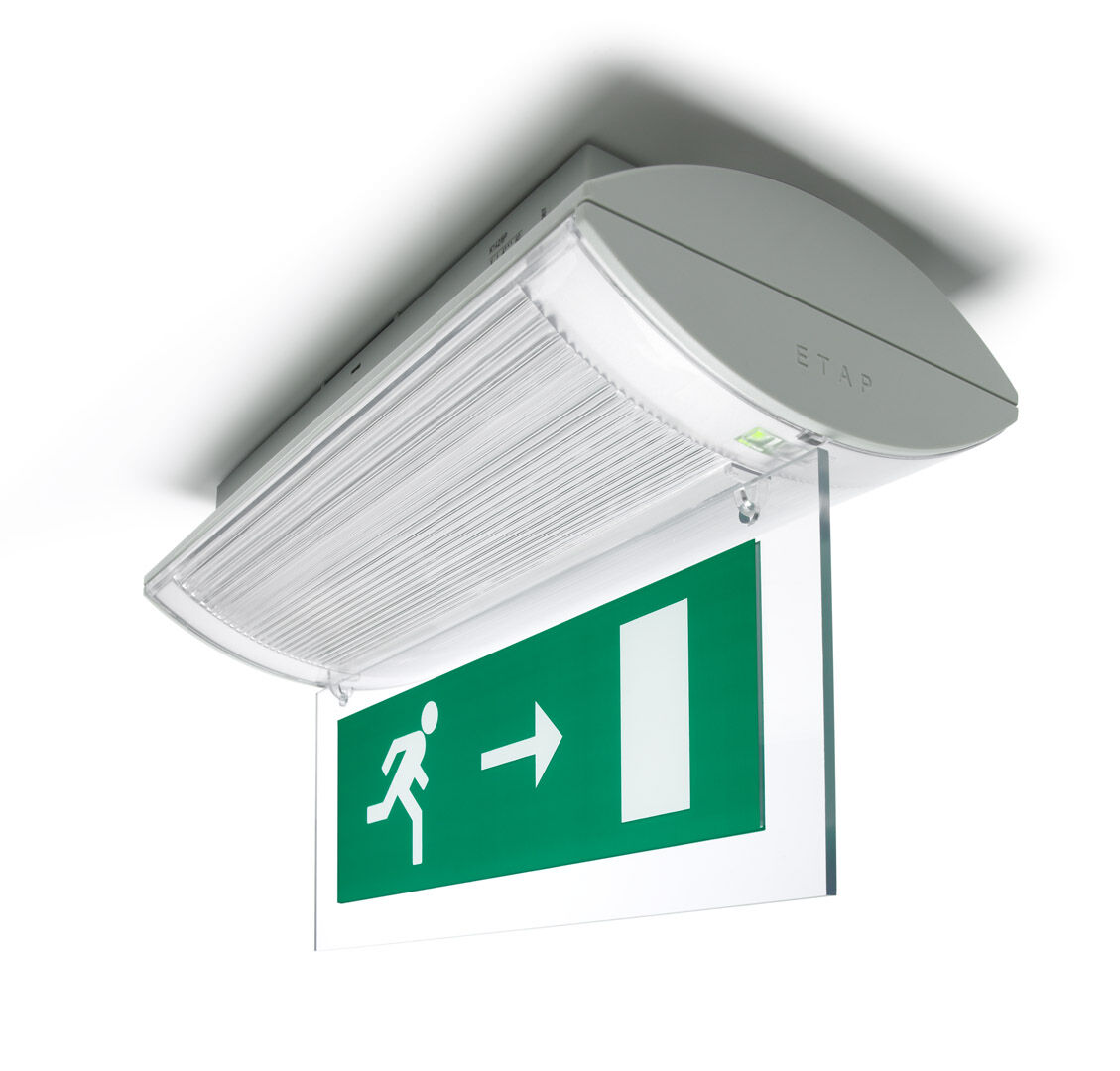
Emergency luminaire for single or double sided signage. Surface mounted. Autonomous luminaire (contains battery). Dimensions: 304 mm x 155 mm x 73 mm. Screwless opening, automatic electrical connection (up to 2.5 mm²) to terminal block, optional accessories for recessed mounting Lumen output in emergency mode: 240 lm. Power consumption in standby: 2.3 W. Voltage: 220-230V. The perception distance of the pictogram is 26 m. Autonomy: 60 minutes. The luminaire contains lamp data, battery date and type as required according to EN 60598-2.22. Battery: 4 x NiMh 1,2V 1,1Ah. Battery lifetime: 10 years. Automatic functional test every week, duration every test 13 weeks, in accordance to EN 50172 and EN 62034. Monitoring and control via ESM software for central maintenance. Polarity independent connection via two wire BUS communication. Maintained/non maintained mode selectable, preset for most common application. Electrical insulation class: class II. Photobiological safety IEC/TR 62778: RG0. Impact-resistant polycarbonate housing, RAL9018 - papyrus white. IP protection level: IP42. IK protection level: IK04. Ambient temperature: 5°C - 35°C. Glowwire: 850°C. 5 years warranty on luminaire, light source, driver and battery (for autonomous luminaires). Certifications: CE, ENEC. The luminaire has been developed and produced according to standard EN60598-1 in a company that is ISO9001 and ISO14001 certified.

