K1M1-230

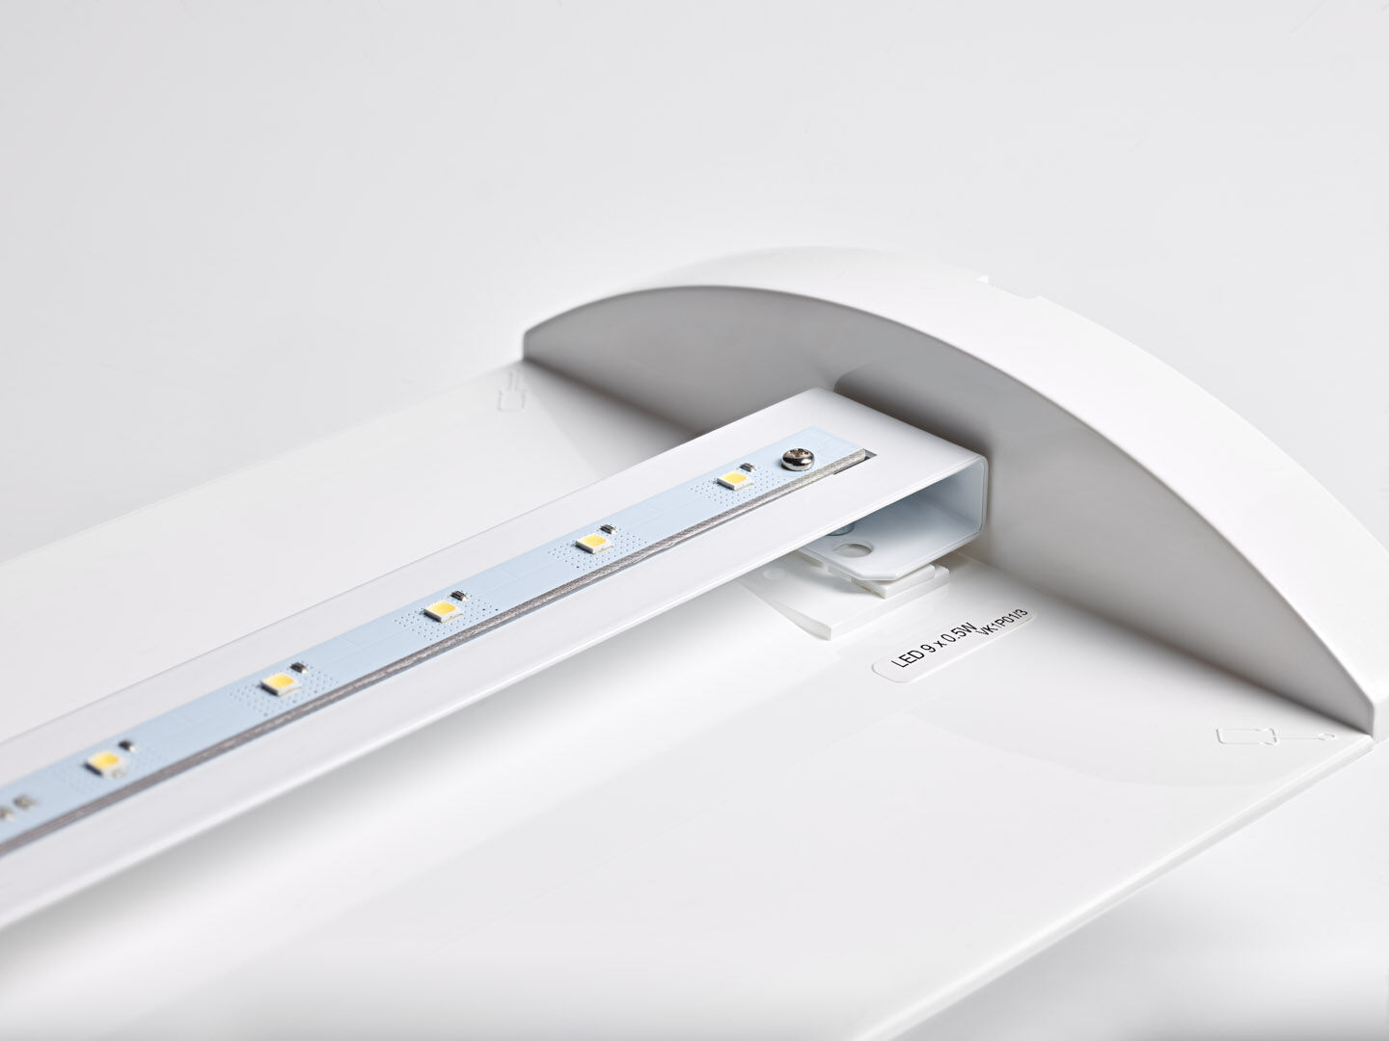
Renovation module to led for ETAP K1 and K2 fluo emergency lighting For central supply. Dimensions: . Plug-and-play, screwless replacement of the interior, exterior housing and wiring are kept as-is. Voltage: 220-230V. For use with central battery system on 230 V AC/DC. Maintained/non maintained mode selectable, preset for most common application. Electrical insulation class: class II. Photobiological safety IEC/TR 62778: RG0. . Glowwire: 850°C. 5 years warranty on luminaire, light source, driver and battery (for autonomous luminaires). Certifications: CE. The luminaire has been developed and produced according to standard EN60598-1 in a company that is ISO9001 and ISO14001 certified.

