K1R11/6N-230

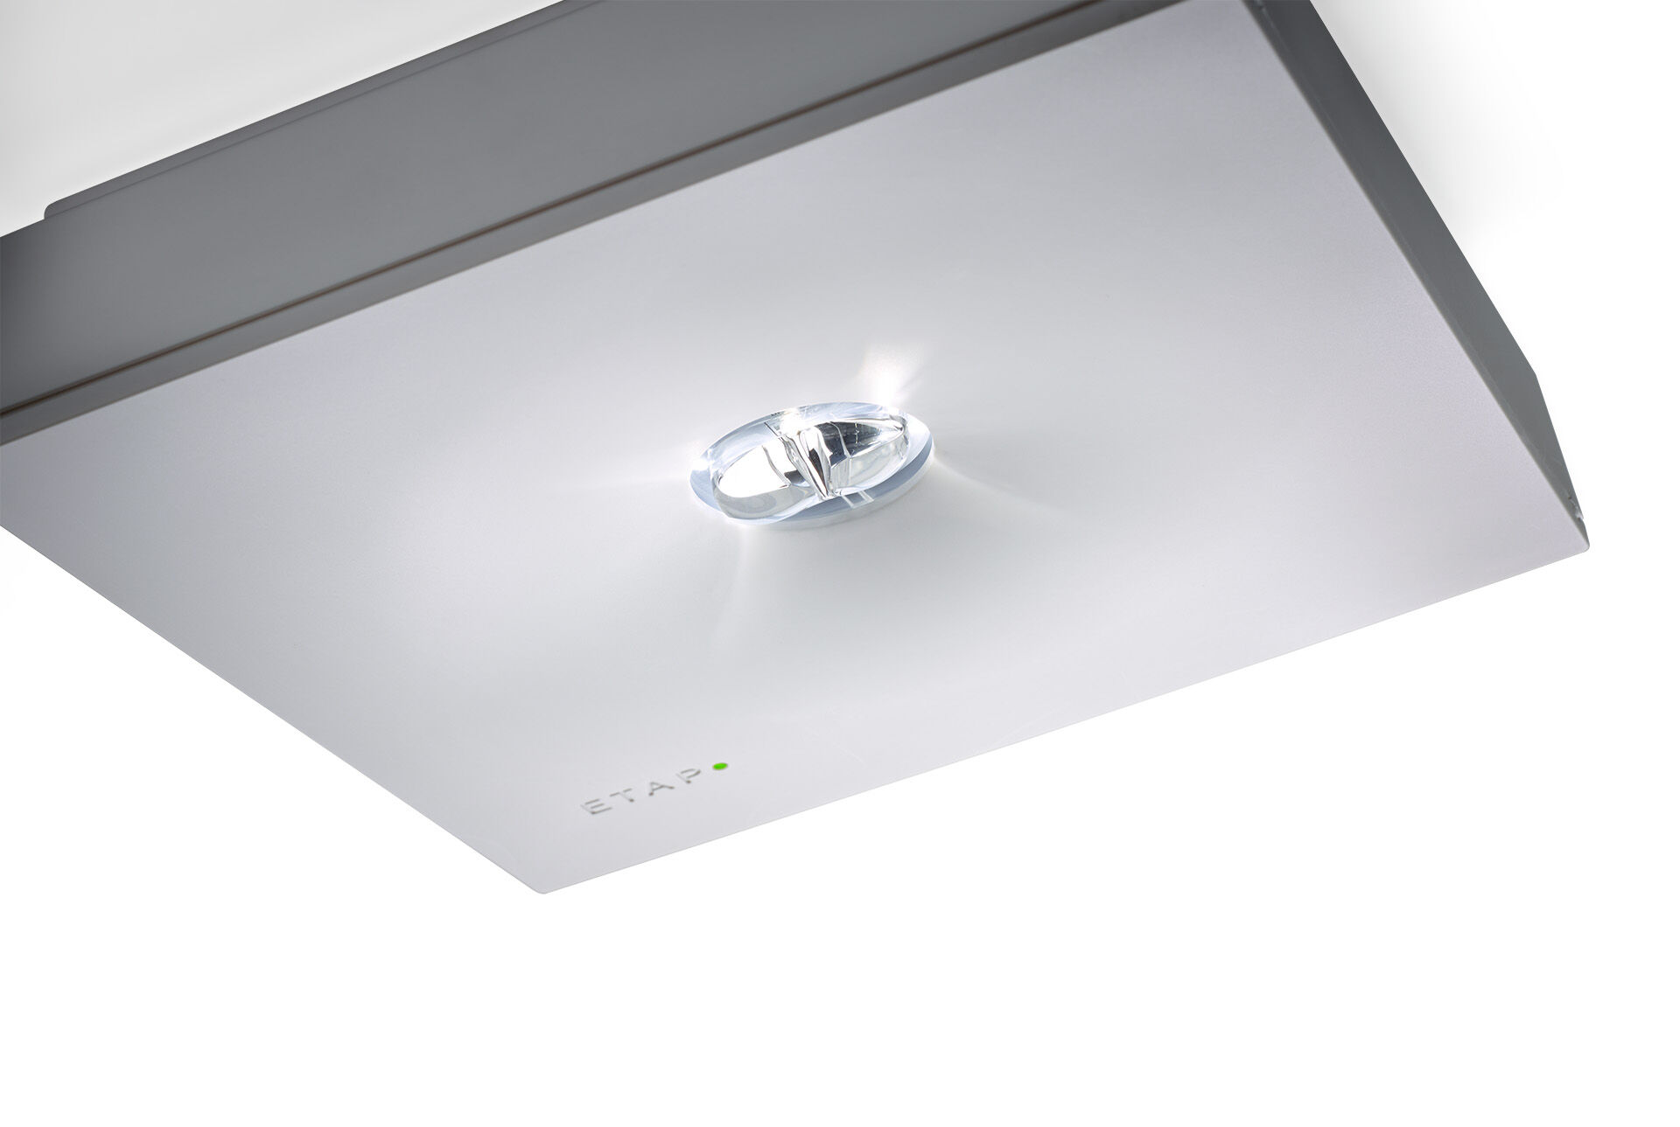
Square emergency luminaire for escape route lighting. Surface mounted. For central supply. Dimensions: 152 mm x 152 mm x 38 mm. Polycarbonate housing with sunk optics and flush aspect, screwless opening, automatic electrical connection, screwless wire terminals (up to 2.5 mm²), optional accessories for recessed mounting, four break-out ports Ø13mm. Concentrated light distribution, optimized for high mounting or staircase illumination. Lumen output in emergency mode: 550 lm. Power consumption in standby: 7.1 W. Inderdistance escape route: at a mounting height of 2.8 m, the illumination on the floor is 1 lux with an interdistance ("b") of 11.7 m. Interdistance anti-panic: at a mounting height of 2.8 m, the illumination on the floor is 0.5 lux with an interdistance ("b") of 9.6 m. At a mounting height of 2.8 m, the illumination on the floor is 1 lux with an interdistance ("b") of 8.4 m. Voltage: 220-230V. For use with central battery system on 230 V AC/DC. Electrical insulation class: class II. Photobiological safety IEC/TR 62778: >1m RG1 ; <1m RG2. Impact-resistant polycarbonate housing, RAL9003 - signal white. IP protection level: IP42. IK protection level: IK04. Ambient temperature: -20°C - 35°C. Glowwire: 850°C. 5 years warranty on luminaire, light source, driver and battery (for autonomous luminaires). Certifications: CE, ENEC. The luminaire has been developed and produced according to standard EN60598-1 in a company that is ISO9001 and ISO14001 certified.

