K1R14/1-230S11

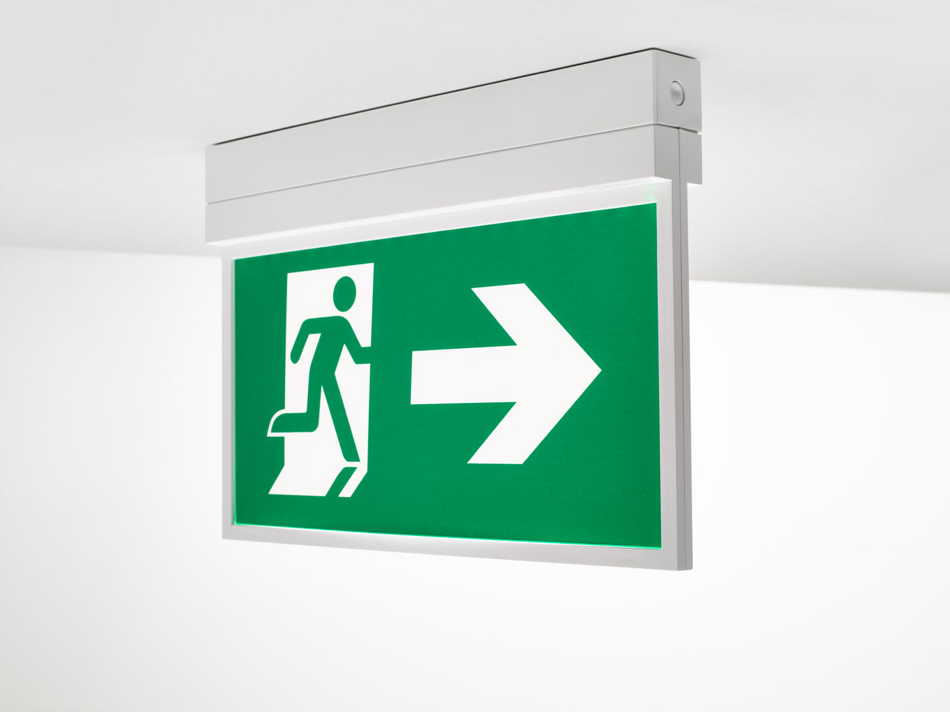
Emergency luminaire for single- or double-sided signage. Surface mounted. For central supply. Dimensions: 315 mm x 33 mm x 219 mm. Screwless opening, automatic electrical connection, screwless wire terminals (up to 2.5 mm²), suited for ceiling and wall mounting, optional accessories for recessed or suspended mounting. Voltage: 220-230V. Automatic functional test every week, duration test every 13 weeks, in accordance to EN 50172 and EN 62034. Monitoring and control via DALI for central maintenance. Connection via two wire BUS communication. Maintained mode of operation. Electrical insulation class: class II. Photobiological safety IEC/TR 62778: RG0. RAL9003 - signal white. IP protection level: IP42. IK protection level: IK04. Ambient temperature: -20°C - 35°C. Glowwire: 850°C. 5 years warranty on luminaire, light source, driver and battery (for autonomous luminaires). Certifications: CE, ENEC. The luminaire has been developed and produced according to standard EN60598-1 in a company that is ISO9001 and ISO14001 certified.

