K1R15/3-230L2

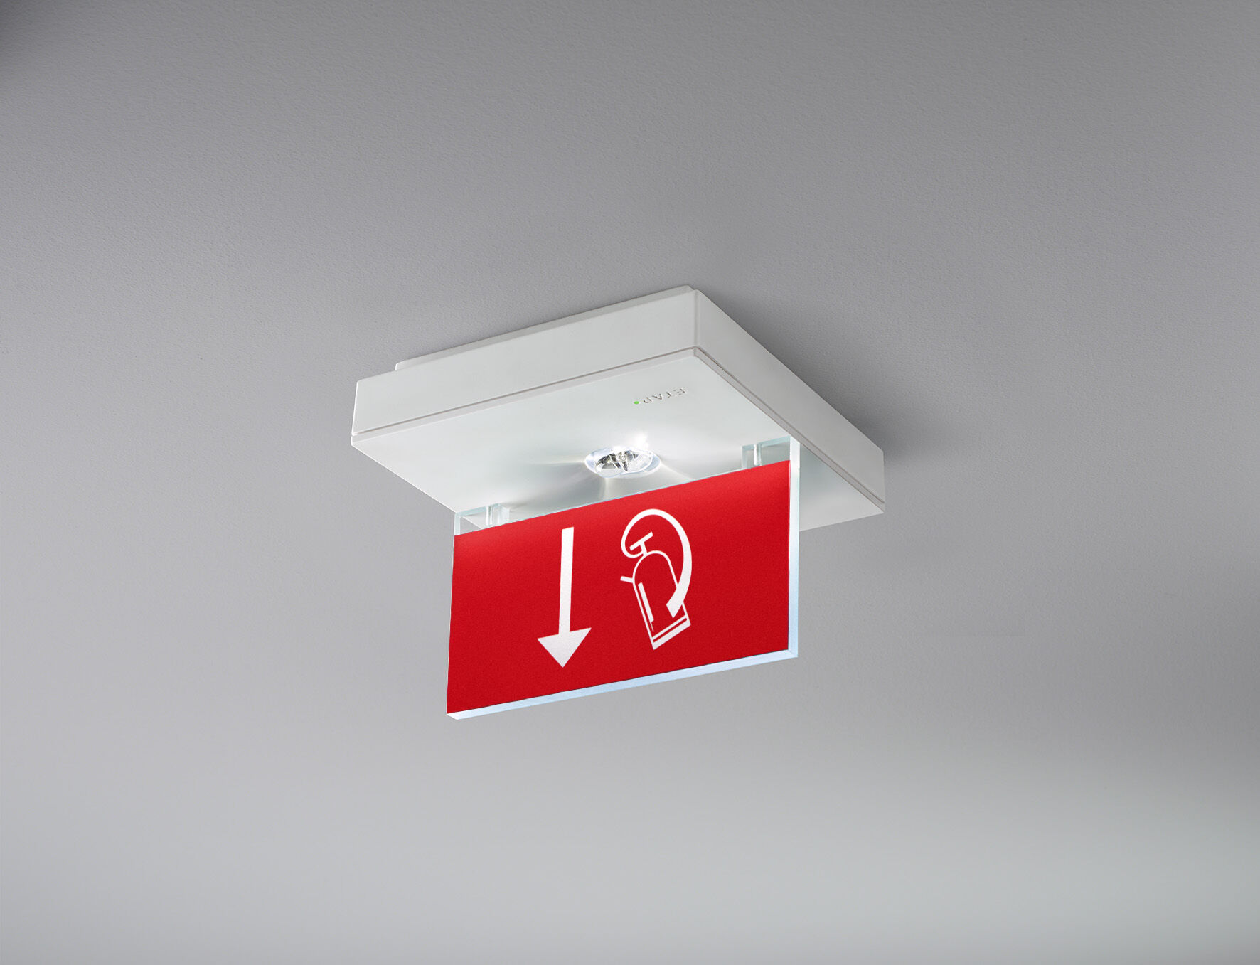
Square emergency luminaire for single- or double-sided signage. Surface mounted. For central supply. Dimensions: 152 mm x 152 mm x 38 mm. Acrylic signage plate 76 mm with illuminated sides, screwless opening, automatic electrical connection, screwless wire terminals (up to 2.5 mm²), optional accessories for recessed mounting, four break-out ports Ø13mm. High lighting output for the vertical illumination of fire-fighting equipment (5 lux). Lumen output in emergency mode: 150 lm. Power consumption in standby: 1.2 W. Voltage: 220-230V. The perception distance of the pictogram is 15 m. For use with central battery system on 230 V AC/DC. Maintained mode of operation. Electrical insulation class: class II. Photobiological safety IEC/TR 62778: >1m RG1 ; <1m RG2. Impact-resistant polycarbonate housing, RAL9003 - signal white. IP protection level: IP42. IK protection level: IK04. Ambient temperature: -20°C - 35°C. Glowwire: 850°C. 5 years warranty on luminaire, light source, driver and battery (for autonomous luminaires). Certifications: CE, ENEC. The luminaire has been developed and produced according to standard EN60598-1 in a company that is ISO9001 and ISO14001 certified.

