K1R152/3S2

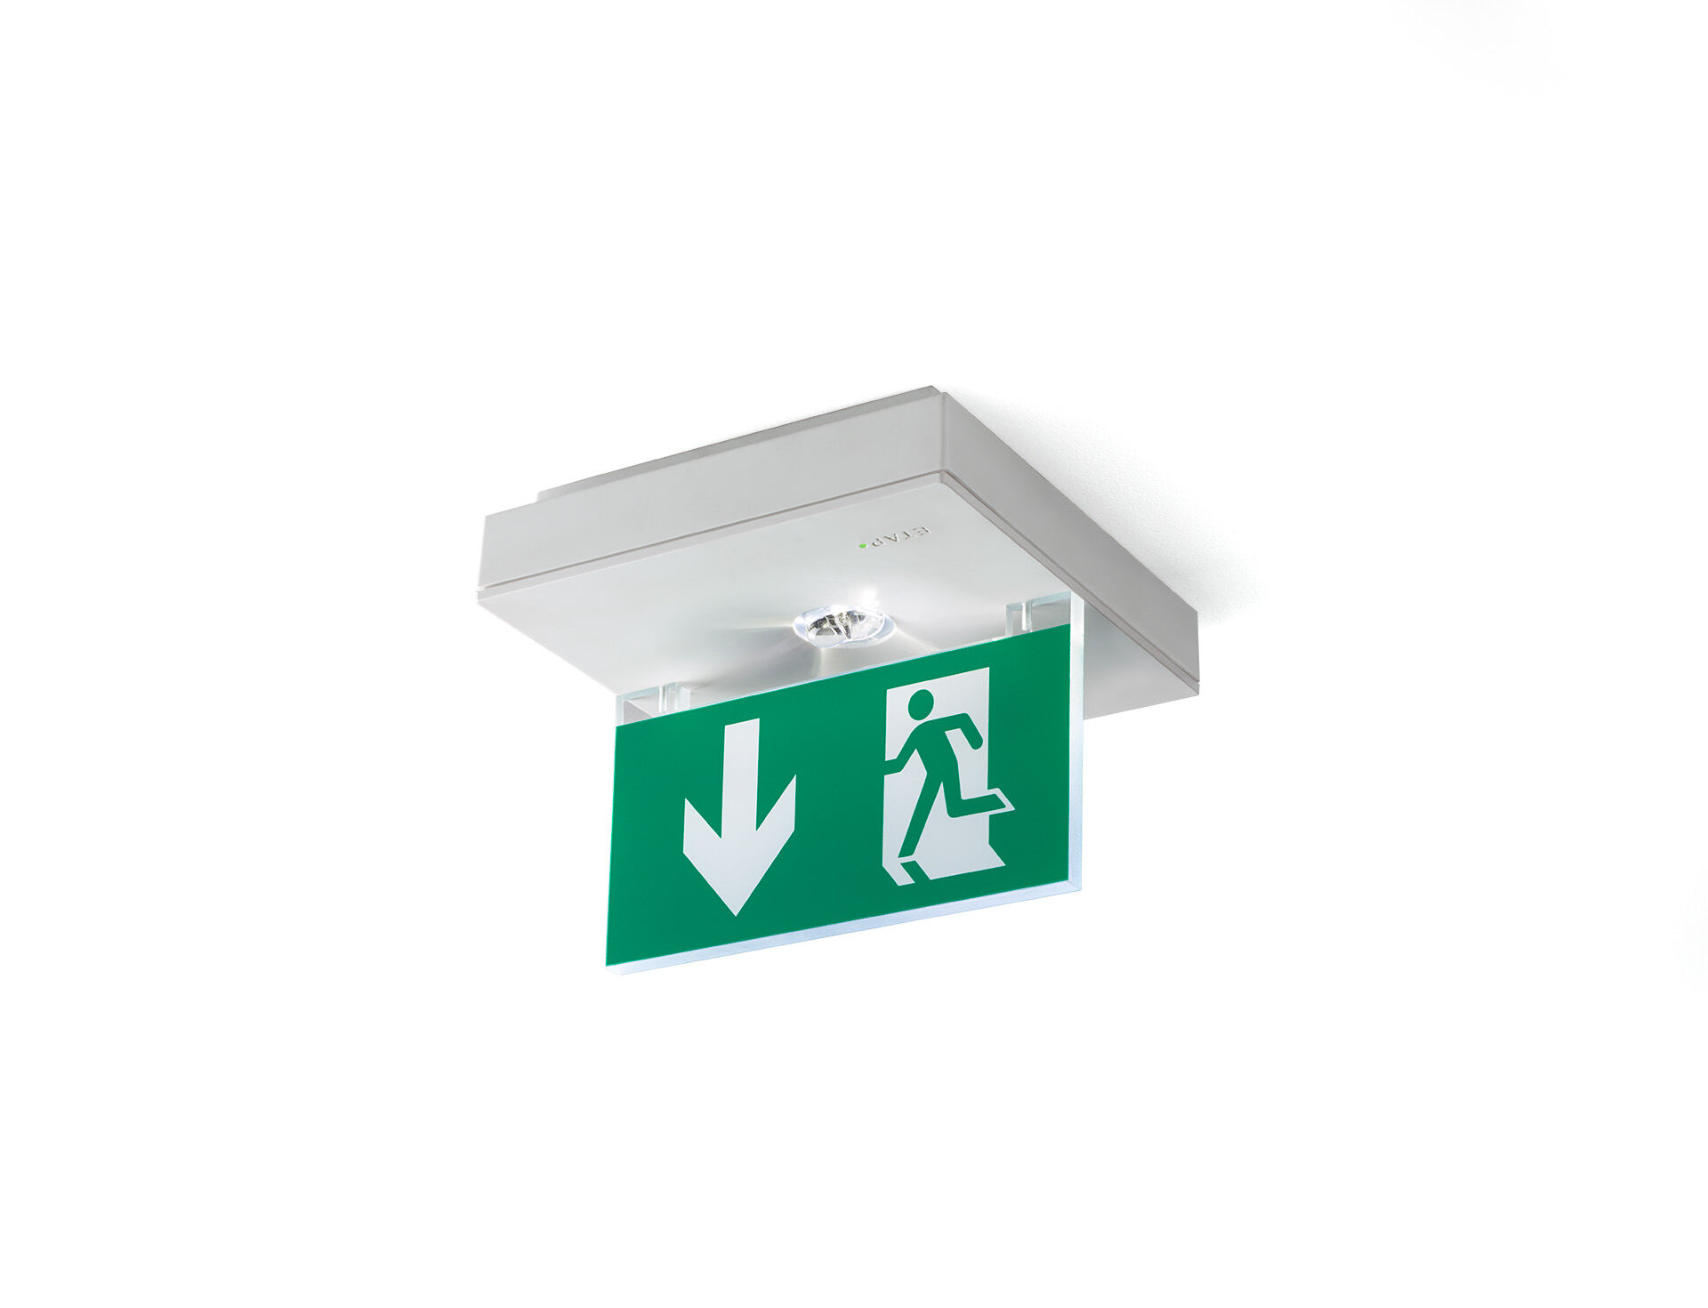
Square emergency luminaire for single- or double-sided signage. Surface mounted. Autonomous luminaire (contains battery). Dimensions: 152 mm x 152 mm x 38 mm. Acrylic signage plate 76 mm with illuminated sides, screwless opening, automatic electrical connection, screwless wire terminals (up to 2.5 mm²), optional accessories for recessed mounting, four break-out ports Ø13mm. Lumen output in emergency mode: 70 lm. Power consumption in standby: 1.0 W. Voltage: 220-230V. The perception distance of the pictogram is 15 m. Autonomy: 180 minutes. The luminaire contains lamp data, battery date and type as required according to EN 60598-2.22. Battery: 4 x NiMh 1,2V 1,1Ah. Battery lifetime: 10 years. Automatic functional test every week, duration test every 13 weeks, in accordance to EN 50172 and EN 62034. Maintained/non maintained mode selectable, preset for most common application. Electrical insulation class: class II. Photobiological safety IEC/TR 62778: RG1. Impact-resistant polycarbonate housing, RAL9003 - signal white. IP protection level: IP42. IK protection level: IK04. Ambient temperature: 5°C - 35°C. Glowwire: 850°C. 5 years warranty on luminaire, light source, driver and battery (for autonomous luminaires). Certifications: CE, ENEC. The luminaire has been developed and produced according to standard EN60598-1 in a company that is ISO9001 and ISO14001 certified.

