K1R155/3L2S2

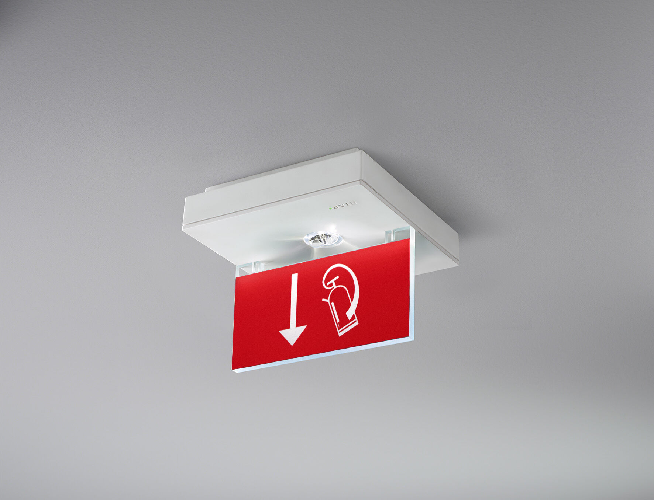
Square emergency luminaire for single- or double-sided signage. Surface mounted. Autonomous luminaire (contains battery). Dimensions: 152 mm x 152 mm x 38 mm. Acrylic signage plate 76 mm with illuminated sides, screwless opening, automatic electrical connection, screwless wire terminals (up to 2.5 mm²), optional accessories for recessed mounting, four break-out ports Ø13mm. High lighting output for the vertical illumination of fire-fighting equipment (5 lux). Lumen output in emergency mode: 150 lm. Power consumption in standby: 0.9 W. Voltage: 220-230V. The perception distance of the pictogram is 15 m. Autonomy: 180 minutes. The luminaire contains lamp data, battery date and type as required according to EN 60598-2.22. Battery: 4 x NiMh 1,2V 2,2Ah. Battery lifetime: 10 years. Automatic functional test every week, duration test every 13 weeks, in accordance to EN 50172 and EN 62034. Monitoring and control via ESM software for central maintenance. Connection via wireless 868 MHz communication. Maintained/non maintained mode selectable, preset for most common application. Electrical insulation class: class II. Photobiological safety IEC/TR 62778: >1m RG1 ; <1m RG2. RAL9003 - signal white. IP protection level: IP42. IK protection level: IK04. Ambient temperature: 5°C - 35°C. Glowwire: 850°C. 5 years warranty on luminaire, light source, driver and battery (for autonomous luminaires). Certifications: CE. The luminaire has been developed and produced according to standard EN60598-1 in a company that is ISO9001 and ISO14001 certified.

