K1R16/1-230

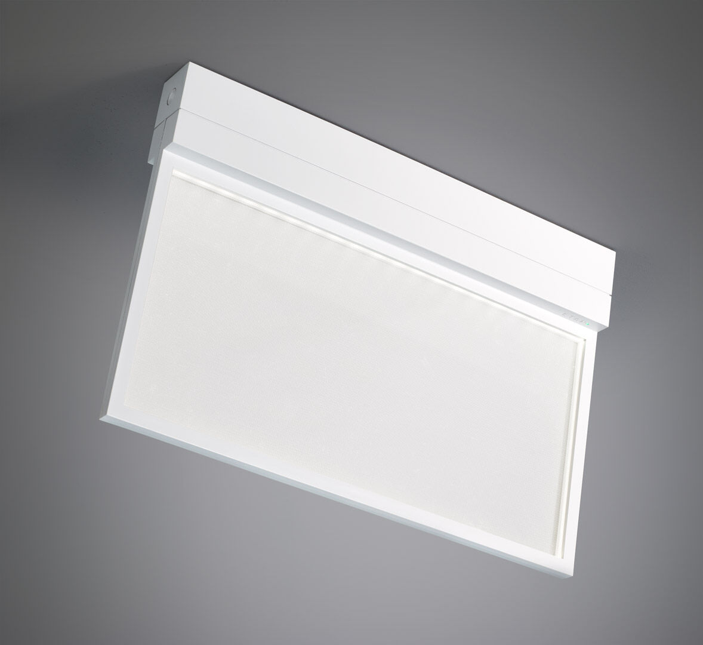
Emergency luminaire with comfortable diffuse lighting. Surface mounted. For central supply. Dimensions: 315 mm x 33 mm x 219 mm. Diffusor plate light source for comfortable illumination. Polycarbonate housing, screwless opening, automatic electrical connection, screwless wire terminals (up to 2.5 mm²), suited for ceiling and wall mounting, optional accessories for recessed or suspended mounting. Lumen output in emergency mode: 200 lm. Power consumption in standby: 3.9 W. Voltage: 220-230V. For use with central battery system on 230 V AC/DC. Maintained mode of operation. Electrical insulation class: class II. Photobiological safety IEC/TR 62778: RG0. Impact-resistant polycarbonate housing, RAL9003 - signal white. IP protection level: IP42. IK protection level: IK04. Ambient temperature: -20°C - 35°C. Glowwire: 850°C. 5 years warranty on luminaire, light source, driver and battery (for autonomous luminaires). Certifications: CE, ENEC. The luminaire has been developed and produced according to standard EN60598-1 in a company that is ISO9001 and ISO14001 certified.

