K1R21/3N-230C3

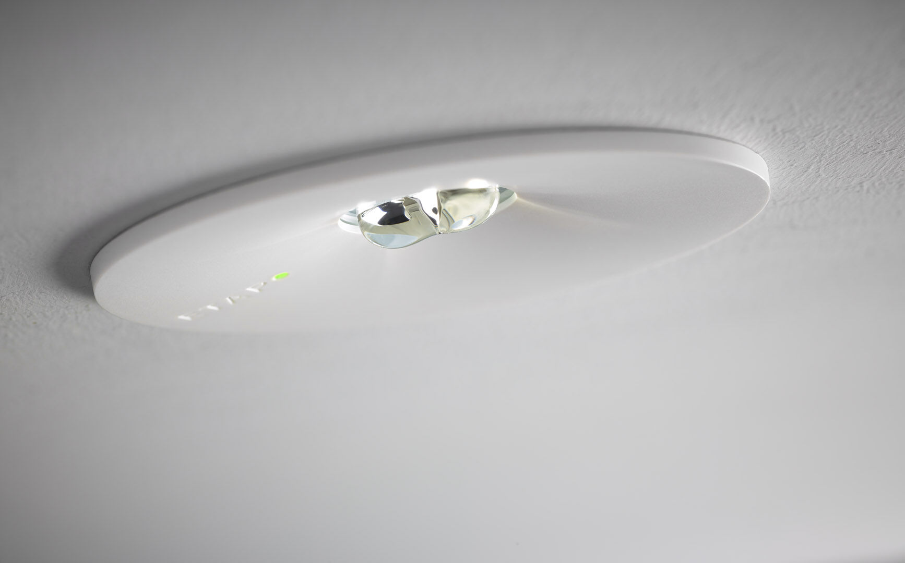
Round emergency luminaire for escape route lighting. Recessed mounting. For central supply. Dimensions: Ø 110 mm x 70 mm. Polycarbonate housing with sunk optics and flush aspect with spring mounting, electronics in separate polycarbonate housing, screwless opening, automatic electrical connection, screwless wire terminals (up to 2.5 mm²). Line-shaped light distribution, optimized for 1 lux along the escape route axis. Lumen output in emergency mode: 280 lm. Power consumption in standby: 4.8 W. Inderdistance escape route: at a mounting height of 2.8 m, the illumination on the floor is 1 lux with an interdistance ("b") of 20.7 m. Voltage: 220-230V. Contains addressable MSÜ3 communication module, for use with a central battery system. Electrical insulation class: class II. Impact-resistant polycarbonate housing, RAL9003 - white. IP protection level: IP42. IK protection level: IK04. Ambient temperature: -10°C - 35°C. Glowwire: 850°C. 5 years warranty on luminaire, light source, driver and battery (for autonomous luminaires). Certifications: CE, ENEC. The luminaire has been developed and produced according to standard EN60598-1 in a company that is ISO9001 and ISO14001 certified.

