K212/3OS2

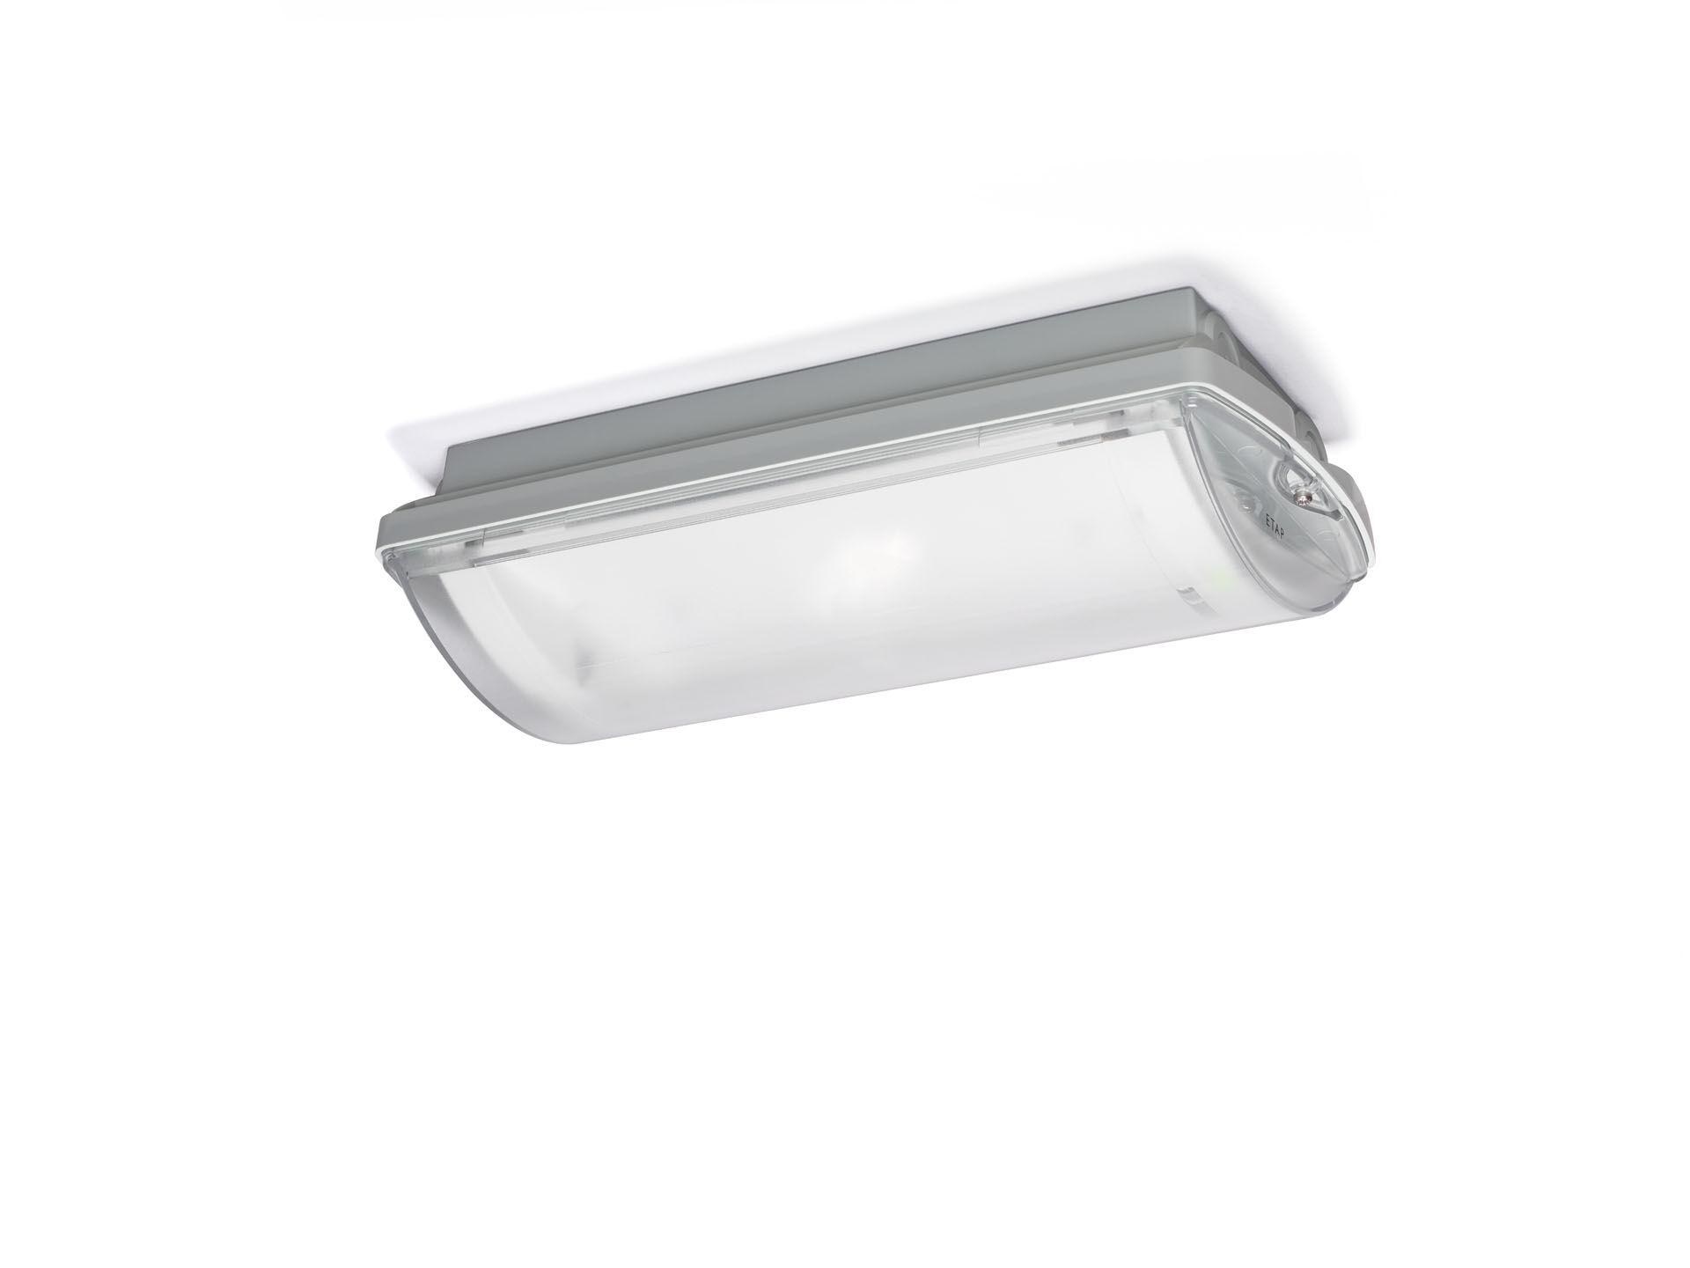
IP65 emergency luminaire for escape route lighting. Surface mounted. Autonomous luminaire (contains battery). Dimensions: 359 mm x 180 mm x 100 mm. Mounted on two stainless steel clamps, automatic electrical connection screwless wire terminals (up to 2.5 mm²), cable gland included, through-wiring possibility, optional accessories for recessed mounting With battery heater, allowed ambient temperature -20°C to +35°C. Line-shaped light distribution, optimized for 1 lux along the escape route axis. Lumen output in emergency mode: 192 lm. Power consumption in standby: 0.9 W. Inderdistance escape route: at a mounting height of 2.8 m, the illumination on the floor is 1 lux with an interdistance ("b") of 19.0 m. Voltage: 220-230V. Autonomy: 180 minutes. The luminaire contains lamp data, battery date and type as required according to EN 60598-2.22. Battery: 4 x NiMh 1,2V 2,1Ah. Automatic functional test every week, duration test every 13 weeks, in accordance to EN 50172 and EN 62034. Maintained/non maintained mode selectable, preset for most common application. Electrical insulation class: class II. Photobiological safety IEC/TR 62778: RG1. Impact-resistant polycarbonate housing, RAL9018 - papyrus white. IP protection level: IP65. IK protection level: IK10. Ambient temperature: -20°C - 35°C. Glowwire: 850°C. 5 years warranty on luminaire, light source, driver and battery (for autonomous luminaires). Certifications: CE, ENEC. The luminaire has been developed and produced according to standard EN60598-1 in a company that is ISO9001 and ISO14001 certified.

