K213/3OS11

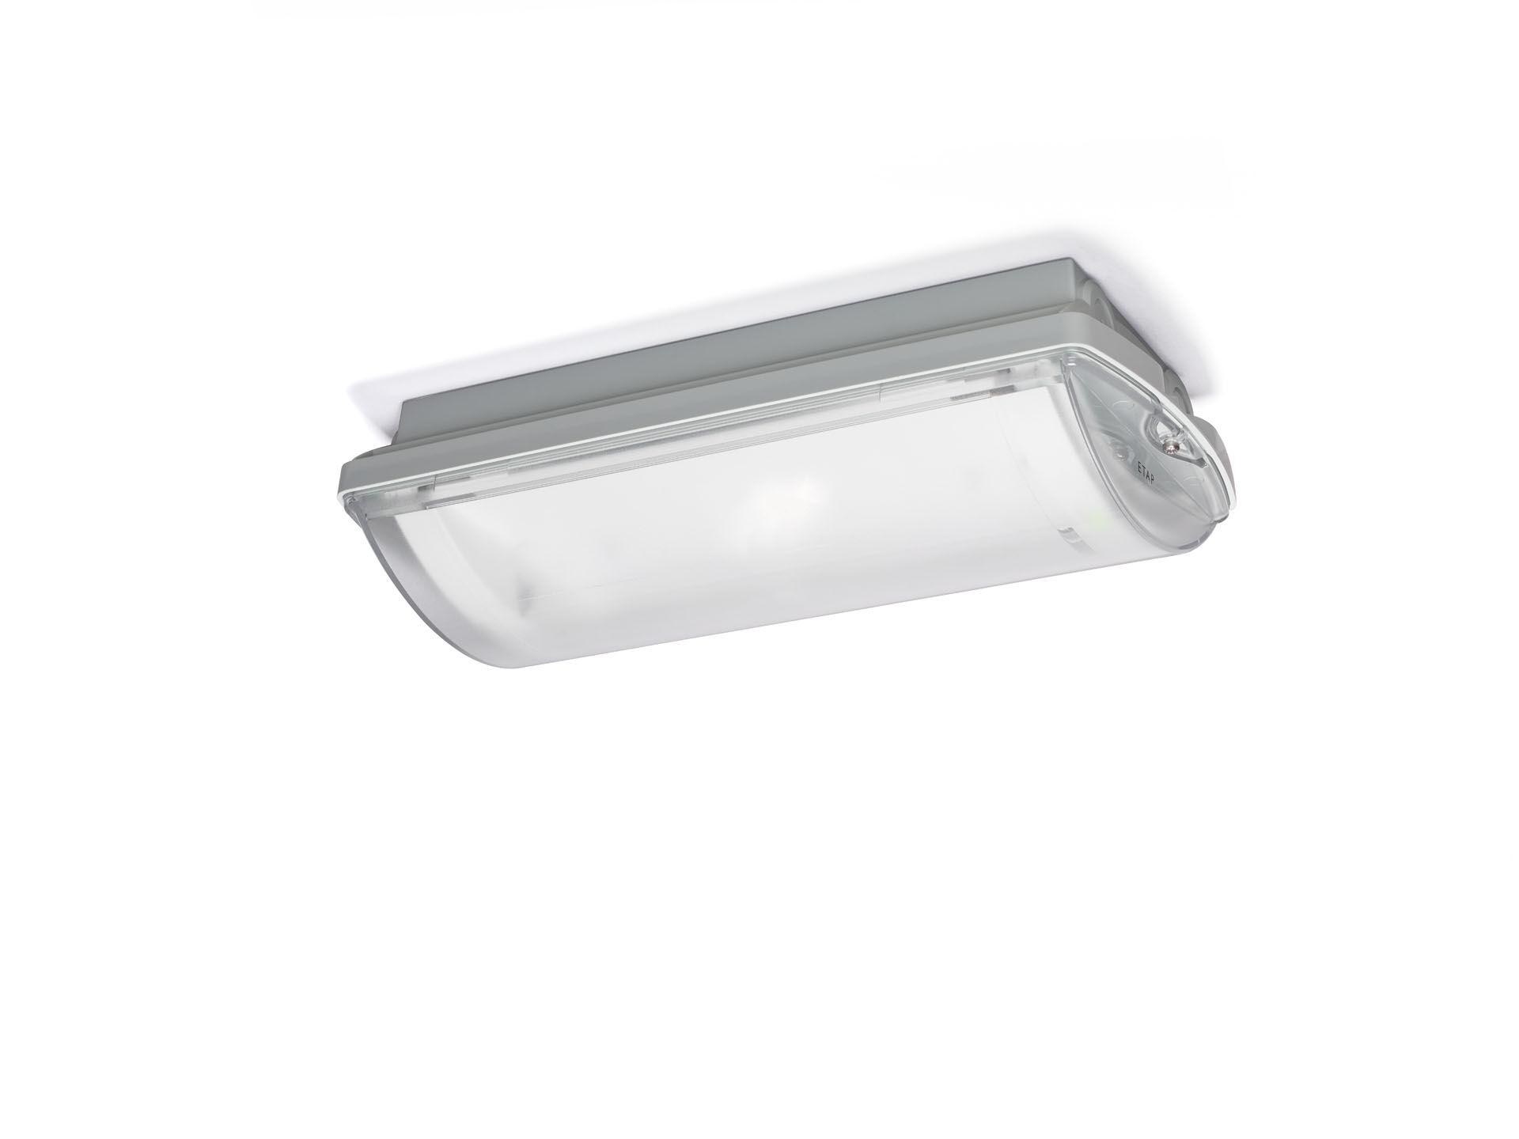
IP65 emergency luminaire for escape route lighting. Surface mounted. Autonomous luminaire (contains battery). Dimensions: 359 mm x 180 mm x 100 mm. Mounted on two stainless steel clamps, automatic electrical connection screwless wire terminals (up to 2.5 mm²), cable gland included, through-wiring possibility, optional accessories for recessed mounting With battery heater, allowed ambient temperature -20°C to +35°C. Line-shaped light distribution, optimized for 1 lux along the escape route axis. Lumen output in emergency mode: 275 lm. Power consumption in standby: 0.9 W. Inderdistance escape route: at a mounting height of 2.8 m, the illumination on the floor is 1 lux with an interdistance ("b") of 20.5 m. Voltage: 220-230V. Autonomy: 60 minutes. The luminaire contains lamp data, battery date and type as required according to EN 60598-2.22. Battery: 4 x NiMh 1,2V 1,1Ah. Automatic functional test every week, duration test every 13 weeks, in accordance to EN 50172 and EN 62034. Monitoring and control via DALI for central maintenance. Connection via two wire BUS communication. Maintained/non maintained mode selectable, preset for most common application. Electrical insulation class: class II. Photobiological safety IEC/TR 62778: RG1. Impact-resistant polycarbonate housing, RAL9018 - papyrus white. IP protection level: IP65. IK protection level: IK10. Ambient temperature: -20°C - 35°C. Glowwire: 850°C. 5 years warranty on luminaire, light source, driver and battery (for autonomous luminaires). Certifications: CE, ENEC. The luminaire has been developed and produced according to standard EN60598-1 in a company that is ISO9001 and ISO14001 certified.

