K22/3N-230

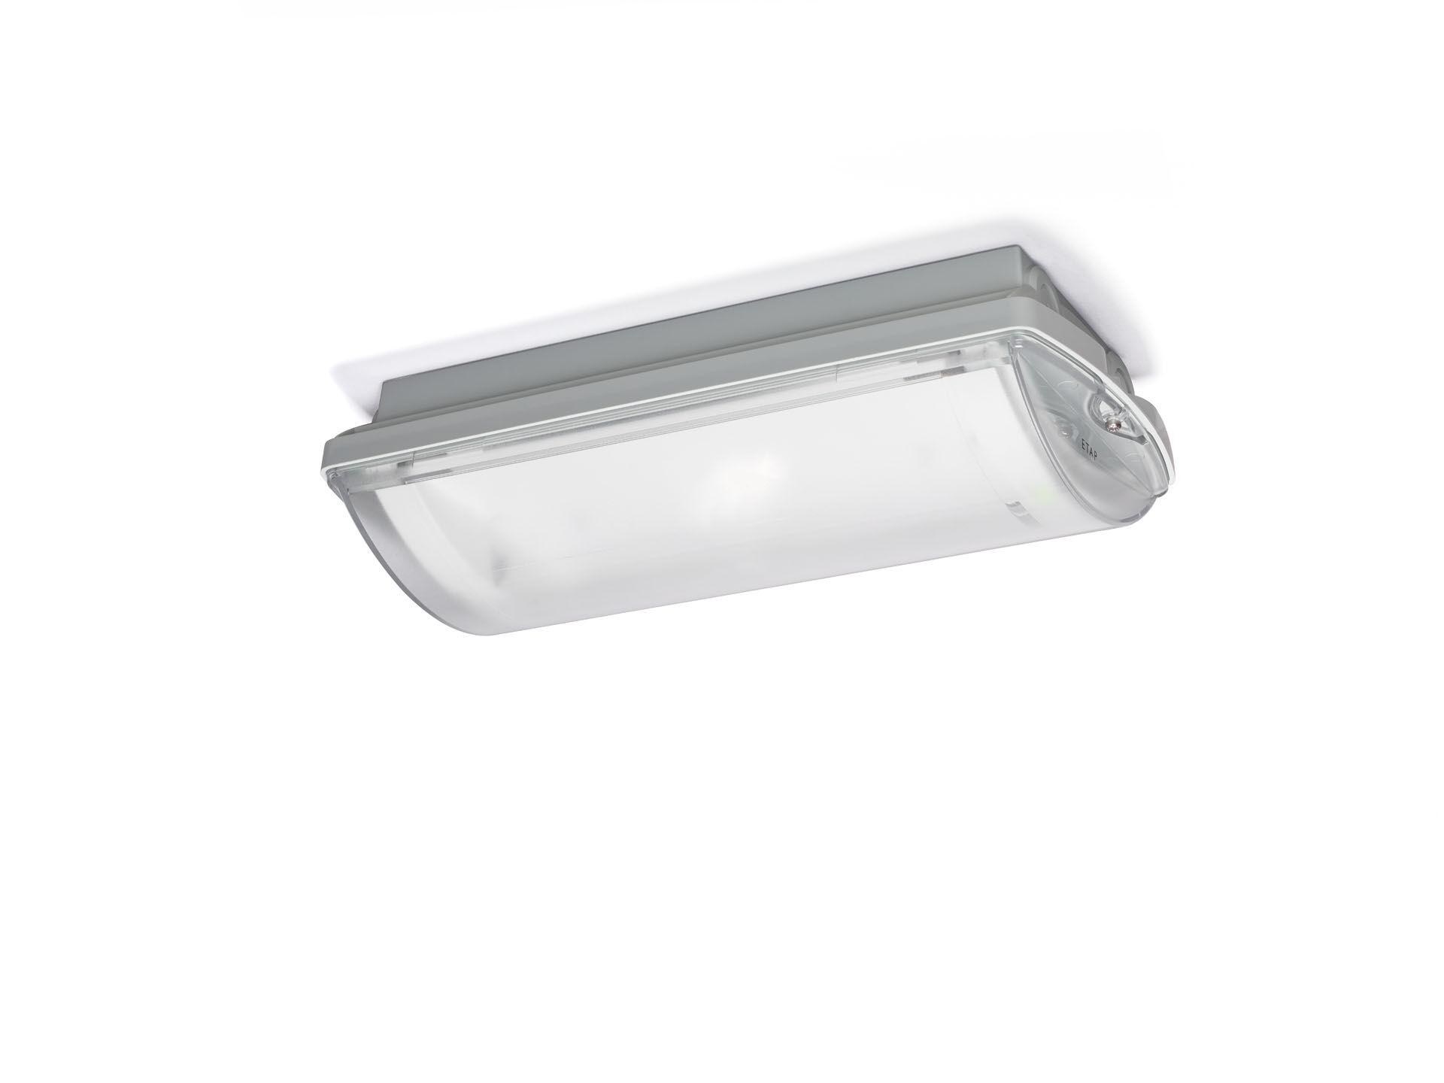
IP65 emergency luminaire for anti-panic lighting. Surface mounted. For central supply. Dimensions: 359 mm x 180 mm x 100 mm. Mounted on two stainless steel clamps, automatic electrical connection, screwless wire terminals (up to 2.5 mm²), cable gland included, through-wiring possibility, optional accessories for recessed mounting Square light distribution, optimized to avoid dark spots. Lumen output in emergency mode: 288 lm. Power consumption in standby: 3.9 W. Interdistance anti-panic: at a mounting height of 2.8 m, the illumination on the floor is 0.5 lux with an interdistance ("b") of 13.3 m. At a mounting height of 2.8 m, the illumination on the floor is 1 lux with an interdistance ("b") of 11.7 m. Voltage: 220-230V. For use with central battery system on 230 V AC/DC. Electrical insulation class: class II. Photobiological safety IEC/TR 62778: RG1. Impact-resistant polycarbonate housing, RAL9018 - papyrus white. IP protection level: IP65. IK protection level: IK10. Ambient temperature: -20°C - 35°C. Glowwire: 850°C. 5 years warranty on luminaire, light source, driver and battery (for autonomous luminaires). Certifications: CE, ENEC. The luminaire has been developed and produced according to standard EN60598-1 in a company that is ISO9001 and ISO14001 certified.

