K23/3-230C3

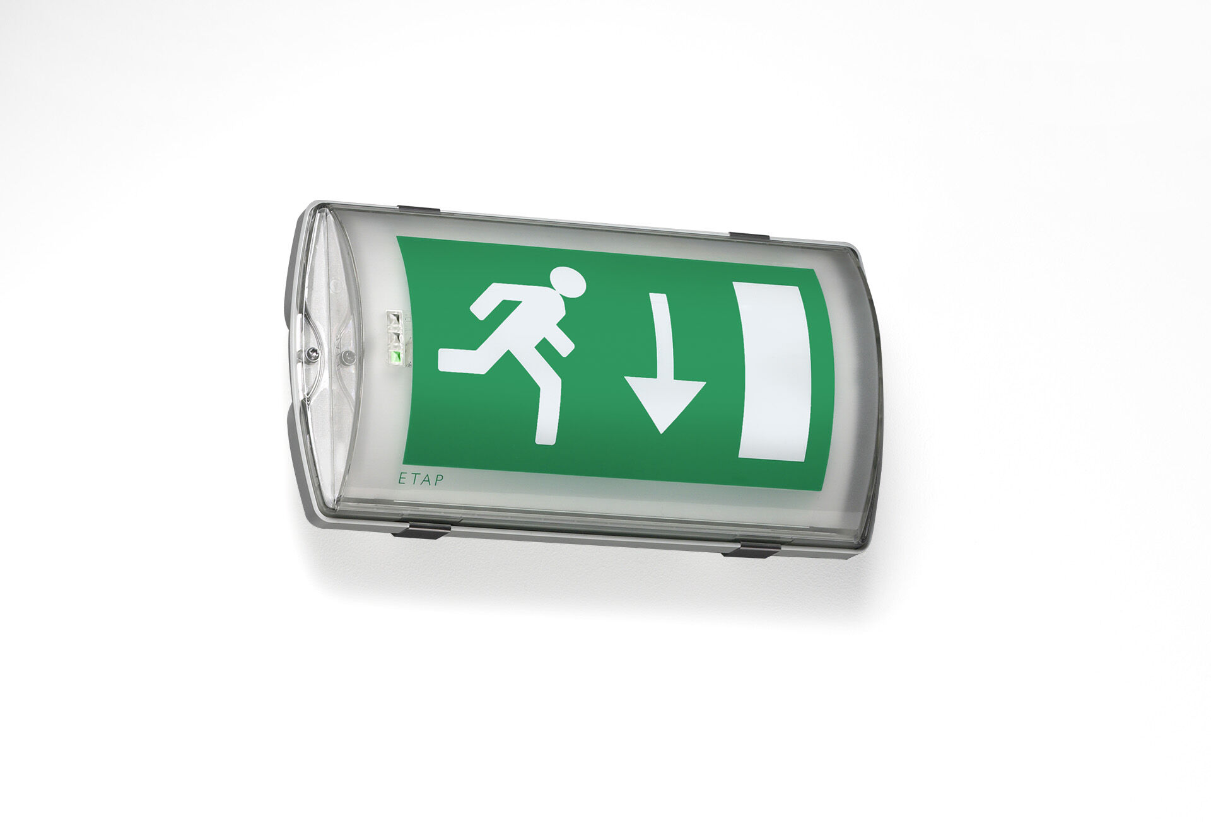
IP65 emergency luminaire for single sided signage. Wall mounted. For central supply. Dimensions: 359 mm x 180 mm x 100 mm. Mounted on two stainless steel clamps, automatic electrical connection, screwless wire terminals (up to 2.5 mm²), cable gland included, through-wiring possibility, optional accessories for recessed mounting Lumen output in emergency mode: 130 lm. Power consumption in standby: 3.1 W. Voltage: 220-230V. The perception distance of the pictogram is 26 m. Contains addressable MSÜ3 communication module, for use with a central battery system. Maintained mode of operation. Electrical insulation class: class II. Photobiological safety IEC/TR 62778: RG0. Impact-resistant polycarbonate housing, RAL9018 - papyrus white. IP protection level: IP65. IK protection level: IK10. Ambient temperature: -10°C - 35°C. Glowwire: 850°C. 5 years warranty on luminaire, light source, driver and battery (for autonomous luminaires). Certifications: CE, ENEC. The luminaire has been developed and produced according to standard EN60598-1 in a company that is ISO9001 and ISO14001 certified.

