K232/3

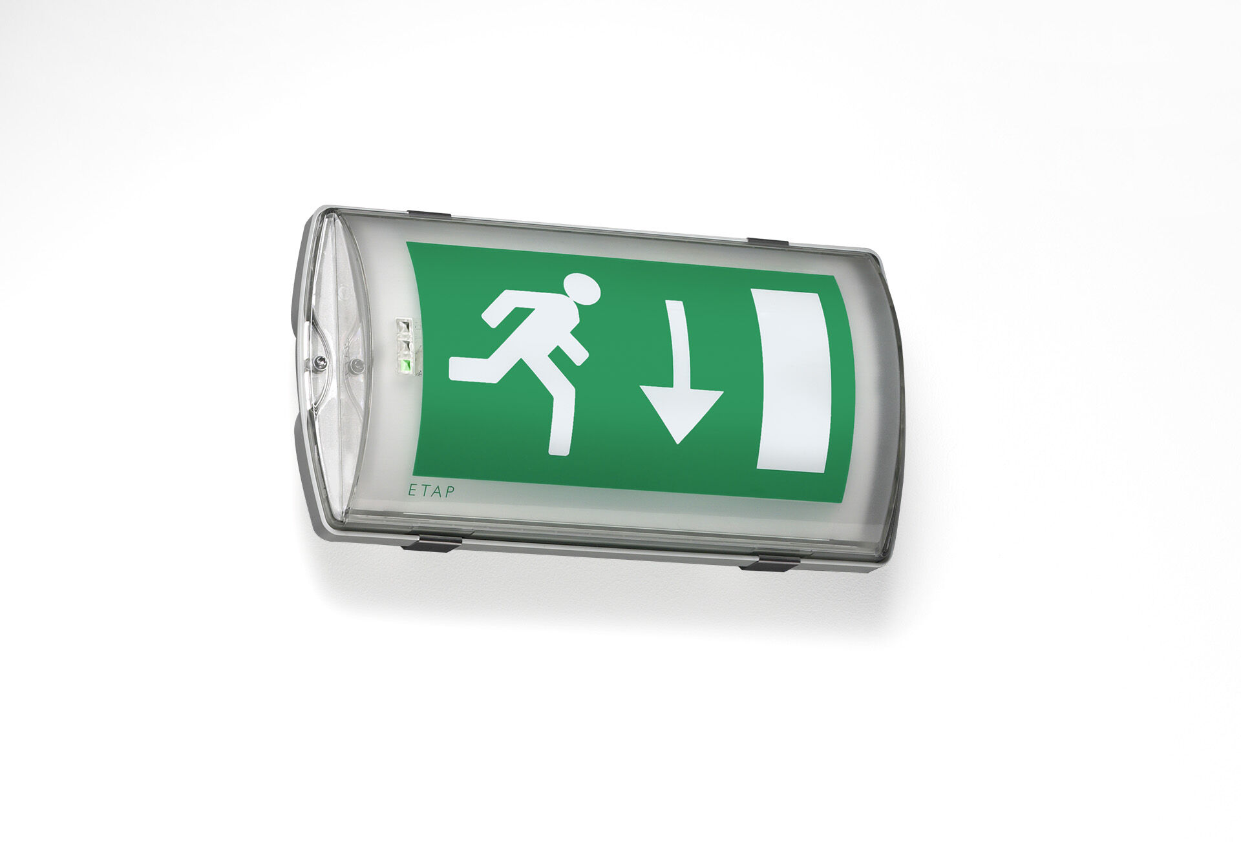
IP65 emergency luminaire for single sided signage. Wall mounted. Autonomous luminaire (contains battery). Dimensions: 359 mm x 180 mm x 100 mm. Mounted on two stainless steel clamps, automatic electrical connection, screwless wire terminals (up to 2.5 mm²), cable gland included, through-wiring possibility, optional accessories for recessed mounting Lumen output in emergency mode: 130 lm. Power consumption in standby: 1.8 W. Voltage: 220-230V. The perception distance of the pictogram is 26 m. Autonomy: 60 minutes. The luminaire contains lamp data, battery date and type as required according to EN 60598-2.22. Battery: 4 x NiMh 1,2V 1,1Ah. Automatic functional test every week, duration test every 13 weeks, in accordance to EN 50172 and EN 62034. Maintained/non maintained mode selectable, preset for most common application. Electrical insulation class: class II. Photobiological safety IEC/TR 62778: RG0. Impact-resistant polycarbonate housing, RAL9018 - papyrus white. IP protection level: IP65. IK protection level: IK10. Ambient temperature: 5°C - 35°C. Glowwire: 850°C. 5 years warranty on luminaire, light source, driver and battery (for autonomous luminaires). Certifications: CE, ENEC. The luminaire has been developed and produced according to standard EN60598-1 in a company that is ISO9001 and ISO14001 certified.

