K3M12

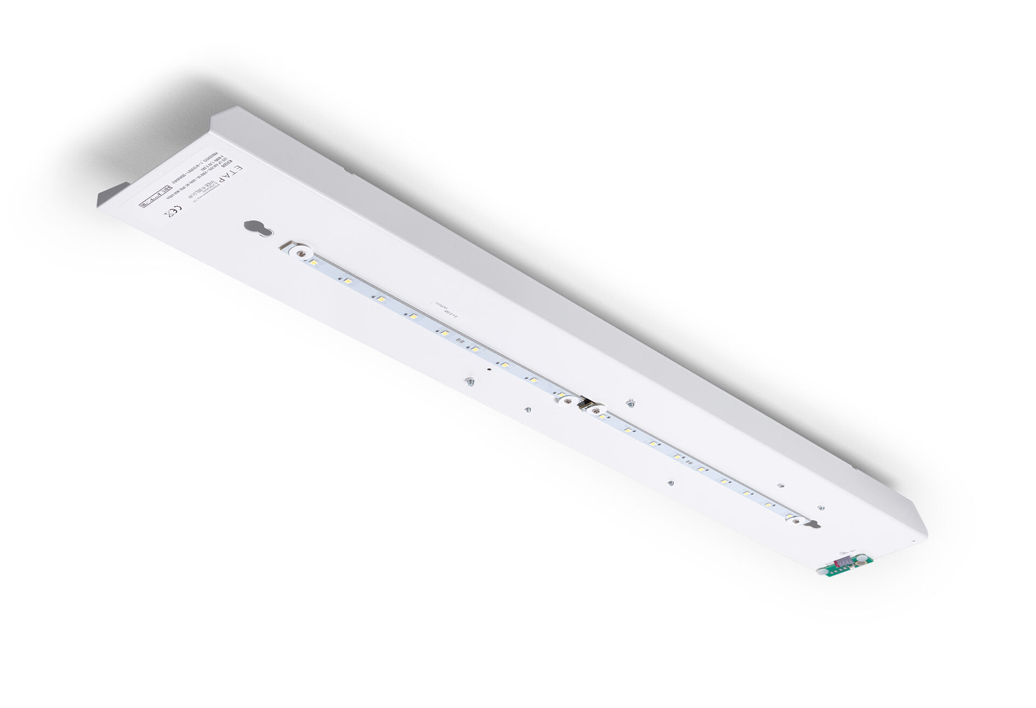
Renovation module to led for ETAP K3 fluo emergency lighting Autonomous luminaire (contains battery). Dimensions: . Plug-and-play, screwless replacement of the interior. Exterior housing and wiring are kept as-is. Lumen output in emergency mode: 640 lm. Power consumption in standby: 0.9 W. Voltage: 220-230V. Autonomy: 60 minutes. The luminaire contains lamp data, battery date and type as required according to EN 60598-2.22. Battery: 4 x NiMh 1,2V 2,2Ah. Battery lifetime: 8 years. Automatic functional test every week, duration test every 13 weeks, in accordance to EN 50172 and EN 62034. Maintained/non maintained mode selectable, preset for most common application. Electrical insulation class: class I. Photobiological safety IEC/TR 62778: RG0. . Glowwire: 850°C. 5 years warranty on luminaire, light source, driver and battery (for autonomous luminaires). Certifications: CE. The luminaire has been developed and produced according to standard EN60598-1 in a company that is ISO9001 and ISO14001 certified.

