K4A-R30-2M0-20-3L0

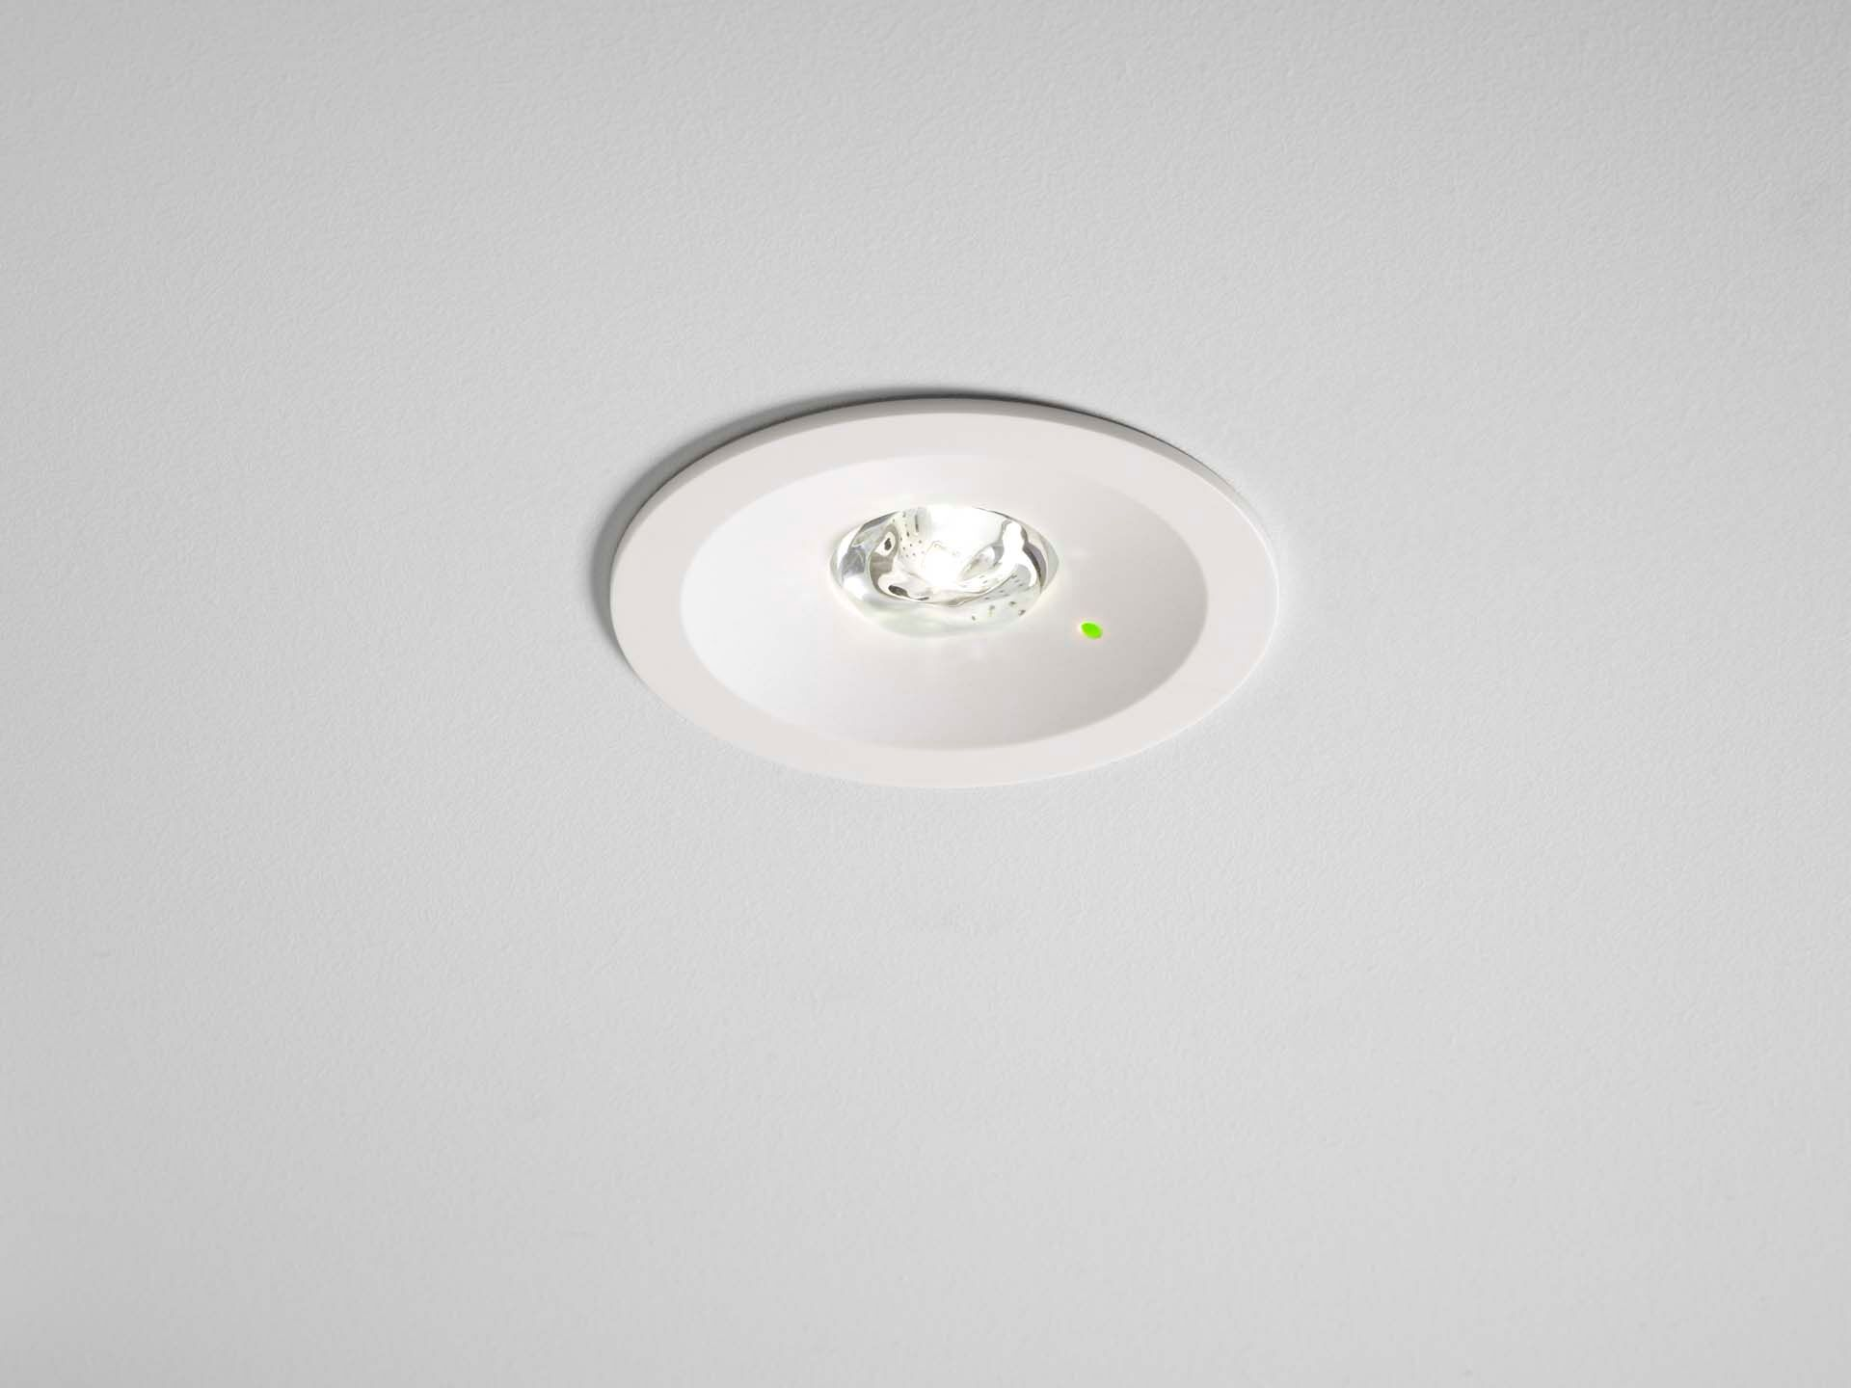
Luminária de emergência redonda para iluminação anti-pânico (área aberta). Montagem embutida. Autonomous luminaire (contains battery). Dimensions: Ø 80 mm x 50 mm. Polycarbonate housing with sunk optics and modern aspect. Spring mounted, electronics in separate transparant minimal-additives polycarbonate housing, screwless opening, screwless push-in wire terminals. Installation height 110 mm. Allows for in-and-out wiring with two cables up to 5G2,5mm², or with 4 cables if bus-wires are separate. Square light distribution, optimized to avoid dark spots. Lumen output in emergency mode: 100 lm. Power consumption in standby: 0.2 W. Voltage: 220-240V. Autonomy: 180 minutes. The luminaire contains lamp data, battery date and type as required according to EN 60598-2.22. Battery: 1 x LiFePO4 3,2V 1,5Ah. Automatic functional test every week, duration test every 13 weeks, in accordance to EN 50172 and EN 62034. Electrical insulation class: class II. Photobiological safety IEC/TR 62778: RG1. Impact-resistant polycarbonate housing, RAL9003 - white. IP protection level: IP42. IP protection level: IP20. IK protection level: IK04. Ambient temperature: 5°C - 35°C. Glowwire: 850°C. 5 years warranty on luminaire, light source, driver and battery (for autonomous luminaires). Certifications: CE. The luminaire has been developed and produced according to standard EN60598-1 in a company that is ISO9001 and ISO14001 certified.

