K6A-R30-1M0-20-3L0

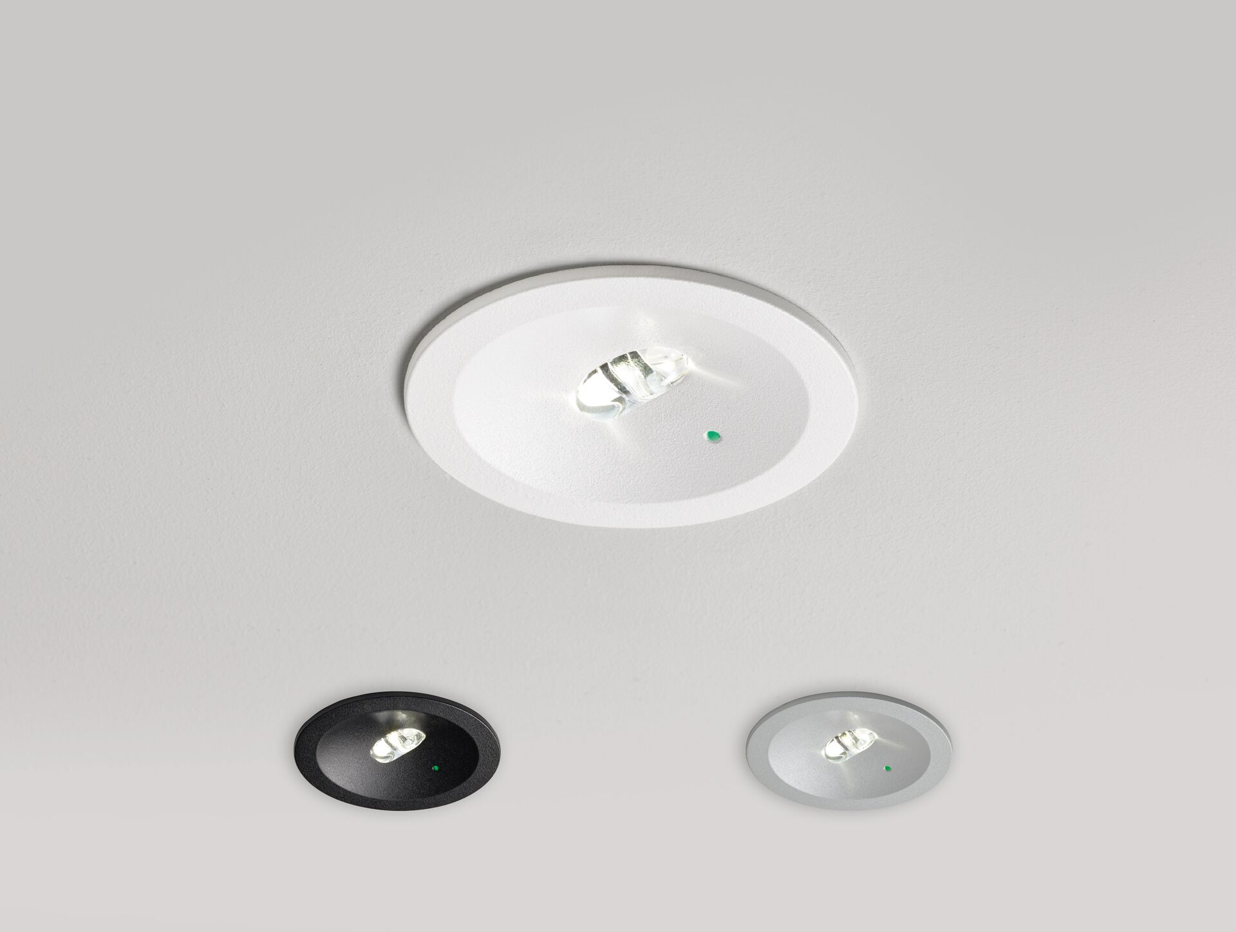
Minimalistic design round emergency luminaire for escape route lighting. Recessed mounted. Autonomous luminaire (contains battery). Dimensions: Ø 80 mm x 50 mm. Line-shaped light distribution, optimized for 1 lux along the escape route axis. Lumen output in emergency mode: 95 lm. Power consumption in standby: 0.2 W. Voltage: 220-240V. Autonomy: 180 minutes. The luminaire contains lamp data, battery date and type as required according to EN 60598-2.22. Battery: 1 x LiFePO4 3,2V 1,5Ah. Automatic functional test every week, duration test every 13 weeks, in accordance to EN 50172 and EN 62034. Electrical insulation class: class II. Photobiological safety IEC/TR 62778: RG1. Texture coated aluminum cover, polycarbonate housing, RAL9003 - white / Configurable. IP protection level: IP20. IK protection level: IK04. Ambient temperature: 5°C - 35°C. Glowwire: 850°C. 5 years warranty on luminaire, light source, driver and battery (for autonomous luminaires). Certifications: CE. The luminaire has been developed and produced according to standard EN60598-1 in a company that is ISO9001 and ISO14001 certified.

