K9R016/3N

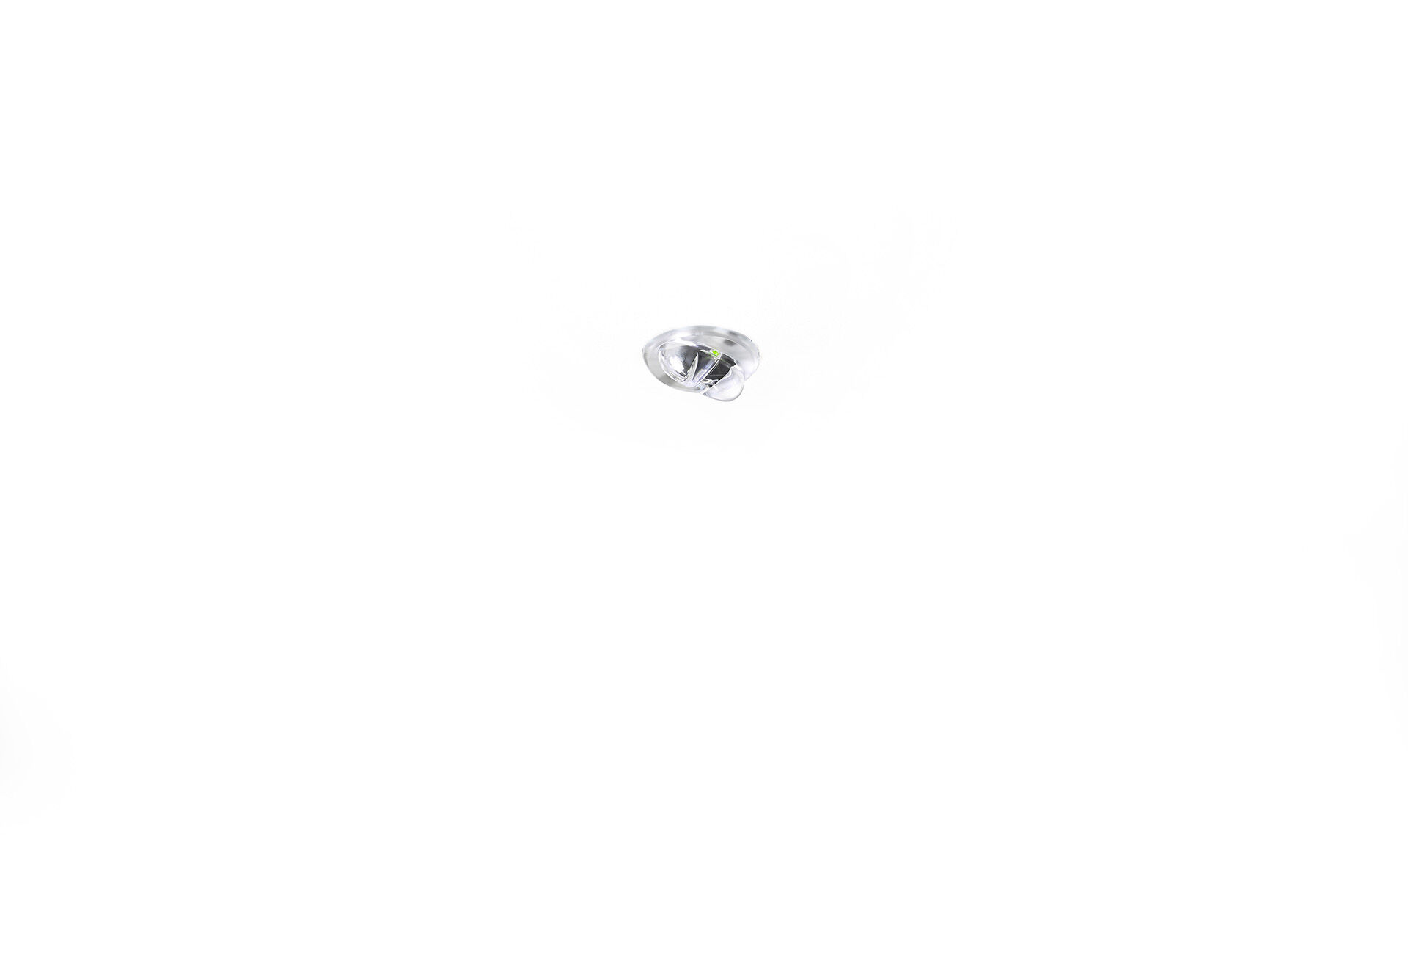
Mini emergency module for escape route lighting. DALI-2. Recessed mounting. Autonomous luminaire (contains battery). Dimensions: Ø 30 mm x 32 mm. Discrete dimensions, with extruded aluminium heatsink and optional 5 mm trim, electronics in separate polycarbonate housing with screwless opening, automatic electrical connection, screwless wire terminals (up to 2.5 mm²). Line-shaped light distribution, optimized for 1 lux along the escape route axis. Lumen output in emergency mode: 210 lm. Power consumption in standby: 1.9 W. Voltage: 220-240V. Autonomy: 60 minutes. The luminaire contains lamp data, battery date and type as required according to EN 60598-2.22. Battery: 4 x NiMh 1,2V 1,1Ah. Battery lifetime: 10 years. Automatic functional test every week, duration test every 13 weeks, in accordance to EN 50172 and EN 62034. Monitoring and control via DALI for central maintenance. Connection via two wire BUS communication. Electrical insulation class: class II. Photobiological safety IEC/TR 62778: RG1. Heat sink in extruded aluminium housing, RAL9003 - white. IP protection level: IP20. IK protection level: IK04. Ambient temperature: 5°C - 35°C. Glowwire: 850°C. 5 years warranty on luminaire, light source, driver and battery (for autonomous luminaires). Certifications: CE, ENEC. The luminaire has been developed and produced according to standard EN60598-1 in a company that is ISO9001 and ISO14001 certified.

