K9R11/3N-23-AX1-D800A25

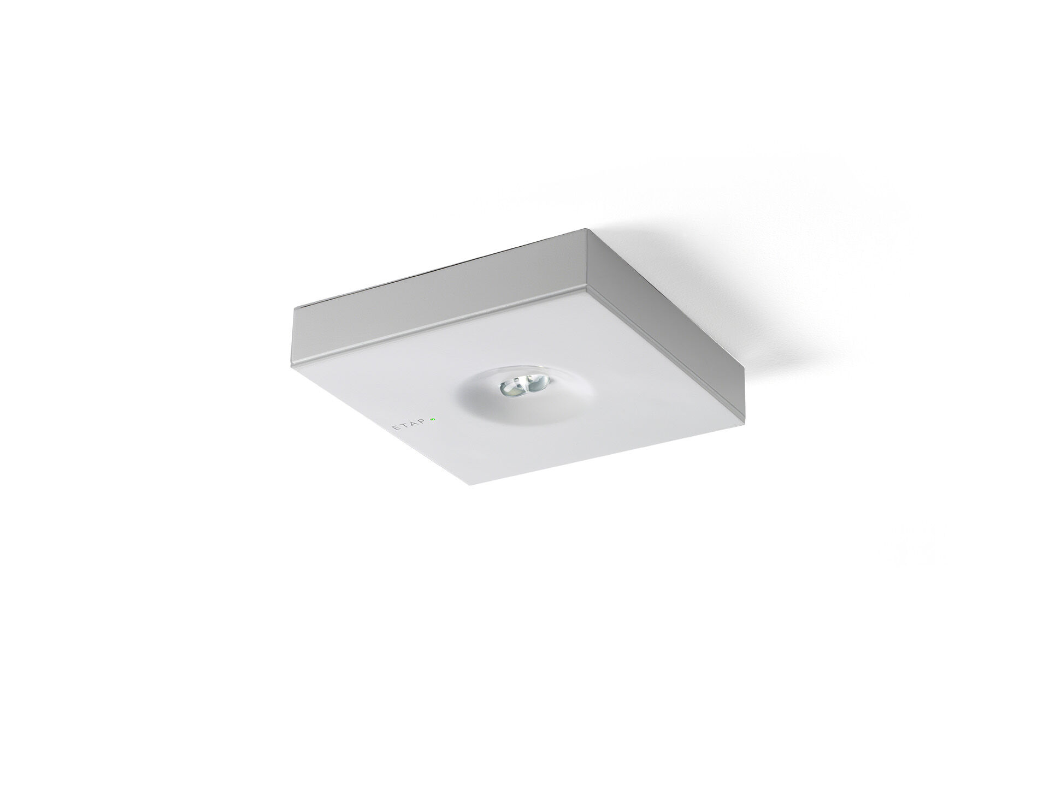
Minimalistic design square emergency luminaire for escape route lighting. Surface mounted. For central supply. Dimensions: 152 mm x 152 mm x 32 mm. Powder coated zamak cover with sunk optics and flush aspect, polycarbonate base, screwless opening, automatic electrical connection, screwless wire terminals (up to 2.5 mm²). Line-shaped light distribution, optimized for 1 lux along the escape route axis. Lumen output in emergency mode: 280 lm. Power consumption in standby: 3.9 W. Inderdistance escape route: at a mounting height of 2.8 m, the illumination on the floor is 1 lux with an interdistance ("b") of 20.7 m. Voltage: 220-230V. For use with central battery system on 230 V AC/DC. Electrical insulation class: class II. Powder coated die-cast zamak housing, RAL9003 - white (textured). IP protection level: IP42. IK protection level: IK04. Ambient temperature: -20°C - 35°C. Glowwire: 850°C. 5 years warranty on luminaire, light source, driver and battery (for autonomous luminaires). Certifications: CE, ENEC. The luminaire has been developed and produced according to standard EN60598-1 in a company that is ISO9001 and ISO14001 certified.

