K9R12/3N-230X2C3

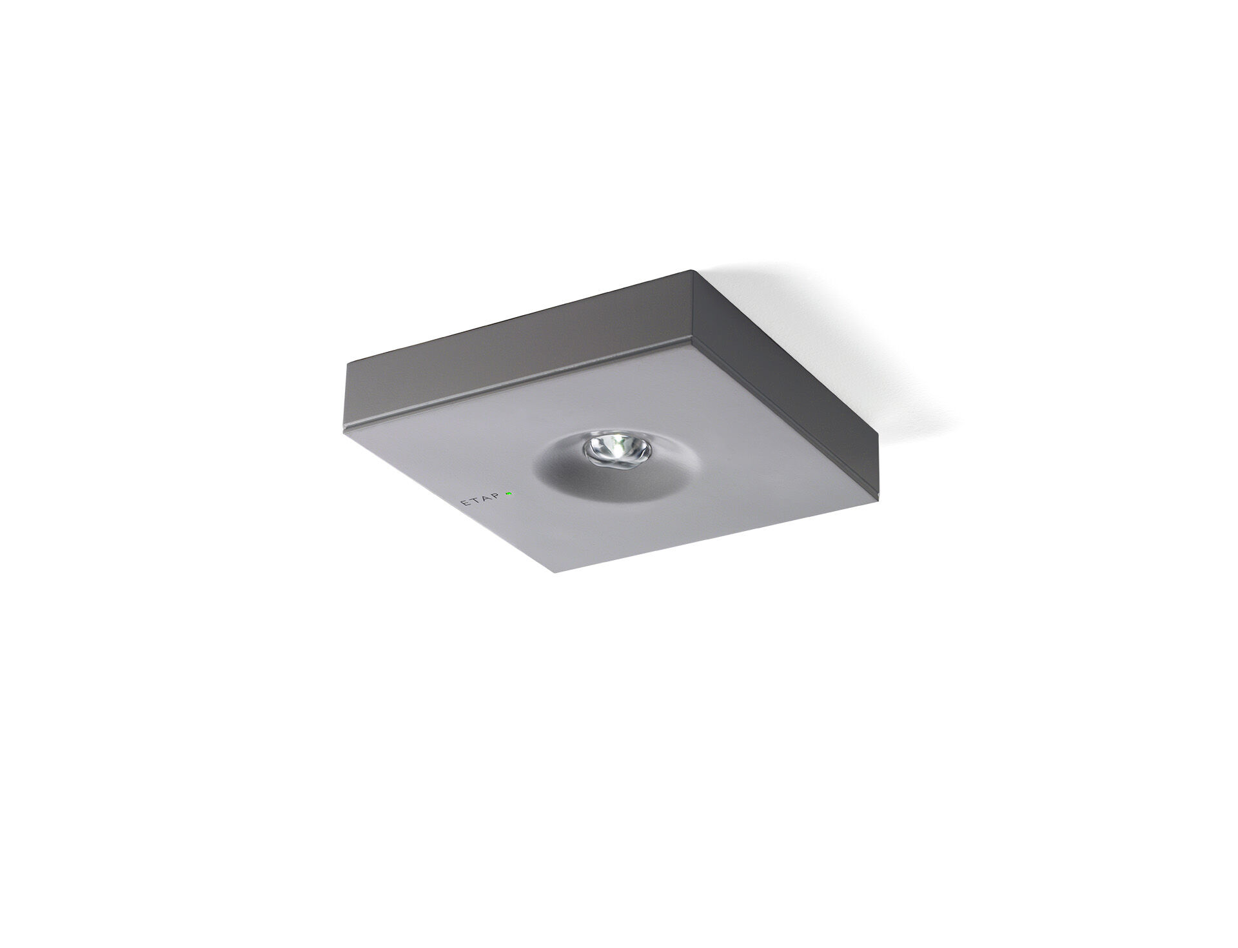
Minimalistic design square emergency luminaire for anti-panic lighting. Surface mounted. For central supply. Dimensions: 152 mm x 152 mm x 32 mm. Powder coated zamak cover with sunk optics and flush aspect, polycarbonate base, screwless opening, automatic electrical connection, screwless wire terminals (up to 2.5 mm²) Square light distribution, optimized to avoid dark spots. Lumen output in emergency mode: 300 lm. Power consumption in standby: 4.3 W. Interdistance anti-panic: at a mounting height of 2.8 m, the illumination on the floor is 0.5 lux with an interdistance ("b") of 12.0 m. At a mounting height of 2.8 m, the illumination on the floor is 1 lux with an interdistance ("b") of 12.0 m. Voltage: 220-230V. Contains addressable MSÜ3 communication module, for use with a central battery system. Electrical insulation class: class II. Powder coated die-cast zamak housing, RAL9006 - white aluminium (textured). IP protection level: IP42. IK protection level: IK04. Ambient temperature: -10°C - 35°C. Glowwire: 850°C. 5 years warranty on luminaire, light source, driver and battery (for autonomous luminaires). Certifications: CE, ENEC. The luminaire has been developed and produced according to standard EN60598-1 in a company that is ISO9001 and ISO14001 certified.

