K9R152/3X0

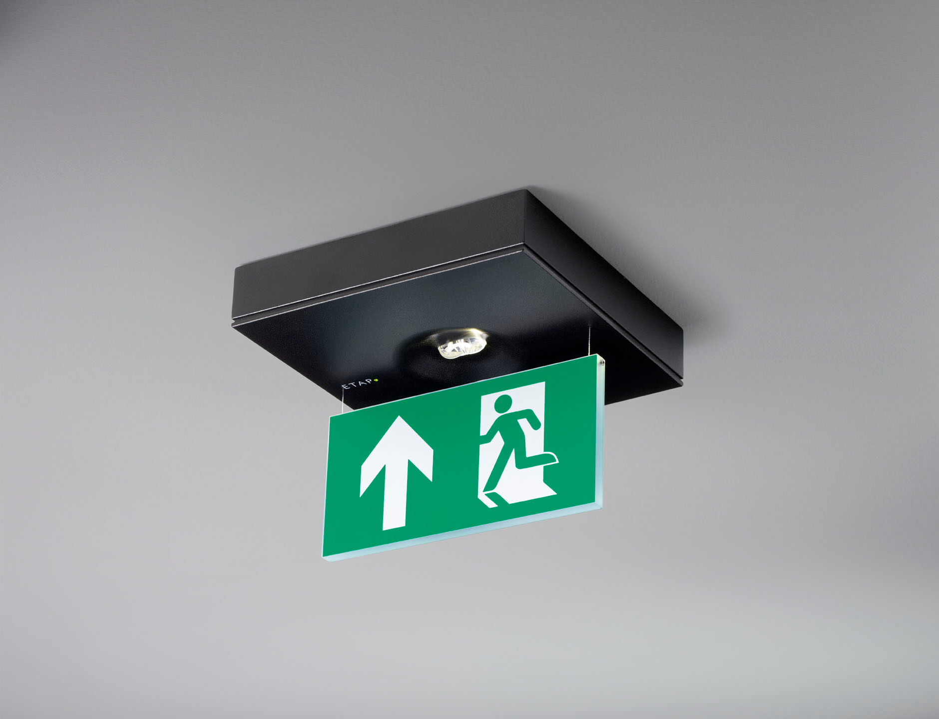
Minimalistic design emergency luminaire for single- and double sided signage. Ceiling mounted. Autonomous luminaire (contains battery). Dimensions: 152 mm x 152 mm x 32 mm. Powder coated zamak housing, screwless opening, automatic electrical connection, screwless wire terminals (up to 2.5 mm²). Signage plate 76 mm height with illuminated borders. Lumen output in emergency mode: 85 lm. Power consumption in standby: 1.0 W. Voltage: 220-230V. The perception distance of the pictogram is 15 m. Autonomy: 60 minutes. The luminaire contains lamp data, battery date and type as required according to EN 60598-2.22. Battery: 4 x NiMh 1,2V 1,1Ah. Battery lifetime: 10 years. Automatic functional test every week, duration test every 13 weeks, in accordance to EN 50172 and EN 62034. Maintained/non maintained mode selectable, preset for most common application. Electrical insulation class: class II. Photobiological safety IEC/TR 62778: RG1. Powder coated die-cast zamak housing, RAL9005 - jetblack (textured). IP protection level: IP42. IK protection level: IK04. Ambient temperature: 5°C - 35°C. Glowwire: 850°C. 5 years warranty on luminaire, light source, driver and battery (for autonomous luminaires). Certifications: CE, ENEC. The luminaire has been developed and produced according to standard EN60598-1 in a company that is ISO9001 and ISO14001 certified.

