K9R24/1-230X1

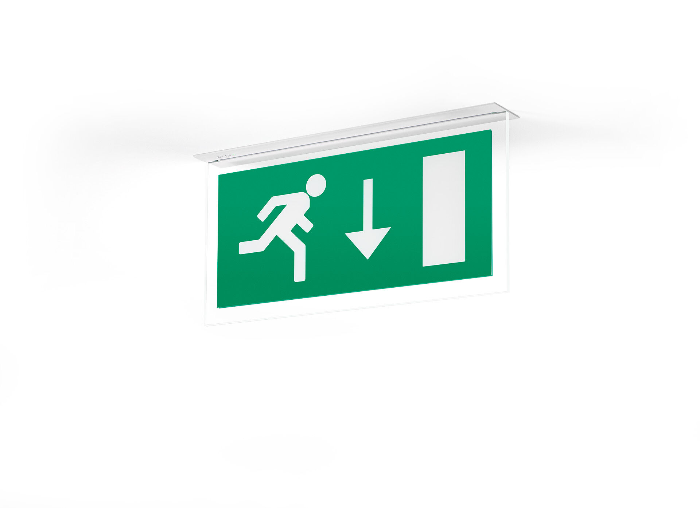
Minimalistic design emergency luminaire for single- and double sided signage. Recessed mounted. For central supply. Dimensions: 324 mm x 46 mm x 60 mm. Powder coated zamak housing, screwless opening, automatic electrical connection, screwless wire terminals (up to 2.5 mm²). Signage plate with illuminated borders. Lumen output in emergency mode: 80 lm. Power consumption in standby: 3.7 W. Voltage: 220-230V. The perception distance of the pictogram is 26 m. For use with central battery system on 230 V AC/DC. Maintained mode of operation. Electrical insulation class: class II. Photobiological safety IEC/TR 62778: RG0. Powder coated die-cast zamak housing, RAL9003 - white (textured). IP protection level: IP42. IK protection level: IK04. Ambient temperature: -20°C - 35°C. Glowwire: 850°C. 5 years warranty on luminaire, light source, driver and battery (for autonomous luminaires). Certifications: CE, ENEC. The luminaire has been developed and produced according to standard EN60598-1 in a company that is ISO9001 and ISO14001 certified.

