K9R26/3N-230X2

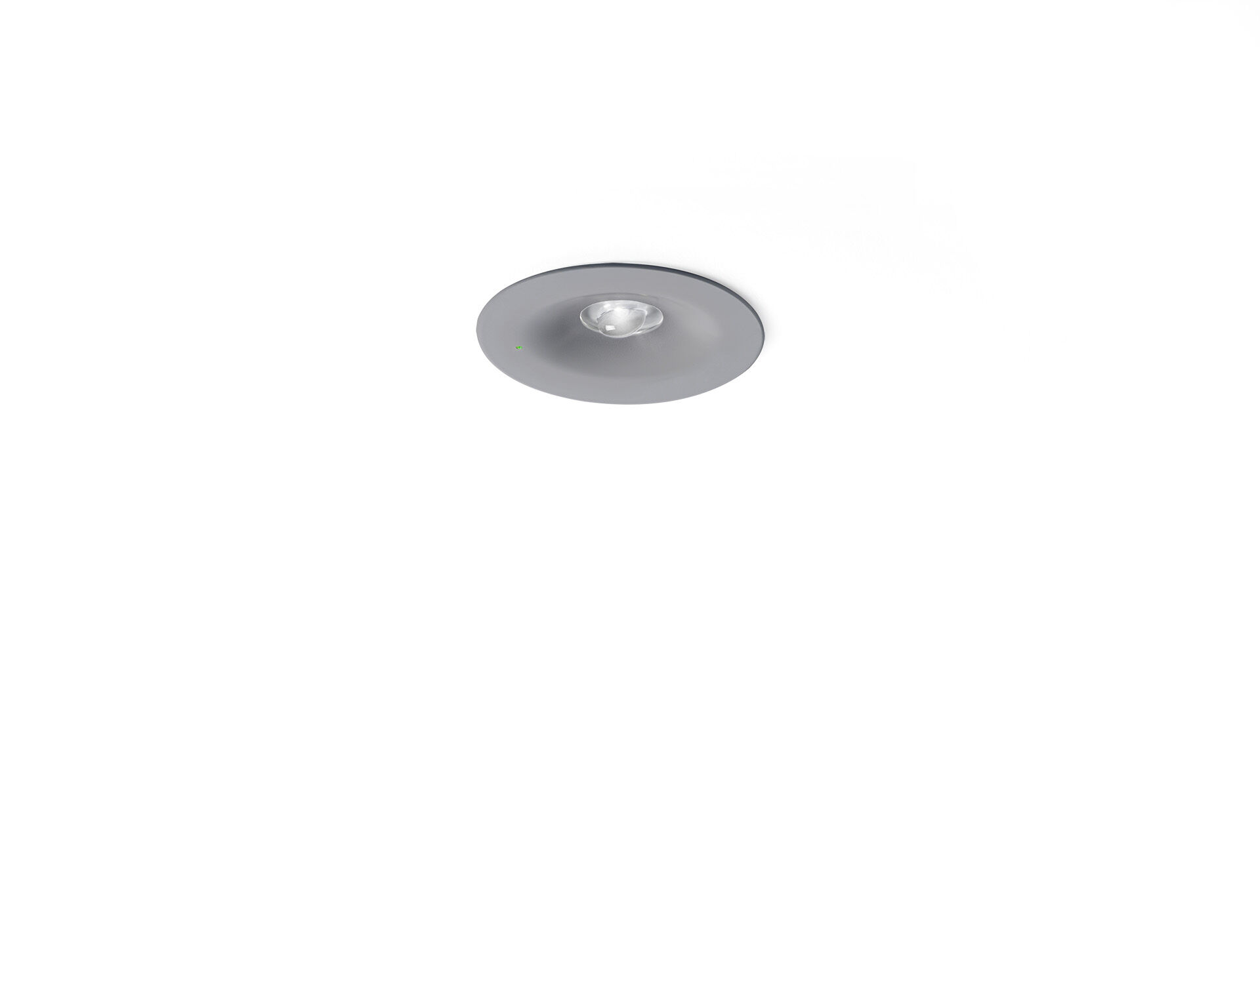
Minimalistic design round emergency luminaire for high light levels. Recessed. For central supply. Dimensions: Ø 90 mm x 37 mm. Concentrated light distribution, optimized for high mounting or staircase illumination. Lumen output in emergency mode: 280 lm. Power consumption in standby: 3.9 W. Inderdistance escape route: at a mounting height of 2.8 m, the illumination on the floor is 1 lux with an interdistance ("b") of 11.3 m. Interdistance anti-panic: at a mounting height of 2.8 m, the illumination on the floor is 0.5 lux with an interdistance ("b") of 8.0 m. At a mounting height of 2.8 m, the illumination on the floor is 1 lux with an interdistance ("b") of 9.0 m. Voltage: 220-230V. For use with central battery system on 230 V AC/DC. Electrical insulation class: class II. Photobiological safety IEC/TR 62778: >1m RG1 ; <1m RG2. Powder coated die-cast zamak housing, RAL9006 - aluminium grey. IP protection level: IP42. IK protection level: IK04. Ambient temperature: -20°C - 35°C. Glowwire: 850°C. 5 years warranty on luminaire, light source, driver and battery (for autonomous luminaires). Certifications: CE, ENEC. The luminaire has been developed and produced according to standard EN60598-1 in a company that is ISO9001 and ISO14001 certified.

