K9R322/3X1

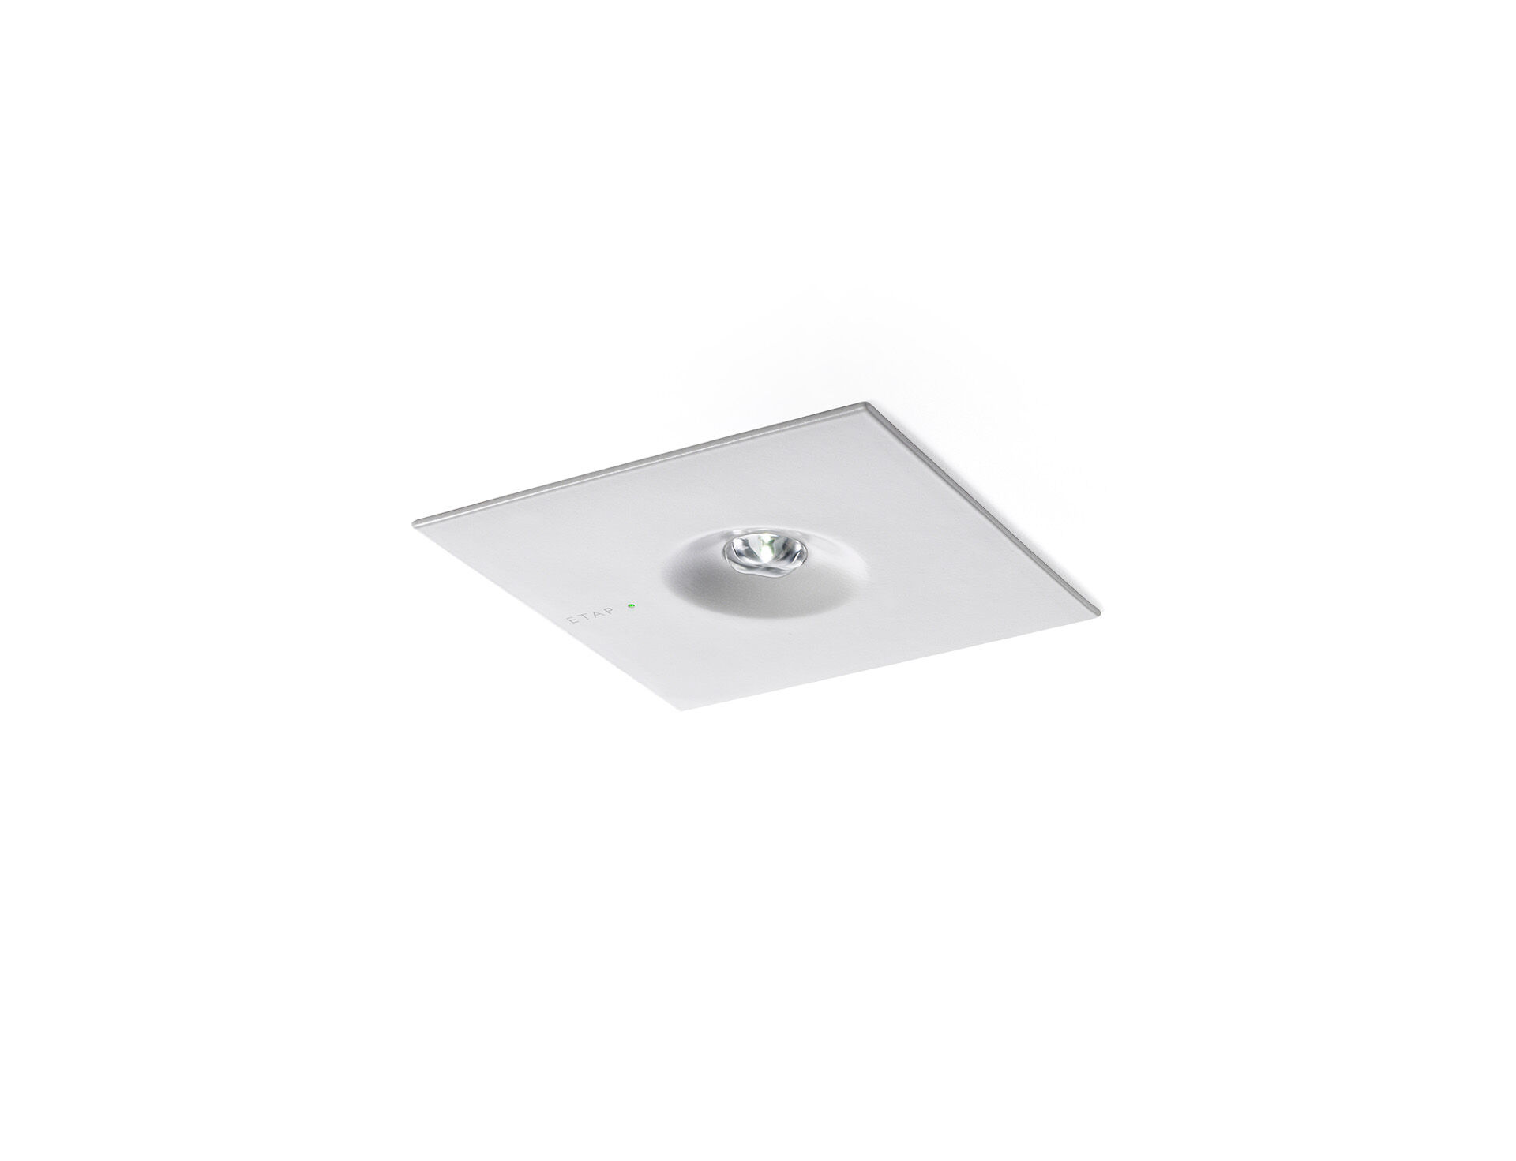
Minimalistic design square emergency luminaire for anti-panic lighting. Recessed mounted. Autonomous luminaire (contains battery). Dimensions: 160 mm x 160 mm x 45 mm. Powder coated zamak cover with sunk optics and flush aspect, polycarbonate base, screwless opening, automatic electrical connection, screwless wire terminals (up to 2.5 mm²) Square light distribution, optimized to avoid dark spots. Lumen output in emergency mode: 300 lm. Power consumption in standby: 0.9 W. Interdistance anti-panic: at a mounting height of 2.8 m, the illumination on the floor is 0.5 lux with an interdistance ("b") of 12.0 m. At a mounting height of 2.8 m, the illumination on the floor is 1 lux with an interdistance ("b") of 12.0 m. Voltage: 220-230V. Autonomy: 60 minutes. The luminaire contains lamp data, battery date and type as required according to EN 60598-2.22. Battery: 4 x NiMh 1,2V 1,1Ah. Battery lifetime: 8 years. Automatic functional test every week, duration test every 13 weeks, in accordance to EN 50172 and EN 62034. Maintained/non maintained mode selectable, preset for most common application. Electrical insulation class: class II. Powder coated die-cast zamak housing, RAL9003 - white. IP protection level: IP42. IK protection level: IK04. Ambient temperature: 5°C - 35°C. Glowwire: 850°C. 5 years warranty on luminaire, light source, driver and battery (for autonomous luminaires). Certifications: CE, ENEC. The luminaire has been developed and produced according to standard EN60598-1 in a company that is ISO9001 and ISO14001 certified.

