K9R542/1X2S2

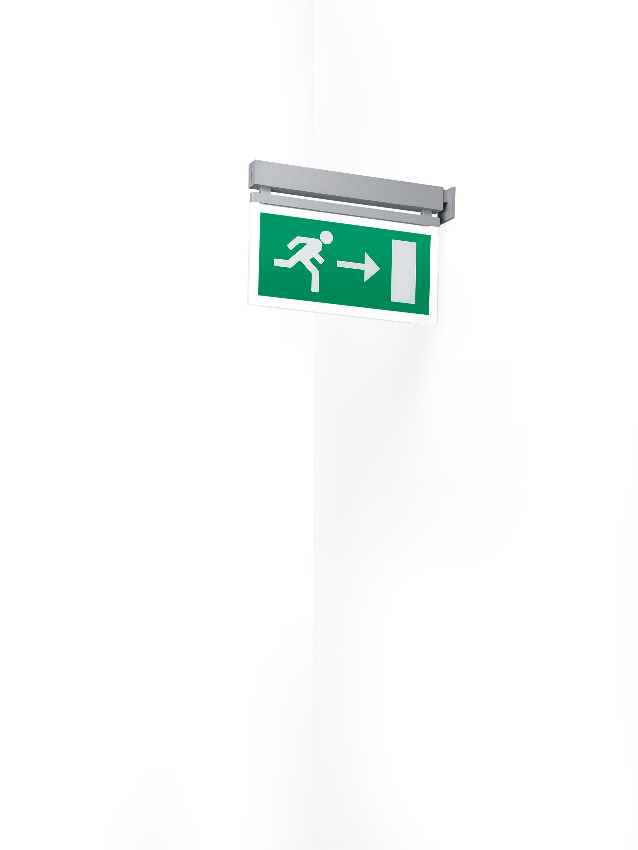
Minimalistic design emergency luminaire for single- and double sided signage. Perpendicular to wall mounting. Autonomous luminaire (contains battery). Dimensions: 324 mm x 26 mm x 63 mm. Powder coated zamak housing, screwless opening, automatic electrical connection, screwless wire terminals (up to 2.5 mm²). Signage plate with illuminated borders. Lumen output in emergency mode: 50 lm. Power consumption in standby: 2.5 W. Voltage: 220-230V. The perception distance of the pictogram is 26 m. Autonomy: 180 minutes. The luminaire contains lamp data, battery date and type as required according to EN 60598-2.22. Battery: 4 x NiMh 1,2V 1,1Ah. Battery lifetime: 6 years. Automatic functional test every week, duration test every 13 weeks, in accordance to EN 50172 and EN 62034. Maintained/non maintained mode selectable, preset for most common application. Electrical insulation class: class II. Photobiological safety IEC/TR 62778: RG0. Powder coated die-cast zamak housing, RAL9006 - aluminium grey. IP protection level: IP40. IK protection level: IK04. Ambient temperature: 5°C - 35°C. Glowwire: 850°C. 5 years warranty on luminaire, light source, driver and battery (for autonomous luminaires). Certifications: CE, ENEC. The luminaire has been developed and produced according to standard EN60598-1 in a company that is ISO9001 and ISO14001 certified.

