KE212/6O-ATEX1

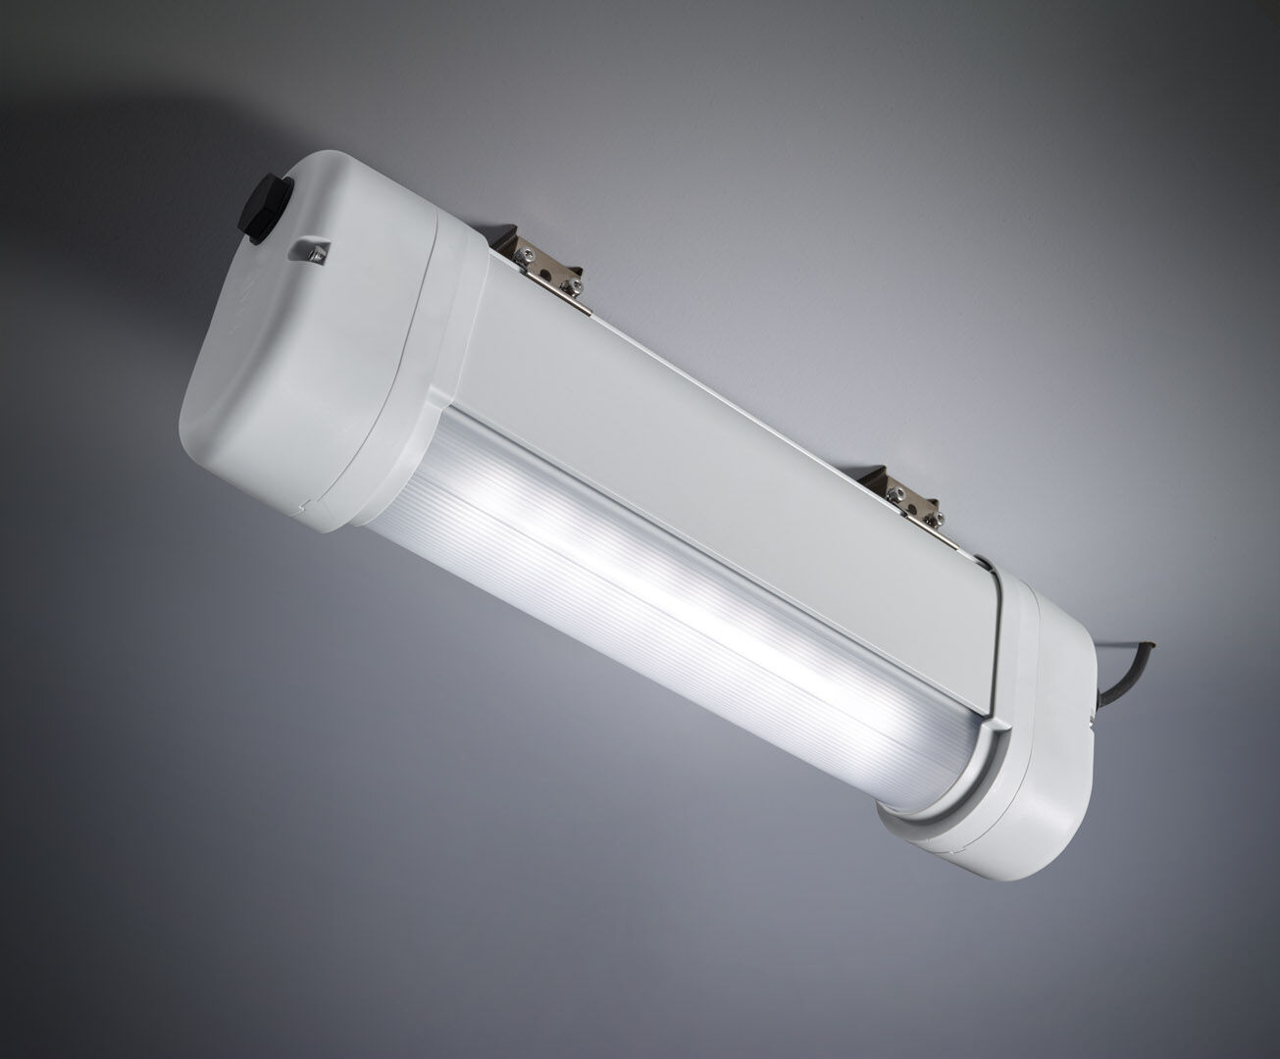
Emergency luminaire for anti-panic lighting in ATEX environments. Autonomous luminaire (contains battery). Dimensions: 423 mm x 80 mm x 135 mm. Aluminum housing, PBT endcaps, sealed polycarbonate optics. Mounted on two stainless steel springs. With battery heater, allowed ambient temperature -20°C to +35°C. Line-shaped light distribution, optimized for 1 lux along the escape route axis. Lumen output in emergency mode: 520 lm. Power consumption in standby: 2.4 W. Inderdistance escape route: at a mounting height of 2.8 m, the illumination on the floor is 1 lux with an interdistance ("b") of 12.1 m. Interdistance anti-panic: at a mounting height of 2.8 m, the illumination on the floor is 0.5 lux with an interdistance ("b") of 14.2 m. At a mounting height of 2.8 m, the illumination on the floor is 1 lux with an interdistance ("b") of 11.3 m. Voltage: 220-240V. Autonomy: 60 minutes. The luminaire contains lamp data, battery date and type as required according to EN 60598-2.22. Battery: 4 x NiMh 1,2V 2,1Ah. Battery lifetime: 5 years. Automatic functional test every week, duration test every 13 weeks, in accordance to EN 50172 and EN 62034. Maintained/non maintained mode selectable, preset for most common application. Electrical insulation class: class I. Photobiological safety IEC/TR 62778: RG0. Lacquered aluminium housing, RAL7035 - light grey. IP protection level: IP66. IK protection level: IK07. Ambient temperature: -20°C - 40°C. ATEX classification: II 2D Ex tb IIIC T80°C Db, II 3G Ex ec IIC T4 Gc. Glowwire: 850°C. 5 years warranty on luminaire, light source, driver and battery (for autonomous luminaires). Certifications: CE, ATEX, ENEC. The luminaire has been developed and produced according to standard EN60598-1 in a company that is ISO9001 and ISO14001 certified.

