KL142/6

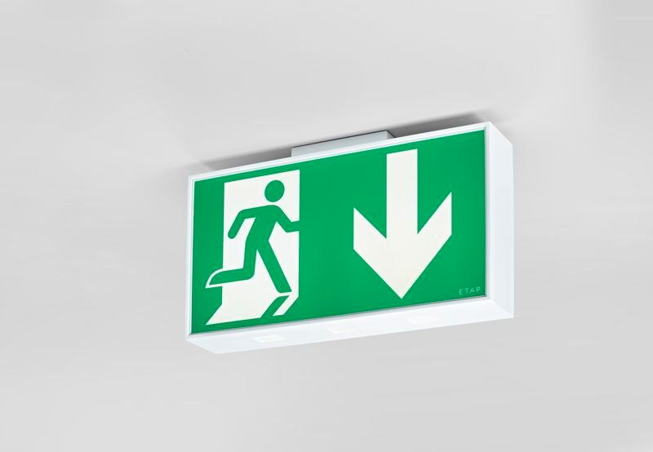
Large emergency luminaire for single or double sided signage. Autonomous luminaire (contains battery). Dimensions: 420 mm x 82 mm x 220 mm. White polycarbonate housing, mounting against the wall, ceiling, or perpendicular to the wall. Connector with screwless wire terminals (up to 2.5 mm²), allows for throughwiring. Lumen output in emergency mode: 110 lm. Power consumption in standby: 3.3 W. Voltage: 220-240V. The perception distance of the pictogram is 40 m. Autonomy: 60 minutes. The luminaire contains lamp data, battery date and type as required according to EN 60598-2.22. Battery: 4 x NiMh 1,2V 1,1Ah. Automatic functional test every week, duration test every 13 weeks, in accordance to EN 50172 and EN 62034. Maintained/non maintained mode selectable, preset for most common application. Electrical insulation class: class II. Photobiological safety IEC/TR 62778: RG1. Impact-resistant polycarbonate housing, RAL9003 - signal white. IP protection level: IP54. IK protection level: IK04. Ambient temperature: 5°C - 35°C. Glowwire: 850°C. 5 years warranty on luminaire, light source, driver and battery (for autonomous luminaires). Certifications: CE, ENEC. The luminaire has been developed and produced according to standard EN60598-1 in a company that is ISO9001 and ISO14001 certified.

